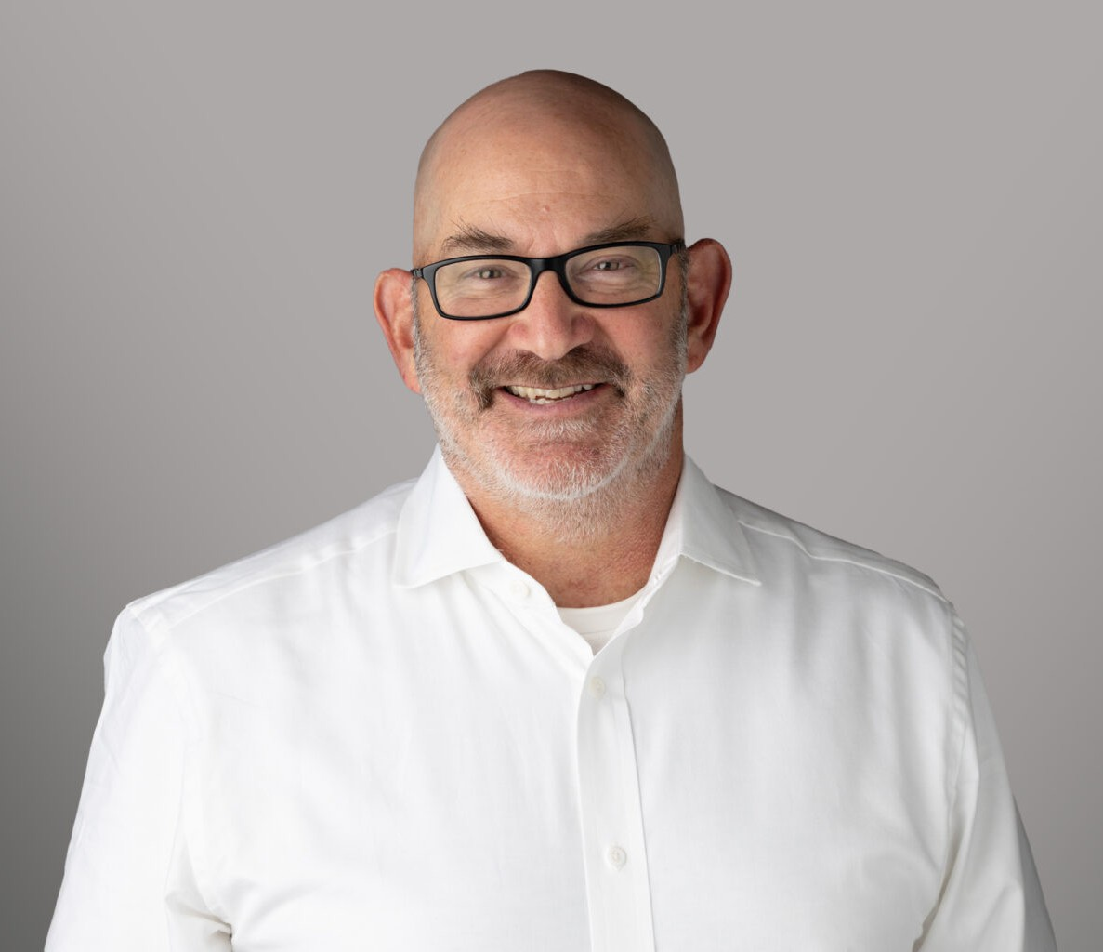

DALE FREEMAN
Director
Business & Finance

Oakland
P: 510.622.7562 F: 510.834.1928
dfreeman@fennemorelaw.com

DALE FREEMAN
Dale Freeman is a Director in Fennemore’s Business & Finance practice group. He assists clients in a wide array of industries, ranging from medical devices to specialty foods, from construction infrastructure to digital media and AI tools. Dale assists his clients through every stage of their
business, from their initial formation to exit (M&A and IPO). He also helps clients with financing equity and debt, licensing, and a range of commercial transactions. In his decades of practice, Dale has served as outside general counsel to an array of clients across industries, assisting them in their corporate, securities, transactional and employment matters and acting as a legal point person when issues arise relating to litigation, tax, intellectual property, and regulatory concerns.
Prior to joining Fennemore, Dale was senior counsel at Brown Gee & Wenger LLP focusing on
corporate, securities and commercial transaction matters. He also spent a decade operating his own practice, Berkeley Business Law. Dale earned his law degree from Berkeley Law (formerly
Boalt Hall), where he served as Managing Editor of the California Law Review. He graduated with honors from Stanford University.
An active member of the East Bay community, Dale has served on the boards of several local nonprofit youth sports and community service organizations. A lifelong East Bay resident, he enjoys exploring the local food scene and is a big supporter of Bay Area collegiate and professional sports teams (especially for the ones with his daughters on their rosters).

EDUCATION
J.D., University of California, Berkeley, School of Law Managing Editor, California Law Review
B.A., Stanford University, with honors

AREAS OF PRACTICE
Business & Finance General Counsel Services

REPRESENTATIVE MATTERS
Sell-side representation of a software company in the area of catastrophic risk mitigation.

Sell-side representation of an equipment manufacturing company.
Sell-side representation of a cloud-based software company that developed tools related to creating greater efficiencies for public- and quasi-public utilities.
Sell-side representation of a commercial food supply company.
Buy-side representation of a digital photography community company in the purchase of an AI tools company.

PROFESSIONAL AND COMMUNITY ACTIVITIES
Past Board Member, ACC Mavericks Past Board Member, Inc. Soccer Club
Past Board Member, Albany Little League
Past Board Member, Jewish Community Center of the East Bay

ADMISSIONS
California

