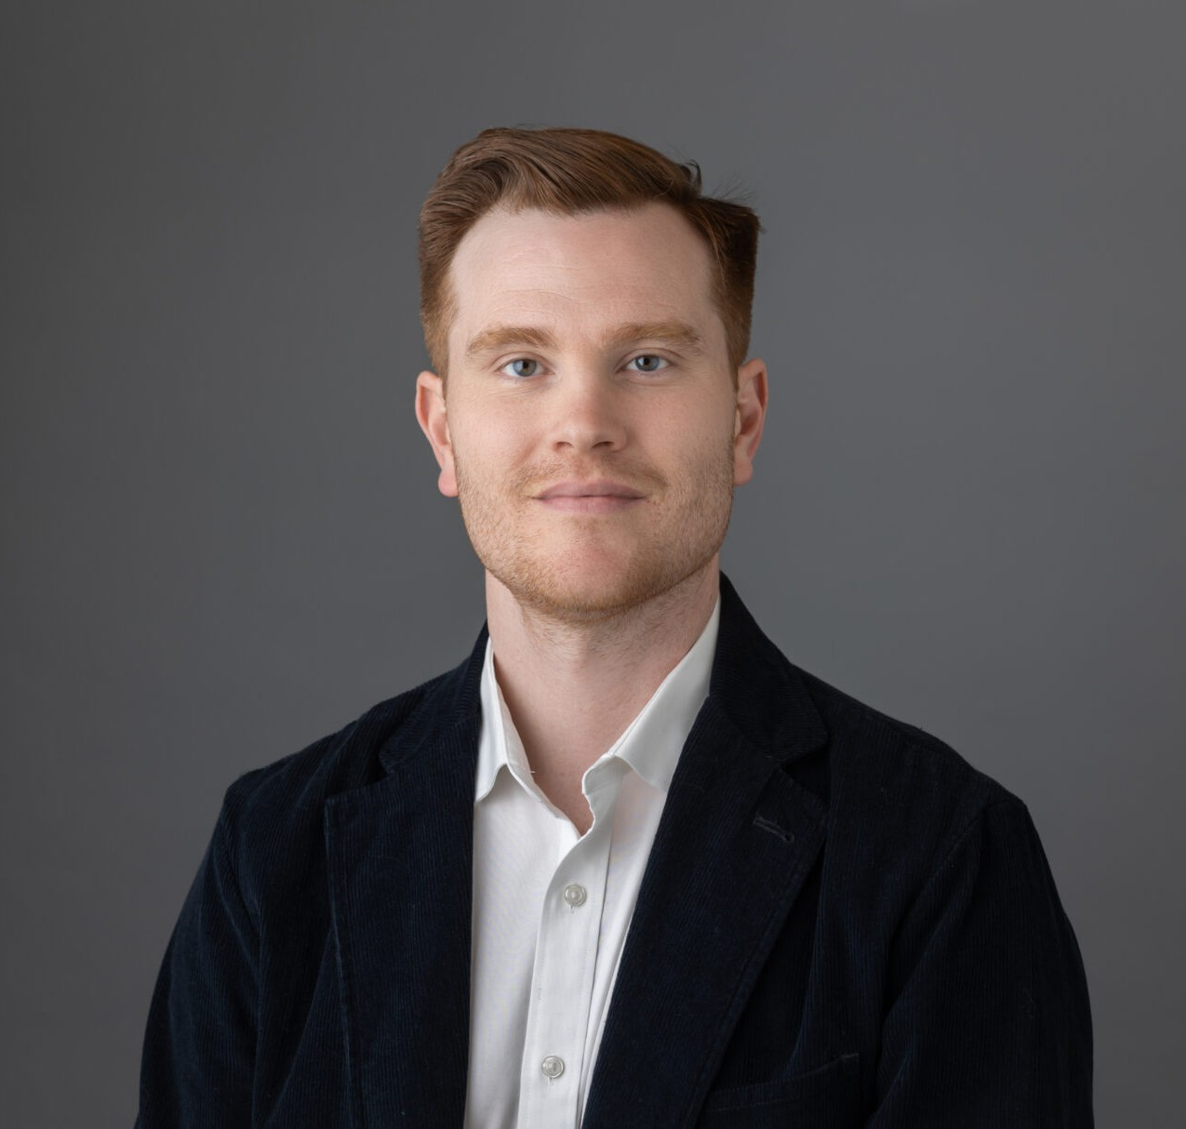

DAVID F. MONSOUR
Director
Trusts & Estates

Oakland
P: 510.834.6600 F: 510.834.1928
dmonsour@fennemorelaw.com

DAVID F. MONSOUR
David practices on behalf of his clients in the area of trusts and estates litigation where he represents and counsels trustees, beneficiaries, and professional fiduciaries through all phases of T&E disputes, from pre-litigation matters through trial.
David attended undergrad at the University of Texas at Austin, where he graduated beta
gamma sigma with a Bachelor of Business Administration from the Red McCombs School of Business. David attended law school and received his Juris Doctor from the University of
California College of the Law, San Francisco (formerly UC Hastings). While in law school, David externed for the Honorable Edward J. Davila of the United States District Court, Northern District of California and for the Office of the Circuit Executive for the Ninth Circuit Court of Appeals in San Francisco.
As a legal professional, David assists clients in solving difficult, and often times emotional
problems. His practice thrives on developing and maintaining trusted relationships with each client, and crafting client-specific legal strategies. David’s client-specific and results-oriented
approach helps his clients achieve their ultimate goals, whether through reaching an amicable settlement or diligently litigating and defending against claims at trial or on appeal. David has been recognized as a Northern California Rising Star by Super Lawyers and by Best Lawyers in
America in the area of trusts and estates litigation.

In his free time, David enjoys volunteering, writing about films, live music, and park days. He lives in San Francisco with his wife and their cat, Frankie.

EDUCATION
J.D., University of California College of the Law, San Francisco (formerly UC Hastings College of the Law)
B.B.A., The University of Texas at Austin, Red McCombs School of Business

AREAS OF PRACTICE
Trusts & Estates

Estate Litigation

ARTICLES AND PRESENTATIONS
Author, “How the One Big Beautiful Bill Act reshapes estate plans and disputes — and how families can avoid ending up in court,” San Francisco Business Times, August 5, 2025
Presenter, “Trusts and Estates Career Panel and Lunch at UC Law San Francisco,” California Lawyers Association, Trusts and Estates Executive Committee, March 27, 2024
Update Co-Author for California Trust and Probate Litigation (Cal CEB), Chapter 20 (Trust Contests) and Chapter 21 (Breach of Trust), 2023-2025
Co-Presenter, EBTEL Speaker Event, “What Estate Planners Should Know – a Litigator’s
Perspective, Tips, Strategies, and Pitfalls to Avoid for Estate Planners to Prevent or Minimize Litigation,” East Bay Trusts and Estates Lawyers, August 9, 2023
Featuring, “Conversation On Lessons Learned & Life In The Law With Attorney David Monsour,” Fennemore Blog, August 17, 2023
Presenter, “Trusts and Estates Career Panel at Berkeley Law,” California Lawyers Association, Trusts and Estates Executive Committee, March 22, 2023
Featuring, “Fennemore attorney David Monsour Shares Insights on Estate Planning, Tips for Mitigating Trusts and Estates Litigation,” San Francisco Business Times, August 1, 2024

AWARDS AND HONORS
Best Lawyers in America®, Ones to Watch, Litigation – Trusts and Estates, Trusts and Estates, 2024 – 2026
Rising Star, Northern California Super Lawyers®, 2018-2025

PROFESSIONAL AND COMMUNITY ACTIVITIES
Member, State Bar of California (SBN #301448)
Member, East Bay Trusts and Estates Lawyers Member, Alameda County Bar Association
JAEC Committee
Member, Contra Costa County Bar Association Member, San Francisco County Bar Association
Member, Trusts and Estates Section, California Lawyers Association Member, Fennemore Community Service & Outreach Committee, Oakland Volunteer, Operation Dignity
Volunteer, Alameda County Community Food Bank

ADMISSIONS
California

