
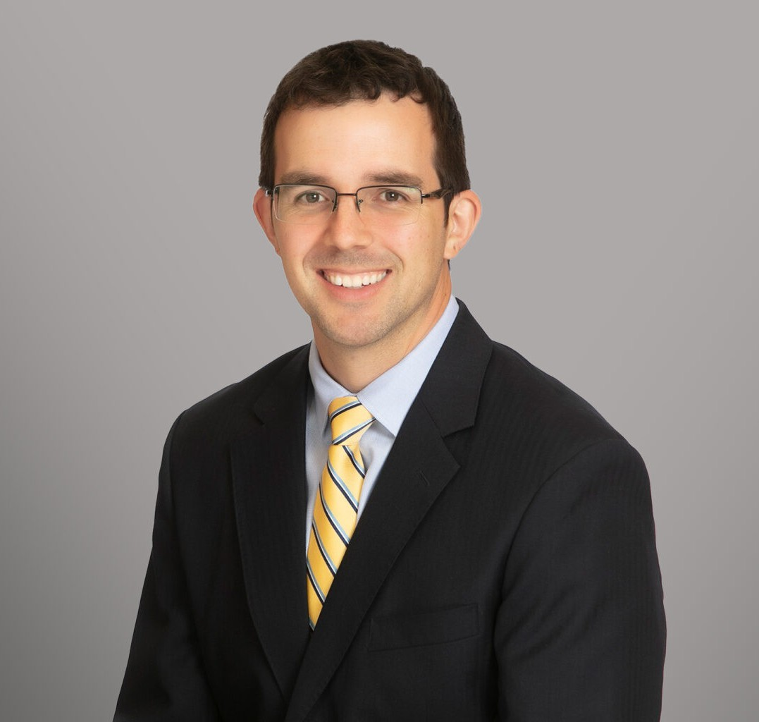
DYLAN A. FARMER
DYLAN A. FARMER
Director
Labor & Employment
San Antonio
P: 210.447.8033
F: 210.447.8036
dfarmer@fennemorelaw.com
Dylan A. Farmer is an attorney in Fennemore’s San Antonio office whose practice focuses on labor and employment law and construction litigation throughout Texas. He represents
employers, contractors, and business leaders in both federal and state courts, providing practical and strategic counsel on a wide range of workplace and construction-related legal issues.
On the employment law side, Dylan has successfully managed complex litigation from initial
complaint through appeal, including cases involving the U.S. and Texas Constitutions, Title VII, the Americans with Disabilities Act (ADA), and the Age Discrimination in Employment Act (ADEA), as well as state anti-discrimination laws. In addition to his employment litigation work, he assists clients with employee handbooks, workplace policies, employment agreements, and other key business documents. On the construction side, he handles construction defect claims and helps clients navigate breach of contract disputes, negligent design allegations, and related matters.
Before joining Fennemore, Dylan was a partner at Schmoyer Reinhard LLP, a San Antonio-based law firm specializing in labor and employment, construction, and business litigation. Earlier in his career, he served as an associate at a Houston law firm representing public employers in
employment, civil rights, and contracting disputes.

Dylan earned his Bachelor of Arts in English from Rice University in 2009 and graduated magna cum laude from the University of North Carolina School of Law in 2013. During law school, he served as an editor for the North Carolina Law Review, received the Gressman-Pollitt Award for exceptional oral advocacy, and completed over 100 hours of pro bono service. He also clerked for the North Carolina Pattern Jury Instruction Committee, helping to draft model jury instructions for civil trials, and later served as a law clerk to the Honorable William L. Osteen, Jr. of the Middle District of North Carolina.

EDUCATION
J.D., University of North Carolina School of Law, magna cum laude
Order of the Coif B.A., Rice University

AREAS OF PRACTICE
Labor & Employment Business Litigation Construction Law

REPRESENTATIVE MATTERS
Obtained pre-trial dismissal of FMLA interference and retaliation claims against a Fortune 50 company and successfully defended the judgment on appeal.
Successfully defended municipal utility against race and disability discrimination claims by a high-level director.
Obtained favorable jury verdict in slip-and-fall case against national homebuilder.
Represented several national homebuilders in warranty and contract disputes in both litigation and arbitration proceedings.
Represented local developer in lien foreclosure suit and helped avoid several other potential lien-related suits through proactive resolution techniques.

AWARDS AND HONORS
Top Labor and Employment Attorney, San Antonio Magazine, 2025
Best Lawyers in America: Ones to Watch®, Commercial Litigation and Labor and Employment Law – Management, 2021 – 2024
San Antonio’s Best Labor And Employment Lawyers, Scene in S.A., 2018 – 2024 San Antonio’s Best Construction Litigation Lawyers, Scene in S.A., 2022 – 2024 Rising Star San Antonio Lawyer, Scene in S.A., 2022 – 2023
Top Labor and Employment Attorney, San Antonio Magazine, 2020 – 2023

ARTICLES AND PRESENTATIONS
Co-Presenter, “FLSA Trends and Developments,” State Bar of Texas 35th Annual Labor & Employment Law Institute (2025) (with contributions to paper)
Lead Author, “A Brave New World After Hamilton v. Dallas County,” 110 Advocate 41, Spring 2025
Co-Presenter, 30(b)(6): “The Procedural and Ethical Idiosyncrasies of Federal Corporate Representative Depositions,” State Bar of Texas 30th Annual Labor and Employment Law Institute (2019) (with paper)
Presenter, “Drugs in the Workplace,” University of Texas 26th Annual Labor and Employment Law Conference (2019) (with paper)
Co-Presenter, “Drugs in the Workplace: Getting Into the Weeds of State and Federal Drug Testing Laws,” State Bar of Texas 29th Annual Labor and Employment Law Institute (2018) (with paper)
Co-Author, “More Parties, More Problems: Exploring the Ups and Downs of Texas’s Responsible Third Party Statute,” 3 Construction Law Journal 27, Winter 2018

Presenter, “Mum’s the Word: Social Workers, Counselors, and Student Record Confidentiality,” Lecture on behalf of Harris County Community Youth Services, 2016

PROFESSIONAL AND COMMUNITY ACTIVITIES
Member, San Antonio Bar Association
Treasurer, San Antonio Bar Association Construction Law Section Officer at Large, San Antonio Bar Association Litigation Section

ADMISSIONS
Texas
U.S. District Courts, Eastern District of Texas
U.S. District Courts, Northern District of Texas
U.S. District Courts, Southern District of Texas
U.S. District Courts, Western District of Texas
U.S. District Courts, Middle District of North Carolina
U.S. Courts of Appeals, 4th Circuit
U.S. Courts of Appeals, 5th Circuit
U.S. Courts of Appeals, 11th Circuit

