

Building relationships with families for over 137 years.
Serving ultra-high net worth individuals, families, and their business concerns.
Family Office and Private Client Attorneys

LEADERSHIP

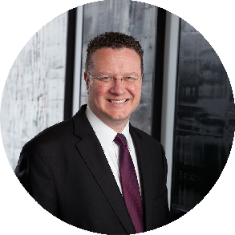
FAMILY OFFICE & PRIVATE CLIENT ATTORNEYS

TRUSTS & ESTATES

Jim Lee
Director

Phoenix

PH 602.916.5422
FX 602.916.5622
jlee@fennemorelaw.c om

Fennemore’s Family Office & Private Client Attorneys—a powerhouse team guiding high-net-worth individuals, multigenerational families, and family offices through the evolving landscape of wealth planning, preservation, and legacy building.
Whether advising on trust and estate planning, business succession, or charitable giving, our attorneys take a holistic, values-driven approach that puts people first. With deep experience across real estate, tax, fiduciary litigation, and cross-border matters, they deliver legal strategies that evolve with families through generations and across geographies.

YOUR CONCIERGE LAWYER

PRIVATE CLIENT SERVICES
Family office general counsel Private wealth planning
Sophisticated business and tax structuring Private equity and angel investment support

Specialty areas, such as agribusiness, aviation trusts, emerging technologies, household
employment, international tax and concerns, mansion and luxury home ownership, privacy law, real estate development, and technology manufacturing

ARIZONA


Stephen A. Good
Director | Business & Finance

P 602.916.5395
sgood@fennemorelaw.com


Hope Leibsohn
Director | Trusts & Estates

P 602.916.5328
hleibsohn@fennemorelaw.com


Stephanie F. Tribe
Director | Trusts & Estates

P 602.916.5325
stribe@fennemorelaw.com

T. James Lee
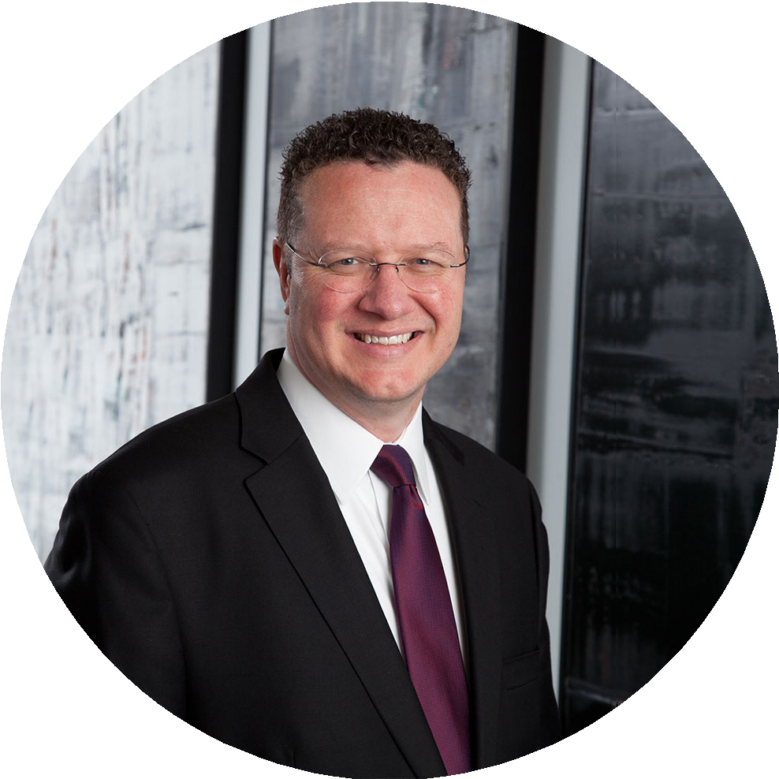
Director | Trusts & Estates

P 602.916.5422
jlee@fennemorelaw.com


J. Barry Shelley
Director | Business & Finance

P 602.916.5390
bshelley@fennemorelaw.com

CALIFORNIA

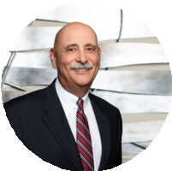
Richard M. Aaron
California Region Chair | Trusts & Estates

P 559.432.4500
raaron@fennemorelaw.com


Monica Dell’Osso
Director | Trusts & Estates

P 510.834.6600
mdellosso@fennemorelaw.com

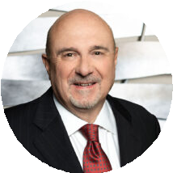
WM. Lanier Thomas
Of Counsel | Trusts & Estates

P 559.432.4500
lthomas@fennemorelaw.com


Jeffrey S. Tachiki
Director | Trusts & Estates

P 510.622.7571
jtachiki@fennemorelaw.com

Francesca K. Boyd

Director | Trusts & Estates

P 510.834.6600
fboyd@fennemorelaw.com

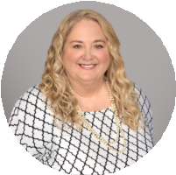
Robin L. Klomparens
Director | Trusts & Estates

P 916.920.5286
rklomparens@fennemorelaw.com


Gamble Parks
Director | Trusts & Estates

P 805.420.6002
gparks@fennemorelaw.com

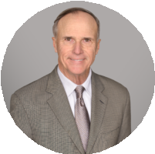
Belan K. Wagner
Director | Business & Finance

P 916.920.5286
bwagner@fennemorelaw.com

COLORADO

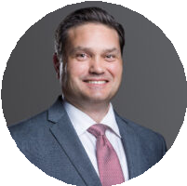
NEVADA

Thomas W. Aldous Jr.
Of Counsel | Trusts & Estates

P 602.916.5468
taldous@fennemorelaw.com

Michael P. Robertson
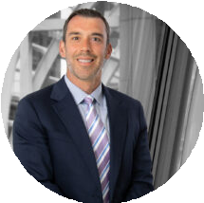
Director | Business Litigation

P 303.764.3723
mrobertson@fennemorelaw.com

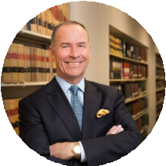
Craig Etem
Director | Business & Finance

P 775.788.2224
cetem@fennemorelaw.com

