
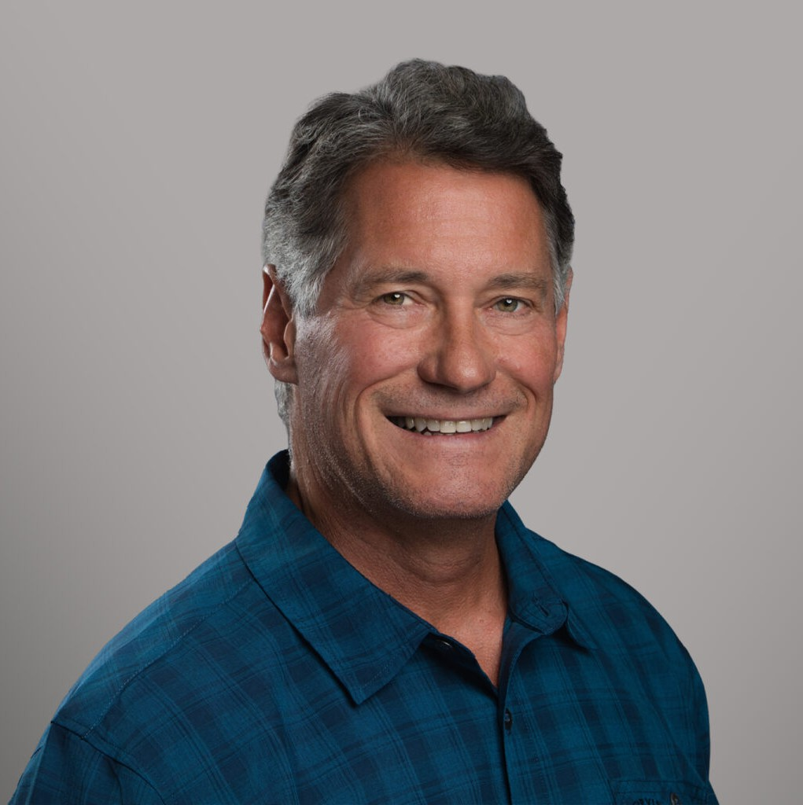
GREGORY N. MISKULIN
GREGORY N. MISKULIN
Chief Practice Group Officer

Gregory N. Miskulin
Fennemore Forward
P: 559.432.4500 F: 559.432.4590
gmiskulin@fennemorelaw.com
“
Rivers, lakes and ocean will attack you. Mountains are different. They wait for you to make a mistake.
- Tom Stienstra
”
Greg Miskulin is our firm’s Chief Practice Officer. As a member of our C-Suite, he is part of the team responsible for the day-to-day management and administrative operations of our firm.
Greg functions much like a COO at the Practice Group level, focusing on the firm’s practice groups as individual business units. He provides business support to the Practice Group Leaders by assisting with a range of tasks from developing group business plans and examining productivity analytics, to helping with project and timekeeper management. He also facilitates succession planning and identifies opportunities for enhancing operational efficiencies. Greg
also works with practice groups and individual attorneys on internal cross-selling and cross-office collaboration.
Prior to joining the Firm, Greg carved a successful 15-year career in the restaurant industry as an owner-operator of a major national brand franchise. He was entrusted with the daily supervision of 15 outlets located throughout California’s Central Valley, overseeing more than 150
employees. It was during this period that Greg gained a deep understanding of the daily legal challenges faced by business owners, which eventually led him to transition to law in a bid to
help others navigate similar issues. As it turns out, he has applied his experience in both worlds to the business of law. He finds immense joy and fulfillment in assisting clients, attorneys, and staff in achieving their goals and striving for success. His blend of operational knowledge and legal
insight makes him a unique asset to our team.

If you aspire to keep pace with Greg during his leisure hours, prepare yourself for an intense adventure. Greg is an enthusiastic lover of the outdoors; the more secluded, challenging, and disconnected from modern comforts, the better. He holds an unwavering conviction that there is

an unparalleled sense of achievement in conquering a peak, a feat demanding days of effort, gallons of sweat, inexhaustible energy, and undivided mental dedication to reach the summit.

EDUCATION
J.D., San Joaquin College of Law

ARTICLES AND PRESENTATIONS
Author, “Turning Talent into Teamwork: How Fennemore Transforms Individual Strengths into Practice Group Success,” Fennemore Blog, May 20, 2025
Author, “How to Write a Business Plan,” Fennemore Blog, December 2, 2022
Interview, “Fennemore’s Swiss Army Knife,” Fennemore Blog, October 28, 2021

PROFESSIONAL AND COMMUNITY ACTIVITIES
Member, State Bar of California Eagle Scout

ADMISSIONS
California

