
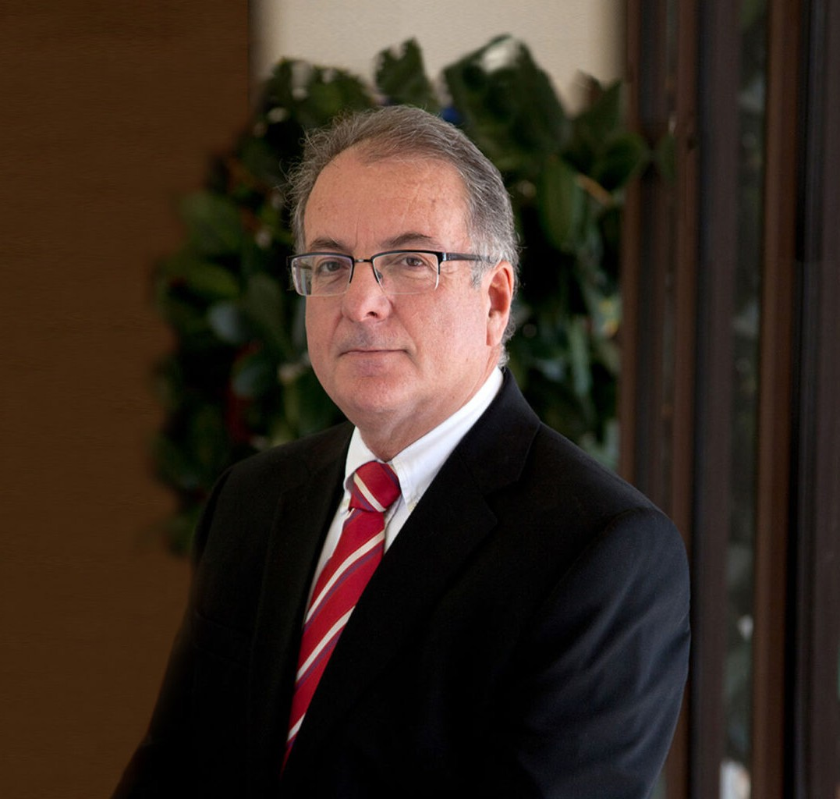
HECTOR G. ARANA
HECTOR G. ARANA
Of Counsel
Business & Finance
Nogales
P: 520.281.3482
F: 520.281.3499
harana@fennemorelaw.com
Hector practices in the areas of agribusiness, corporate and securities, estate planning and probate, international, real estate, and tax law. He has significant experience in handling tax disputes with the IRS Office of Appeals, district counsel offices, and advance pricing teams.
Fluent in Spanish, Hector represents both foreigners and U.S. residents with U.S. businesses and property interests and deals with the business and tax aspects of those businesses and holdings.

EDUCATION
J.D., University of Arizona, James E. Rogers College of Law B.S., Accounting, Arizona State University, cum laude
AREAS OF PRACTICE

OTHER EXPERIENCE

International Business & Finance Estate Planning Agribusiness
Tax Law Real Estate
Estate Litigation Trusts & Estates

AWARDS AND HONORS
Best Lawyers in America®, International Trade and Finance Law, Tax Law, 2005-2026

AV® Preeminent™ Peer Review Rated (the highest rating available), by Martindale-Hubbell

ARTICLES AND PRESENTATIONS
Co-Author, “Cross collaboration among Denver and Nogales lawyers fuels agribusiness
knowledge, seeds positive culture and client relations,” Fennemore Blog, March 10, 2025

PROFESSIONAL AND COMMUNITY ACTIVITIES
Member, State Bar of Arizona
Member, Santa Cruz County Bar Association Member, American Bar Association
Member, American Association of Attorney Certified Public Accountants Former Board Member, International Law Center, University of Arizona

ADMISSIONS
Arizona
U.S. District Court, District of Arizona
U.S. Court of Appeals, Ninth Circuit
U.S. Supreme Court
U.S. Tax Court

LANGUAGES
Spanish, Fluent

