
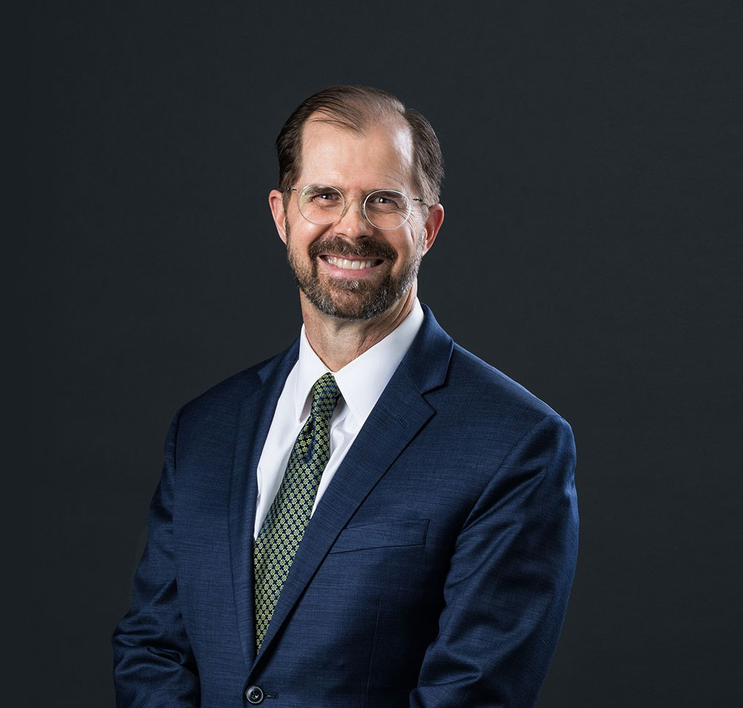
Jeff Pitcher is a director in our real estate practice group where he works as a transactional attorney and an outside general counsel. His practice focuses on institutional and other lenders, and his experience covers a wide range of both conventional and complex lending
JEFFREY S. PITCHER
Director
Real Estate
Phoenix
P: 602.916.5307 F: 602.916.5507
jpitcher@fennemorelaw.com
“
The way to get started is to quit talking and begin doing.
-Walt Disney
JEFFREY S. PITCHER
”
transactions, including real estate and transactional finance and financial restructuring. He represents some of the country’s largest financial institutions, as well as local community banks and credit unions, in originating complex secured real estate loans, construction loans, warehouse lines of credit and a variety of other asset-based lending transactions.
From a very early age, Jeff knew that he wanted to be an attorney – with the ability to help people through a lawyer’s specific skill set. Throughout his career, Jeff has acquired extensive experience in multi-state and multi-party real estate and lending transactions, including loans secured by shopping centers, office buildings, multifamily properties, industrial facilities, residential communities, hotels, grocery stores, mini-storage facilities and other real estate and related assets. Jeff also assists lenders and CMBS Special Servicers in intelligently and creatively managing their existing loan portfolios and related risks, crafting specialized loan participations and syndications, making loan modifications, negotiating and documenting workouts, procuring deeds in lieu of foreclosure, obtaining the appointment of qualified receivers and executing both judicial and non-judicial foreclosures. He takes great pride in helping his clients meet their objectives and goals.
In addition, Jeff regularly advises and negotiates on behalf of property managers, property owners and owners of master- planned and mixed-use developments, rental, retail, medical, industrial and office buildings, and other types of commercial and residential real estate on a variety of issues involving property purchase and sale transactions, real estate development and commercial leasing, and lease enforcement.

Married with four grown children, outside of work you’ll probably find Jeff planning his next travel adventure. Japan is perhaps his favorite place on earth, and fluent in Spanish, the country of Spain also holds a special place in his heart.

EDUCATION
J.D. ,Brigham Young University, J. Reuben Clark Law School B.A., University of Utah
Associate Editor, Brigham Young Journal of Public Law

AREAS OF PRACTICE
Real Estate Business & Finance
Financial Restructuring

REPRESENTATIVE CASES

Leasing
Represented the Arizona Department of Administration on behalf of the Arizona Department of Health Services in connection with the sublease of St. Luke’s Medical Office Building
Represent the Arizona Department of Administration on behalf of the Arizona Department of Health Services in the connection with the sublease of the Tucson Convention Center
Represent a commercial developer for 15 years in the acquisition, development and leasing of various multi-tenant industrial facilities including a four building, 340,000 square foot,
development in Phoenix, Arizona
Represented the owner of a multi-tenant medical office building for the past fifteen years

Lending
Represents special servicers in loan workouts, mediation, loan sales and foreclosures of residential properties across Arizona, Nevada and Utah
Represented a commercial lender on a $50 million loan on a golf course and fractional-interest project. He also represented a lender in the foreclosure of a $95 million resort.
Represent the lender in connection with the drafting and negotiation of more than 40 real estate secured loans, loan amendments and loan participations in the last two years including most recently, a $125 million construction loan, $19.5 billion, term loan, and a $6.5 million construction loan
Represent the lender in connection with the drafting and negotiation of a $20.5 million real estate secured construction loan

Acquisition and Development
Assisted the buyer in connection with the $60 million acquisition of an approximately 900,000 square foot warehouse building
Assisted the buyer in connection with the $65 million acquisition of a mixed use office complex
Represent the developers in connection with sale and purchase of more than 450 residential subdivision lots this year

AWARDS AND HONORS
Best Lawyers in America®, Real Estate Law, 2013-2025
The Legal 500 US, Energy-Renewable/Alternative, 2014-2015
Ranking Arizona: The Best of Arizona Business,” Construction and Real Estate Law, 2011
AV® Preeminent™ Peer Review Rated (the highest rating available), by Martindale-Hubbell

ARTICLES AND PRESENTATIONS
Featuring, “Here’s How a Developer Became a Big Name in the Receivership Business,” CoStar, May 30, 2023
Quoted, “Your Business & the Law Attorneys help businesses stay on top of social and regulatory change,” inBusiness, May 2022
Lecturer, “Commercial Real Estate Loan Documentation from Start to Finish”, National Business Institute, 2016, 2018
Contributing Author, “Trigild Deskbook, a Guide to Receivership & Foreclosure, Seventh Edition”
Lecturer, Arizona School of Real Estate and Business, on various real estate, lending and workout topics
Jeff regularly provides his clients with in-house seminars and presentations on topics requested by the clients, addressing topics that include current loan issues and underwriting best
practices. Jeff also works with clients to provide legal updates and related training. Jeff regularly presents in-firm continuing legal education to associates and paralegals.

PROFESSIONAL AND COMMUNITY ACTIVITIES
Member, Planning and Zoning Board, City of Mesa
Member and former Chairman, Economic Development Advisory Board, City of Mesa

ADMISSIONS
Arizona Utah

