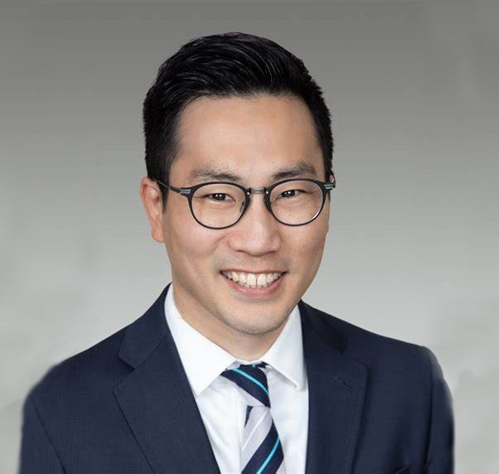

JEFFREY S. TACHIKI
Director
Trusts & Estates

Oakland
P: 510.622.7571 F: 510.622.7571
jtachiki@fennemorelaw.com

JEFFREY S. TACHIKI
Jeff Tachiki is a Director in our Trusts & Estates practice group and has two decades of experience advising clients through the complexities of estate planning, tax planning, trust administration and probate. Jeff counsels estate planning clients of all wealth levels, utilizing sophisticated wealth preservation and tax planning strategies to establish plans that meet
clients’ objectives in a thoughtful and pragmatic way. He also has a broad range of trust administration experience that includes gift and estate tax return preparation, generation-skipping transfer tax and other post-mortem income, estate, and property tax planning, modifying and decanting trusts, multi-jurisdictional issues, and advising trustees and beneficiaries in disputed matters.
A frequent lecturer on a variety of trust and estate planning topics, Jeff has been selected as a Northern California Super Lawyer every year since 2021 and is a certified specialist in Estate
Planning, Trust and Probate Law by the California Board of Legal Specialization. He is also active in the Bay Area legal community, serving on the Board of Directors for Legal Assistance for Seniors of Alameda County since 2020.
Outside of work, Jeff and his wife enjoy the joyful blur created by two young children. He also loves a good cup of coffee and is an avid sports fan, following nearly every sport imaginable.
Trusts & Estates Tax Law
Family Office & Private Client Attorneys

EDUCATION
J.D., The University of Utah, S.J. Quinney College of Law B.A., University of Utah

AREAS OF PRACTICE
Trusts & Estates Tax Law

Family Office & Private Client Attorneys

AWARDS AND HONORS
Northern California Super Lawyers®, 2021-2026
Northern California Super Lawyers Rising Stars®, 2009-2010
Barristers’ Distinguished Service Award – Young Lawyer, Alameda County Bar Association, 2012

ARTICLES AND PRESENTATIONS
California Advocates for Nursing Home Reform: Ethical Issues and Common Estate Planning Challenges, November 22, 2025
California Advocates for Nursing Home Reform Estate Planning Summit: Ethics and Professional Responsibility in Estate Planning, April 29, 2025
California Advocates for Nursing Home Reform, 2024 Elder Law Conference – Artificial
Intelligence, Real Responsibility: Ethical Considerations in the Use of Artificial Intelligence in Legal Practice, November 23, 2024
Continuing Education of the Bar – Ethics and Professional Responsibility in Estate Planning, March 19, 2024
East Bay Trusts and Estates Lawyers – But I Like My Ol’ Hat!: Rethinking Marital Deduction Formulas in Estate Planning, January 10, 2024
Moving to Mastery – Fundamentals of California Trust Administration: Subtrust Allocation and Funding at the Death of the First Spouse in a Joint Trust, April 20, 2023
San Luis Obispo County Bar Association: IRA Beneficiary Designations in the Age of the SECURE Act, September 23, 2020
Cameron House: Tail of the Charitable Dog: Tax and Control Considerations in Planned Giving, August 22, 2020.
Dying and Private Keys, Perkins Coie, LLP Virtual Currency Report, March 6, 2019
Council of Business Advisors: Property Tax Issues in Estate Planning – An Overview, January 27, 2015
IRA Trusts and Beneficiary Designations, May 22, 2018
Continuing Education of the Bar (CEB): Drafting Revocable Trusts I and II, October 28, 2011; Estate Planning Intensive Course Faculty member 2015 and 2017 – Transfer Tax Issues;
“How to Be an Ethical Trusts and Estates Attorney” – Basics 2017: Estate Planning; “How to Be An Ethical Trusts and Estates Attorney” – Basics 2018: Estate Planning
East Bay Trusts and Estates Lawyers (EBTEL): “Taking the Certified Specialist Exam,” August 12, 2015.
National Business Institute: Trusts: The Ultimate Guide – Retirement Trusts, December 14, 2017; Probate Boot Camp – First Steps, October 28, 2014;
The Probate Process From Start to Finish – Maintaining an Ethical Balance in Probate, May 12, 2014; Trusts 101 – Ethical Considerations, August19, 2013;
Tax Planning for Trusts and Estates – Estate Tax Planning Considerations, September 19, 2012; Trusts 101 – Revocable Living Trusts and Irrevocable Life Insurance Trusts, December 9, 2011;

Trust Administration: Preventing and Litigating Fiduciary Liability – Managing and Modifying Trusts and Legal Ethics, June 22, 2011;
Drafting Effective Wills and Trusts – Using Living Trusts and Powers of Attorney as Estate Planning Tools, September 21, 2010.
Alameda County Bar Association: Volunteer Legal Services – Wills and Trusts Training Seminar, February 17, 24, 2011. Provided training to 40+ attorneys able to provide pro bono representation to over 80 low-income clients needing basic estate planning services.
PENSCO Trust Company: Roth Conversions and other Retirement Plan Exit Strategies, October 23-24, 2008.
Professional Fiduciary Association of California: Administering Special Needs Trusts, November 5-6, 2009.
Strafford Publications: “Mitigating Successor Trustee Liability for Prior Fiduciary Breach: Trust Structure and Administrative Tools,” October 31, 2017.
Berkeley Association of Realtors: Real Estate Planning: Real Property Issues from an Estate Planning Perspective, February 25, 2009.

PROFESSIONAL AND COMMUNITY ACTIVITIES
Member, Board of Directors, Legal Assistance for Seniors, 2020-present
Liaison to Diversity, Equality and Inclusion Committee, Legal Assistance for Seniors, 2021-present
Vice President, East Bay Trusts and Estates Lawyers (EBTEL), 2022 Secretary, East Bay Trusts and Estates Lawyers (EBTEL), 2021
Chair, Estate Planning and Administration Committee, East Bay Trusts and Estates Lawyers (EBTEL), 2018-2020
Member, Judicial Appointment Evaluation Committee (JAEC), Alameda County Bar Association, 2016-2019
Vice Chair, Trusts and Estates Section, Alameda County Bar Association, 2011-2014 Volunteer Legal Services, Alameda County Bar Association
Mentor, Barristers’ Mentorship Program, Alameda County Bar Association, 2011-2013
Mentor, Young Lawyer Mentorship Program, Asian American Bar Association Mentorship Program, 2011-2013
Member, California Bar Association Member, San Francisco Bar Association Member, Alameda County Bar Association Member, East Bay Trusts and Estates Lawyers
Member, Asian American Bar Association, Bay Area Chapter

ADMISSIONS
California

