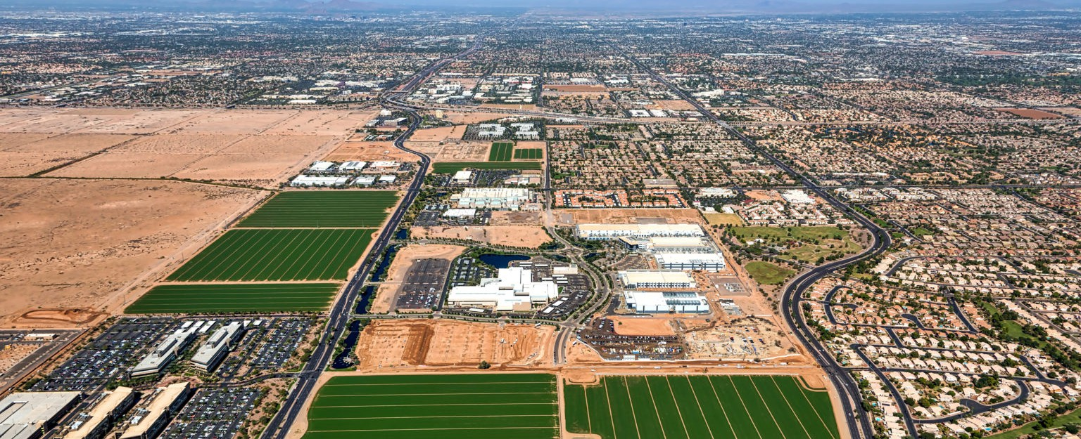

As land use issues continue to evolve and become more complex, our land use attorneys help clients find creative solutions. We advise private and public sector clients in all aspects of development and permitting, including land use litigation.
Fennemore’s land use attorneys take major development projects from inception to approval, providing counsel on all required land use permits and entitlements. We also assist clients in obtaining traditional land use approvals, and facilitate coordination with all departments of local governments to address any unique matters.
For More Than 140 Years – Helping Our Clients Realize Their Vision For Responsible Development In The American West
Land Use

LEADERSHIP

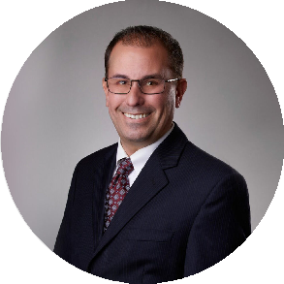
LAND USE REAL ESTATE
Donovan C. Collier
Chair
San Bernardino
PH 909.723.1814
FX 909.890.9877
dcollier@fennemorela w.com
LAND USE REAL ESTATE

Patricia E. Curtin
Vice Chair
Walnut Creek
PH 510.834.6600
FX 510.834.1928
pcurtin@fennemorela w.com

RESOLVING LAND USE CHALLENGES
As land use issues continue to evolve and become more complex, our land use attorneys help clients find creative solutions. From major residential, commercial, industrial and mixed-use developments to small redevelopment projects, we assist with zoning and permitting matters in cities, counties, and special districts.
Whether your project is ground-up construction or reuse of an existing site, our attorneys manage the intricate legal details so that you can focus on project development. Our team will support
you throughout every phase of the development process, from initial environmental due diligence to the acquisition of land use approvals that maximize the use of your property.

With a firm history spanning more than 140 years, our attorneys have the expertise, agency relationships, and legal knowledge to handle any matter effectively and efficiently.

PUBLIC HEARINGS AND APPROVALS
Our knowledge of local, regional, state and federal throughout the West helps us minimize roadblocks. For example, in California, our attorney team includes current and former board
and commission members in San Francisco Bay Area jurisdictions and regional agencies, former city planners, and advanced degree holders in related planning land-use fields. This experience provides unique insight for guiding clients through the complex land use process and providing representation before city councils, boards of supervisors, planning commissions, zoning boards, and commissions.
We appear at hearings on behalf of project proponents and are able to secure highly contested land use approvals in jurisdictions throughout the West.

SUPPORTING THE DEVELOPMENT TEAM
We work with client project teams to prepare documentation to obtain land use approvals, including development agreements, tentative and final subdivision maps, complex project
applications, conditions of approval, and state and federal environmental review documents. Working closely with architects, surveyors, engineers, contractors and others, we help streamline the process. Our practical experience untangling the local, state and federal regulations that govern land use applications (including CEQA, NEPA, the Subdivision Map Act, density bonus and housing streamlining legislation, wetlands, air quality, historic resource and congestion
management regulations) keeps your project on track.

PUT OUR EXPERIENCE TO WORK FOR YOU
Our land use attorneys have unparalleled experience serving commercial, industrial and residential developers; renewable energy project developers, municipalities and other government entities; as well as property and business owners, brokers, lenders and borrowers. Our team works with government entities at all levels, as well as Native American communities on a broad variety of land use and zoning matters.
We advise our clients with respect to state land entitlements; amendments to city and county general plans, special plans and zoning ordinances; adoption and modification of area plans and comprehensive master plans; negotiation, drafting and approval of development
agreements, annexation and pre-annexation agreements, economic incentive agreements, the creation and application of overlay zoning districts.
Our land use attorneys also bring substantial experience in the pursuit of zoning code interpretations; use permits; approval and implementation of master-planned developments; historic preservation districts and overlays, conservation easements, hillside overlays, and the
proposal and adoption of text and ordinance amendments, formation of community facilities districts, including California Geologic Hazard Abatement Districts, and all other aspects of land use legislative and administrative processes.
We work with clients seeking to purchase, lease and entitle lands managed by state and federal governments for purposes of residential and commercial development. Our attorneys work with clients to acquire easements and rights of way over state trust lands for purposes of streets and access roads as well as municipal and utility infrastructure.
Additionally, our land use attorneys have a substantial background in analyzing and arguing state land issues regulated by the Federal Enabling Act, State constitutions and statutes. Our

attorneys routinely interface on land use, land exchange and property acquisition with representative agencies, including the U.S. Bureau of Land Management, the U.S. Forest Service, and state and county departments of transportation, water resources, natural resources, mining and mineral resources, flood control districts and others.
Our land use attorneys also have extensive experience representing clients in obtaining incidental take authorization under the Federal Endangered Species Act and incidental take permits and streambed alteration permits from the California Department of Fish and Wildlife.

BROAD EXPERIENCE WITH ALL TYPES OF DEVELOPMENT IN CALIFORNIA
Our attorneys have deep experience with projects throughout California. We have a great depth of knowledge in the California Environmental Quality Act (CEQA), and our attorneys are well-versed in the details of the California Planning and Zoning Law, the Subdivision Map Act and Takings jurisprudence.

LITIGATION AND DISPUTE RESOLUTION
Our attorneys are resolution-oriented, using their experience to find creative solutions to complex issues. As needed, we help clients defend their rights through litigation and alternative dispute
resolution, including negotiation, mediation, and arbitration. We have successfully represented clients in matters involving CEQA, the Subdivision Map Act, exactions and development fees, building moratoria, and similar issues.

FENNEMORE REGULARLY REPRESENTS DEVELOPERS OF:
Retail and shopping centers
Manufacturing, warehouses, distribution centers, and logistics centers Residential projects, including multi-family, single-family and senior housing Mining projects
Schools and educational institutions
Automotive uses, such as truck facilities and auto dealerships Office buildings
Military base reuse
Biotech and life science facilities
Entertainment and performing arts centers Public-Private Partnership projects Hospitals and medical facilities
Vineyard and winery development Cemeteries
Geologic Hazardous Abatement Districts

