
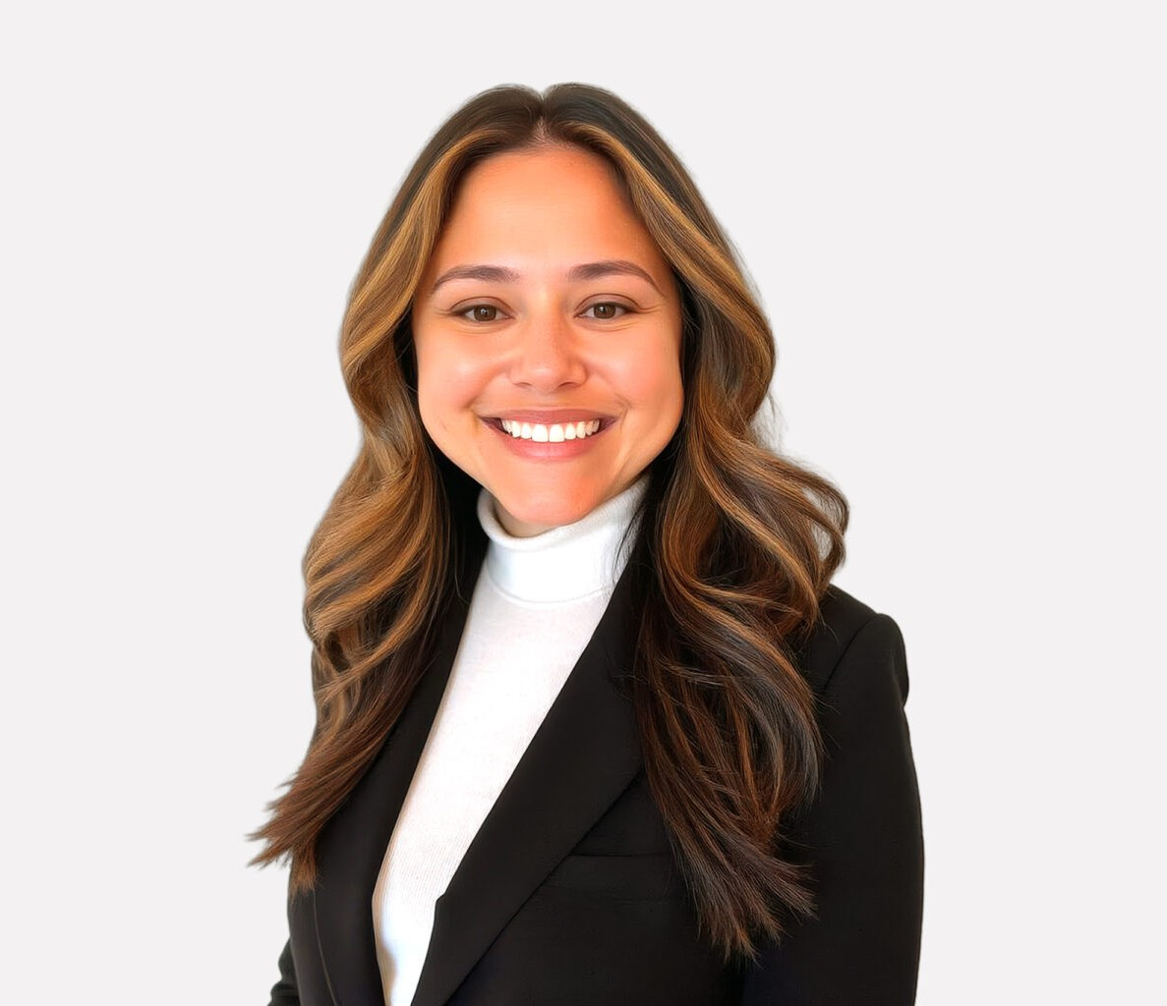
Leah Wilson is a skilled paralegal in Fennemore’s Business Litigation group with more than a decade of experience supporting complex litigation, appellate matters, and corporate
LEAH WILSON
Paralegal
Business Litigation
Denver
P: 303.764.3703
lwilson@fennemorelaw.com
“
The Man in the Arena
Theodore Roosevelt
LEAH WILSON
”
transactions. Her practice includes organizing and managing large volumes of case materials, preparing and formatting pleadings, assisting with trial and hearing preparation, and supporting attorneys through all phases of dispute resolution.
Leah also has experience in corporate legal operations, particularly in mergers and acquisitions. She coordinated pre- and post-closing deliverables and ensured compliance across fast-moving document and contract processes.
With a collaborative approach and commitment to high-quality work product, Leah is a trusted resource for the legal teams she supports. She brings a practical, solutions-oriented mindset to every matter and is dedicated to delivering reliable, consistent, and client-focused support.
Outside of the office, she can be found baking, golfing, running, traveling, and spending time with her husband, dog, and cat.

EDUCATION
Associates of Applied Science – Paralegal Studies, Arapahoe Community College

AREAS OF PRACTICE
Business Litigation

ADMISSIONS
*Not licensed to the practice of law

