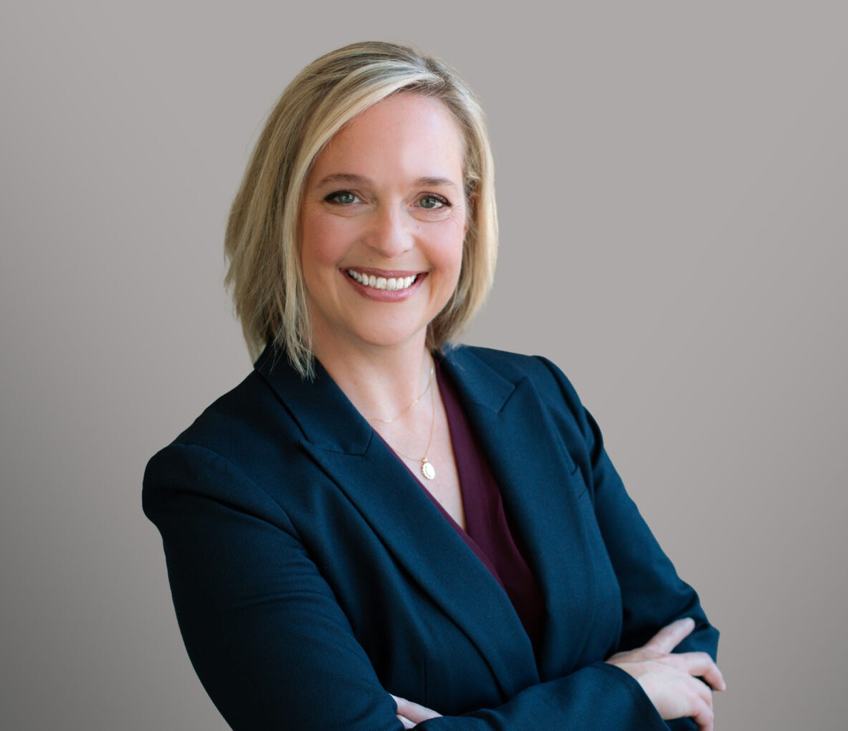

M. KATE STRAUSS
Director
Business Litigation

Denver
P: 303.704.4585
kstrauss@fennemorelaw.com

M. KATE STRAUSS
Kate Strauss is a Denver-based construction law attorney who counsels and advocates for clients across Colorado on both transaction and litigation matters. In her practice, Kate counsels her clients on matters related to construction defects, mechanic’s lien foreclosures, delays and scheduling impact claims, and other business and contract issues. Her clients include general
contractors, design professionals, subcontractors, and specialty trades, as well as material suppliers.
Kate was recently named one of the Colorado Women’s Chamber of Commerce’s Top 25 Most Powerful Women in Business for 2025, as well as one of ColoradoBiz’s Top Women in Colorado.
She has been recognized as a 2019-2025 Colorado Super Lawyer and a 5280 Magazine Top Lawyer in 2024 and 2025. Committed to professional development and the advancement of the law, Kate is a professional member of the American Subcontractors Association of Colorado, for which she co-chairs the Women in Construction Committee, and she is active in the Colorado Bar Association, serving on the Colorado Bar Association Ethics Committee, for which she is a
past Chairperson.

EDUCATION
University of Pittsburgh School of Law, cum laude, 2006
Pennsylvania State University, Schreyer Honors College, 2001

AREAS OF PRACTICE
Business Litigation Construction Law

AWARDS AND HONORS
Top 25 Most Powerful Women in Business 2025, Colorado Women’s Chamber of Commerce ColoradoBiz Top Women in Colorado 2025
Colorado Bar Foundation – Fellow
5280 Magazine, Top Lawyer for Construction Defect Litigation, 2024-2025 Colorado Super Lawyers, 2019-2025

Colorado Super Lawyers, Rising Star, 2015-2017

ARTICLES AND PRESENTATIONS
“How She Built This” Moderator, American Subcontractor’s Association Women of Construction, September 2025
“Colorado Mechanic’s Liens: What You Need to Know” Colorado Roofing Association, August 2025
“Contracts, Claims & CYA Clauses: Legal Tools for Subcontractors” The HOYA Foundation, July 2025
“Contracts and Negotiations: Panel Discussion” AIA Colorado Christopher Kelly Leadership Development Program, June 2025
“Gavel, Grace & Grit” Women Talk Construction podcast, Ep. 155, May 2025
“Fundamentals of Construction Contracts” Rocky Mountain Masonry Institute Certification Seminar, March 2025
“Fundamentals of Construction Contracts: Concepts, Clauses, and Compliance” World of Concrete, January 2025
“The Ethics Review: Starring the Law Club” Colorado Bar Association CLE, November 2024 “The Payment Playbook: Winning Strategies for Subcontractors,” October 2024 “Construction Defect Claims” Colorado Roofing Association, September 2024
“Future Challenges and Obstacles for the CD Industry” and “Construction Defects Along the Front Range – Current Concerns and Trends” Panel Presentations, Rocky Mountain Region Construction Defect Seminar, August 2024
“When Sh*t Hits the Fan” Rocky Mountain Masonry Institute, July 2024 “AI on the Jobsite” Tradecraft Industries, June 2024
“CLE IP Fundamentals & 22nd Rocky Mountain IP Institute” Colorado Bar Association, May 2024
“Pinpoint Seminar: Legal Updates for Your Business” Colorado Roofing Association, May 2024 “2024 Colorado Legislative Update” El Paso County Roofing Association, March 2024
“The Ethics Review: Starring the Law Club” Colorado Bar Association CLE, November 2023
“Fundamentals of Construction Contracts: Concepts, Clauses, and Compliance” Rocky Mountain Masonry Institute, September 2023
“The Do’s and Don’ts of Contract Review” CRS Insurance Education, May 2023
“31st Ethics Seminar and Professionalism Award Presentation” Larimer County Bar Association,

April 2023
“New Year Tune-Up Checklist: Creating Success in 2023” Tradecraft Industries, March 2023 The Ethics Review: Starring the Law Club” Colorado Bar Association CLE, November 2022
“Acquiring, Valuing, and Selling Businesses Part 2” Trade Craft Industries Lunch and Learn,

September 2022
“The Highs and Lows of Anti-Freeze and Common Fire Protection Litigation Issues” Colorado Chapter of the American Fire Sprinkler Association, April 2022

“Get Me Off This Escalator: Managing Pandemic Cost Escalations and Delays” SUBStrong,

American Subcontractors Association of Colorado, April 2022
“Choose Foresight Not Hindsight: What Every Contractor Needs to Know in 2022” Tradecraft Industries, February 2022
“The Ethics Review: Starring the Law Club” Colorado Bar Association CLE, November 2021 “Best Ways to Recover Your Money” Tradecraft Industries Lunch and Learn, October 2021 “The Mill: Katerrible” Rocky Mountain Forest Products Podcast, August 2021
“When the S#it Hits the Fan: How to Navigate Contract Disputes,” Rocky Mountain Masonry Institute, July 2021
“Never Let a Good Crisis Go to Waste: A Discussion on Ethics in Law Firm Culture, Responsibility, and Technology after a Remarkable Year” Colorado Bar Association 2021 Real Estate
Symposium, June 2021
“Ethics Update” Colorado Bar Association 2021 Real Estate Symposium, June 2021
Master of Ceremonies, “Awards in the Park” American Subcontractors Association of Colorado, June 2021
“The 5 Critical Concepts of Construction Contracts,” Fundamentals of Construction Contracts Series, Rocky Mountain Masonry Institute Certification Seminar, April 2021
“Key Contract Clauses that Will Make or Break You,” Fundamentals of Construction Contracts Series, Rocky Mountain Masonry Institute Certification Seminar, April 2021
“Contract Implementation and Compliance,” Fundamentals of Construction Contracts Series,

Rocky Mountain Masonry Institute Certification Seminar, April 2021
“Risk Mitigation: Best Practices for Documentation” Newforma Webinar, March 2021 “Understanding Risk Allocation in Contracts and Contracting to Protect your Status as a
Project Creditor” American Subcontractors Association of Colorado, SUBStrong Conference,
February 2021
“The Mill: Did a Tech Company Revolutionize the Construction Industry? Part 2” Rocky Mountain Forest Products Podcast, February 2021
“The Mill: Galvanize Law with Kate Strauss” Rocky Mountain Forest Products Podcast, October 2020
“Points on Pot: Considerations for Construction Professionals Building in Colorado”, American Subcontractors Association Colorado, 2019
“Proper Use of Inference, Extrapolation, and Allocation in Property Claims”, Claims Litigation Management (CLM) National Conference, 2019
“A Growing Dilemma: A Lawyer’s Ethical Obligations in the World of Weed”, Victor O.

Schinnerer Annual Meeting of Invited Attorneys (AMIA), 2019
“Hurdles & High jumps: Hot Topics in Construction Defect Claims & Litigation”, Envista Forensics North American Webinar Series, 2019
“Basics of Mechanic’s Liens for Construction Professionals”, Tradecraft Industries, 2019
“Closing the Gap with the Inexperienced & Unqualified Workforce”, CLM Construction Conference, 2018

“Joint Representation 2.0: What You Don’t Know Can Hurt You”, Colorado Bar Association Ethics 7.0 Course, 2018
“Negotiation Skills: A Values Based Approach to Communication”, DIRTT Partner Camp, 2018
“Impacts of Qualified Workforce Issues on Risk Management in Your Business”, American Subcontractors Association Colorado, Legal Summit, 2018
“Contract Risk Management”, American Subcontractors Association Colorado, 2018
“The Ethics Revue Starring the Law Club”, Panelist for Colorado Bar Association Course, 2017-2019
“DORA and Board Reporting for Architects”, Client Presentation, 2017
“Ethical Considerations for Associate Lawyers”, Colorado Bar Association Ethics 7.0 Course, 2017
“Demonstrative Exhibits: Simplifying Complex Evidence”, Colorado Defense Lawyers Association Annual Conference, 2015
“Independent Contractor or Employee? Municipal Contracting and the Fair Labor Standards Act”, Colorado Municipal League, 2010

PROFESSIONAL AND COMMUNITY ACTIVITIES
Past Chair, Colorado Bar Association Ethics Committee Colorado Bar Association
Denver Bar Association
Chair, Women of Construction Committee, American Subcontractors Association of Colorado American Subcontractors Association
Transportation & Construction Girl Colorado Contractors Association Rocky Mountain Masonry Institute Colorado Roofing Association

ADMISSIONS
Colorado
U.S. District Court, District of Colorado
U.S. Court of Appeals, Tenth Circuit

