
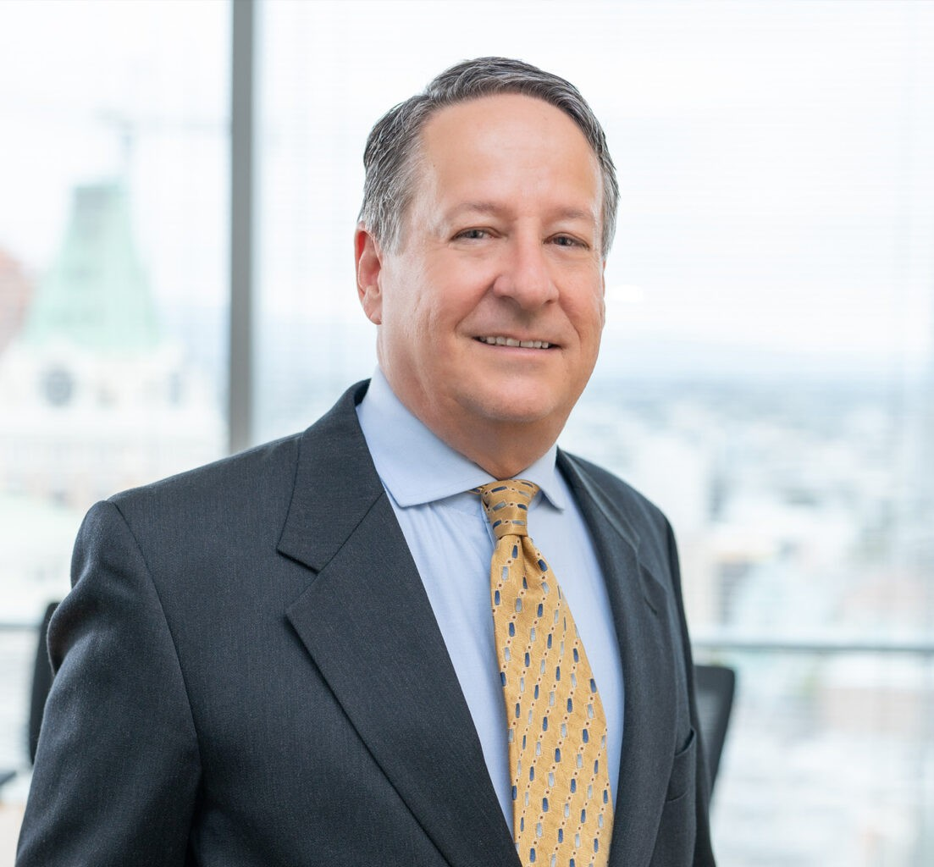
MARC BRAINICH
MARC BRAINICH
Of Counsel
Business Litigation
Oakland
P: 510.622.7673
P: 415.205.5367
F: 510.834.1928
mbrainich@fennemorelaw.com
Marc Brainich is a distinguished attorney in our Oakland office who has more than 25 years of business litigation experience. His dynamic practice focuses on matters such as public entity
liability, mass toxic torts, medical professional liability, and personal injuries across various
industries, including governmental entities, healthcare providers, major energy producers, manufacturers, and shipping companies. He brings substantial experience to the firm’s well-established business litigation practice.
Outside of work, you may find Marc backpacking or cross-country skiing in the Sierra Nevada and the Trinity Alps, walking his 90lb hound at Fort Funston, or coaching the barbel lifts at his gym. Marc and his wife also enjoy hiking, exploring the wine country, and travelling to Greece.

EDUCATION
J.D., University of California, Hastings College of the Law M.A., University of California, Berkeley
B.A., University of California, Santa Barbara

AREAS OF PRACTICE
Business Litigation

ARTICLES AND PRESENTATIONS
Presenter, “Take-Home Asbestos Exposure: Two Pending California Supreme Court Cases,” Sedgwick, September 2016
Author, “California District Court Grants Summary Judgment based on Lack of Evidence Supporting Claims for Asbestos Exposure,” Sedgwick, May 2015
Author, “Washington District Court Holds that CERCLA Displaces Federal Common Law Public Nuisance Claims,” Sedgwick, February 2015
Author, “NY Lessees Are Not Liable Under CERCLA As Owners,” Law360, December 18, 2014
Author, “New York District Court Holds Lessee Not Liable Under CERCLA as an Owner,” Sedgwick, November 2014

Author, “Texas Supreme Court Declines to Address Recovery for Stigma Damages in the Absence of a Permanent Physical jury to Property,” Sedgwick, September 2014
Author, “U.S. Court of Appeals Dismisses Almost All Claims of Ecuadorian Provinces and Individual Plaintiffs Against DynCorp,” Sedgwick, June 2014
Author, “Ninth Circuit Upholds BLM’s Environmental Assessment Allowing Expansion of the Reid Gardner Generating Station,” Sedgwick, December 2013
Author, “California Appellate Courts Impose Significant Limitations on Plaintiffs’ Claims for Medical Damages,” Sedgwick, Spring 2013
Author, “Ninth Circuit Finds No Duty to Warn in Light of the State of the Art Regarding the Specific Risks of Taser Use,” Sedgwick, August 2012
Author, “Northern District of California Finds Disputed Oral Statements Made Off-The-Record Do Not Trigger Removal,” Sedgwick, July 2012
Co-Author, “Significant Rulings from the Deepwater Horizon Court on Discovery and Evidentiary Matters,” Sedgwick, April 2012
Author, “US Supreme Court: State Law Claims Against Locomotive Manufacturers Are Preempted by Federal Law,” Sedgwick, March 2012
Author, “California Court of Appeal Finds Possible Liability Under Privette Doctrine of Retained Control,” Sedgwick, February 2012

PROFESSIONAL AND COMMUNITY ACTIVITIES
Member, Alameda County Bar Association Member, California Bar Association

ADMISSIONS
California
U.S. District Court, Eastern District of California
U.S. District Court, District of North Dakota
U.S. Court of Appeals, Ninth Circuit

