
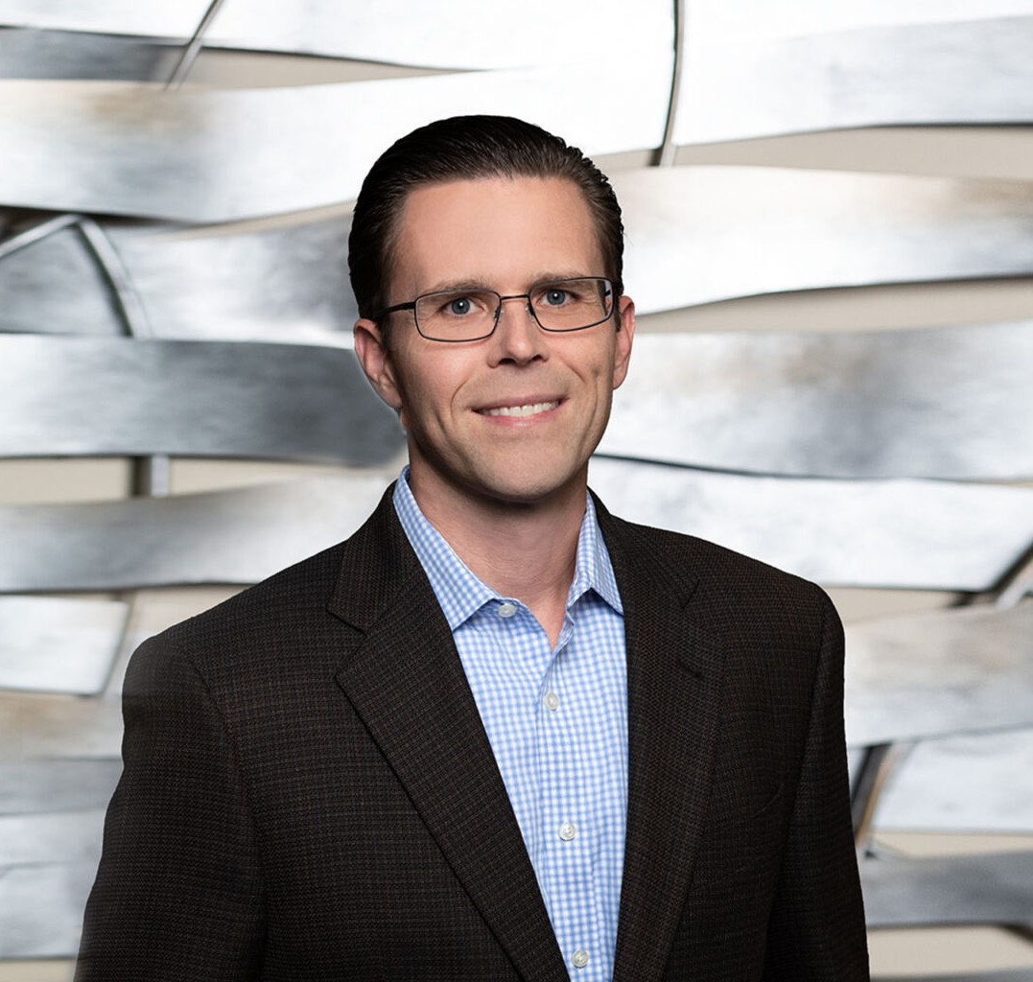
Marcus DiBuduo is an attorney in our Fresno office where his practice supports entrepreneurs of all ages, whether startups, investment-ready businesses, or firmly established multi- national
MARCUS N. DIBUDUO
Director
Intellectual Property
Fresno
P: 559.432.4500
F: 559.432.4590
mdibuduo@fennemorelaw.com
“
Problems are the price of progress.
-Charles Kettering
MARCUS N. DIBUDUO
”
enterprises. He is regularly called on by his clients to provide strategic counsel on all aspects of intellectual property law, including the acquisition, enforcement, and licensing of patents,
trademarks, copyrights, and trade secrets. Marcus also advises clients on matters unique to e-commerce, such as compliance with various consumer and data privacy laws, cybersquatting, domain name disputes, and online copyright infringement matters.
Marcus never set out to be an attorney; a series of fortuitous events brought him to the practice of law. He began his professional career developing cellular communications and geo-location firmware, and then he continued to develop surveillance equipment power and motion control circuitry. As an engineer, Marcus was fortunate enough to conceive of ideas that exposed him, as an “inventor”, to the U.S. patent system (he has even seen his name in the USPTO’s National Inventors Hall of Fame and Museum). His background gives him the advantageous ability to truly understand his clients’ technology and business to better assist them in navigating complex legal matters. Marcus excels at, and he deeply enjoys, helping his clients to develop and implement effective strategies to protect their ideas, brands, and creative works. Marcus has a Martindale-Hubbell Distinguished™ peer reviewed rating in Intellectual Property, Patents and Litigation from and has been selected by Super Lawyers® to its Northern California List for Intellectual Property.
So as to not stray too far from his family’s deep agricultural roots in California’s Central Valley, Marcus, his wife, and three children live on rural property with pecan trees and various livestock. “Time off” generally involves boots and shovels, and some form of agricultural engineering, although he still manages to occasionally tinker with homemade microprocessor-based Internet-of-Things devices.

EDUCATION
J.D., San Joaquin College of Law
B.S., Electrical Engineering, California State University, Fresno

AREAS OF PRACTICE

OTHER EXPERIENCE

Business and Tort Litigation
Business Transactions and Entity Formation Internet and E-Commerce
Intellectual Property Agribusiness Business & Finance Business Litigation
Emerging Businesses & Technologies Privacy & Data Security
Food & Beverage Apparel & Fashion

ARTICLES AND PRESENTATIONS
Author, “Protecting What’s Yours: A Guide to IP Protection for Entrepreneurs and Innovators,” Fennemore Blog, April 23, 2025

AWARDS AND HONORS
Northern California Super Lawyers®, 2019-2025
Northern California Super Lawyers® Rising Stars, 2012-2018 Martindale-Hubbell Distinguished™ Rating

PROFESSIONAL AND COMMUNITY ACTIVITIES
Member, American Intellectual Property Law Association Member, International Trademark Association
Member, Federal Circuit Bar Association
Member, San Joaquin Valley Association of Business Trial Lawyers
Member, Federal Bar Association, Intellectual Property and Communications Law Section Member, American Bar Association, Intellectual Property Law Section
Member, State Bar of California, Intellectual Property Law Section Member, Fresno County Bar Association

ADMISSIONS
California
U.S. District Court, Central District of California
U.S. District Court, Eastern District of California
U.S. District Court, Northern District of California
U.S. District Court, Southern District of California
U.S. Court of Appeals, Ninth Circuit
U.S. Court of Appeals, Federal Circuit
U.S. Patent and Trademark Office

