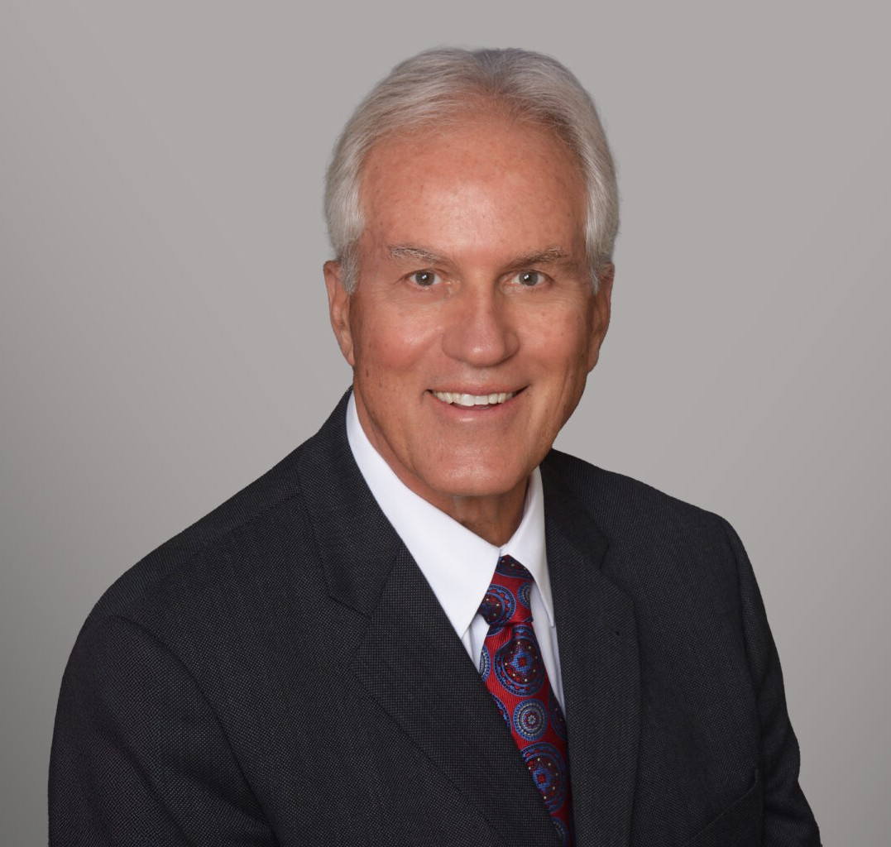

MICHAEL E. GRAHAM
Director
Estate Planning

Fennemore Forward
P: 530.906.8088
megraham@fennemorelaw.com

MICHAEL E. GRAHAM
Michael E. Graham is a California Certified Specialist in Estate Planning, Trust and Probate Law, bringing nearly five decades of experience to his practice. Licensed in both California and
Nevada, Michael focuses on estate planning, trust and probate administration, alternative dispute resolution, and business succession planning. His work also encompasses business entity formation and real property transactions connected to estate and trust matters.
Michael earned his law degree at the University of California, San Francisco, Hastings College of the Law, has been recognized with Martindale-Hubbell’s highest “AV Preeminent” peer review
rating, and has served in leadership roles within the Tahoe-Truckee Bar Association, including as President. Deeply involved in his community, he has provided pro bono legal counsel to organizations such as the Truckee Tahoe Community Foundation, the Tahoe-Truckee Excellence in Education Foundation, the Truckee Donner Land Trust and Friends of the Truckee Library. He has also lectured at Sierra College and has been an active member of the Truckee Rotary Noon Club since 1979, where he is a Paul Harris Fellow.
Before his legal career, Michael served in the U.S. Navy as an air traffic controller from 1968 to
1972 serving at NAS Guantanamo Bay, Cuba and NAS Point Mugu, California. Outside the office, he enjoys golf at Lahontan Golf Club and La Cumbre CC, e-assist biking, skiing, basketball,
photography, travel, and the Santa Barbara International Film Festival.

EDUCATION
J.D., Hastings Law School, University of California, San Francisco B.A., University of California, Santa Barbara

AREAS OF PRACTICE
Estate Planning Trusts & Estates

AWARDS AND HONORS
Martindale-Hubbell “AV Preeminent” Peer Review Rating

Previous Northern California Super Lawyer

ARTICLES AND PRESENTATIONS
Seminar Speaker, Truckee Tahoe Community Foundation Lecturer, Sierra College, Placer County

PROFESSIONAL AND COMMUNITY ACTIVITIES
Member, Paul Harris Fellow, Truckee Rotary Noon Club, 1979-Present
Pro Bono Legal Counsel, Past Incorporator, Tahoe-Truckee Excellence in Education Foundation Pro Bono Legal Counsel, Truckee Donner Land Trust
Certified Specialist, Estate Planning, Trust and Probate Law, Board of Legal Specialization, State Bar of California
Trust and Estate Section Member, State Bar of California
Past President, Board Member and various Officer Positions, Tahoe-Truckee Bar Association Past Delegate, Conference of Delegates, State Bar of California

ADMISSIONS
California Nevada
California Supreme Court Nevada Supreme Court
U.S. District Court, Northern District
U.S. District Court, Eastern District United States Supreme Court

