
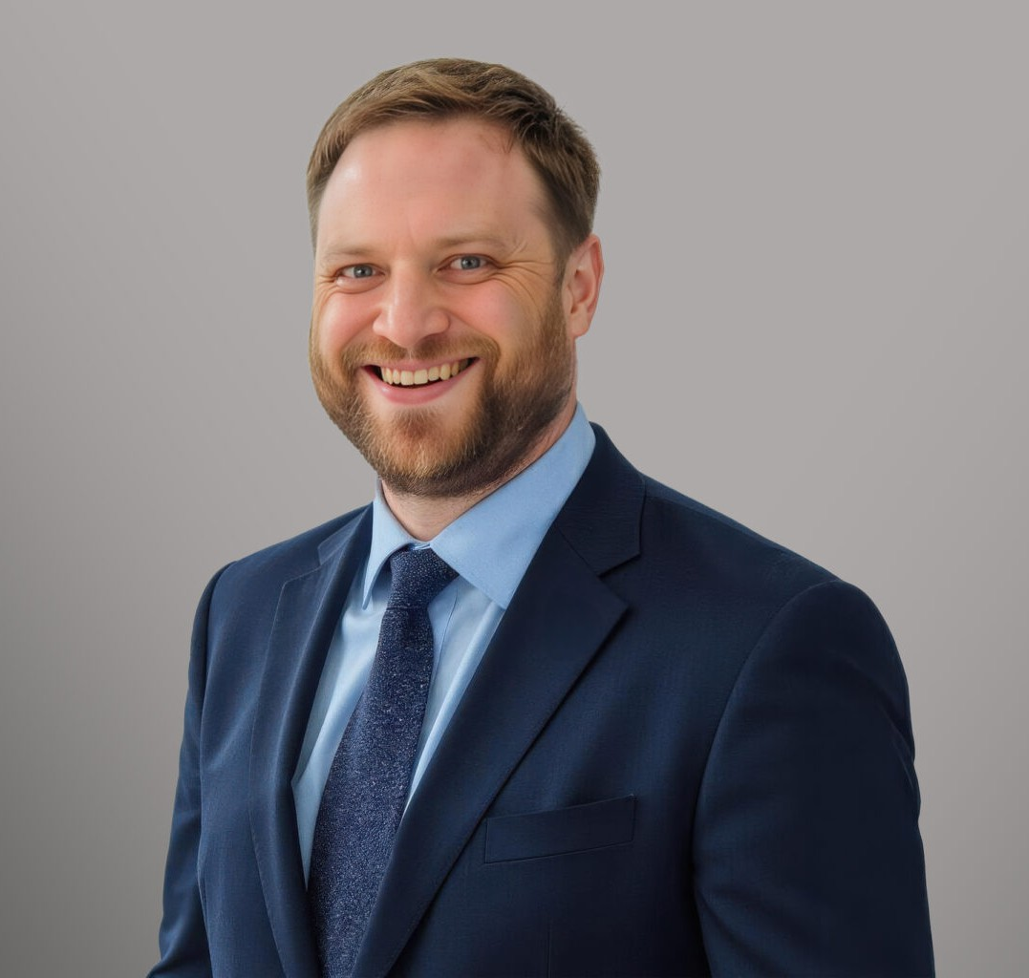
NICHOLAS N. DYER
NICHOLAS N. DYER
Of Counsel
Real Estate
Denver
P: 303.764.3704
F: 303.291.3201
ndyer@fennemorelaw.com
Nicholas N. Dyer is a transactional attorney in Fennemore’s Real Estate and Corporate practice groups with more than $5 billion in aggregate deal volume. Nick’s practice focuses on complex real estate and corporate matters with an emphasis on all aspects of planned residential, mixed use, and commercial development projects, commercial and luxury residential property purchase and sale transactions, borrower and lender-side institutional and private lending, commercial leasing, and, on the corporate side, mergers and acquisitions, business divorces,
investment entity formation, corporate and partnership governance, and serving as outside general counsel to clients across multiple industries.
Nick’s representative work includes:

Development: Advising developers regarding the entire life cycle of mixed-use and master-planned community projects from land use planning, site acquisitions, public improvement and mentro districts, drafting property covenants, conditions and restrictions (CCRs) for residential and commercial property, joint development agreements, construction and construction management contracts, through eventual sales and developer exits.
Acquisitions and Sales: Counseling both buyers and sellers of commercial, industrial and luxury residential real estate ranging from a few million dollars up to $450 million+ in a single
transaction.
Finance: Representing borrowers and lenders with respect to both institutional and customized private financing of up to $225 million in a single loan. Nick also has assisted his clients with structuring and implementing highly complex and uniquely customized line of credit loans, construction loans, tax-exempt bond offerings, ground leases, and other transactions to raise capital or free liquidity.
Commercial Leasing: Finding solutions for landlords and tenants with commercial leases,
subleases, enforcement and workouts across a spectrum of asset classes that include Class A office, indoor and outdoor storage facilities, medical facilities, industrial and ground leases.
Corporate Structuring and Mergers and Acquisitions: Serving clients’ corporate needs both in the context of separate real estate transactions as well as general governance, compliance and contracting matters. Nick’s experience includes representing buyers and sellers in

complex asset purchase transactions, mergers, formation and structuring of special purpose entities and more.
Tax Exempt Entities: Assisting nonprofit clients with a range of matters including the formation of multiple 501(c)(3) charitable, educational and religious entities, 501(c)(4) social welfare organizations, trade organizations, private foundations and more with respect to compliance matters, governance, real estate transactions and general outside counsel advice.
Nick earned his law degree from Harvard Law School and his Bachelor of Arts in English, magna cum laude, from Utah State University. He is licensed to practice in Colorado and Utah. Deeply committed to community engagement, Nick has served on the boards of several Colorado nonprofit organizations focused on youth, education, and public service.
Outside of his legal work, Nick enjoys backpacking, yoga, caring for his collection of houseplants, and watching cheesy films.

EDUCATION
J.D., Harvard Law School
B.A., Utah State University, magna cum laude

AREAS OF PRACTICE

OTHER EXPERIENCE

Commercial Finance Corporate
Tax-Exempt Entities Real Estate

PROFESSIONAL AND COMMUNITY ACTIVITIES
Former Director, 5280 High School, a Denver public charter school with a specialized curriculum track focused on helping youth suffering from addiction
Founding Director and outside counsel, Fire Foundation of Colorado Springs
Former Director, Community Prep School, a Colorado Springs alternative-education campus public charter school for at-risk high school students
Former Director, The Place (f/k/a) Urban Peak Colorado Springs, a shelter for youth experiencing homelessness

ADMISSIONS
Colorado Utah

