
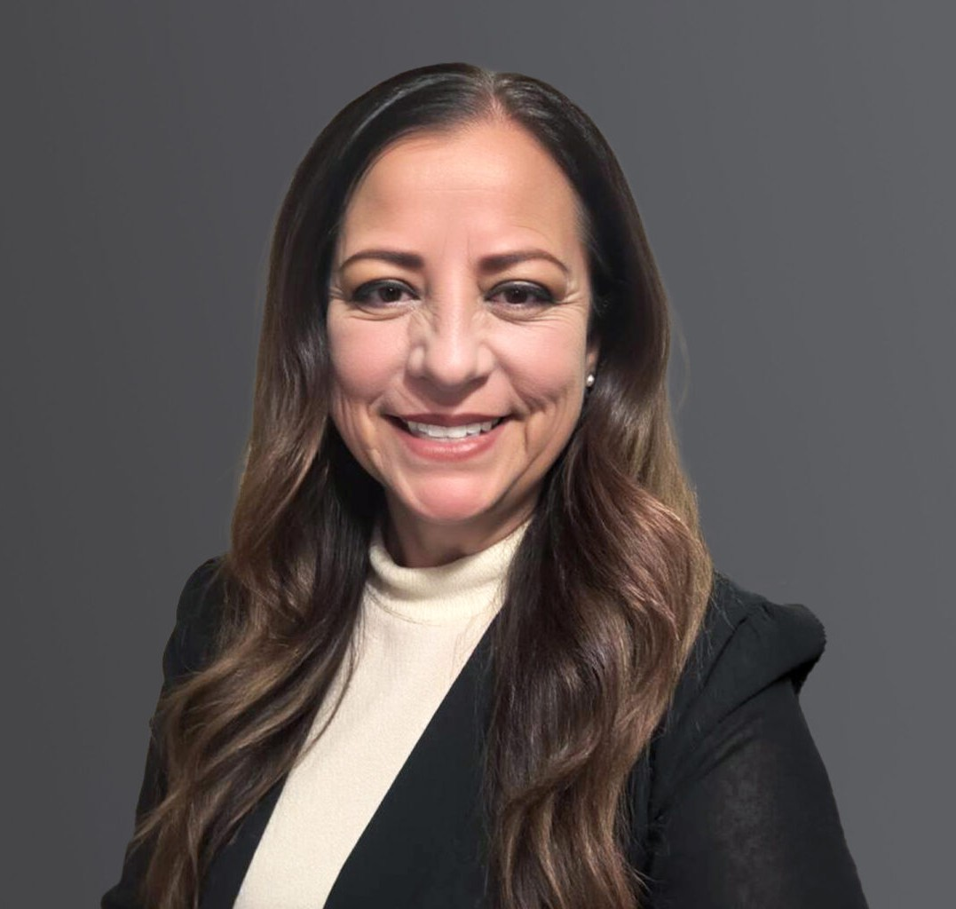
PAULA M. PEREIRA
PAULA M. PEREIRA
Paralegal
Trusts & Estates
Sacramento
P: 916.273.1803
ppereira@fennemorelaw.com
“
The power for happiness, for good, for everything we need of life is within each one of us. The power is there, unlimited power
Robert Collier
”
Paula M. Pereira has been assisting clients with probate, trust administration, conservatorship, and guardianship matters for over 28 years. She handles probate cases from beginning to end. She has extensive experience in working with large firms, boutique firms, and sole practitioners.
Paula previously served as a court liaison with the Sacramento County Counsel and the probate department.
Outside of the office, Paula spends her time on her five-acre property with her spouse and two children, Thoroughbred horse, mini donkey, goat, chickens, and two Boston Terriers.

EDUCATION
Paralegal Certificate, American River College A.A., American River College
AREAS OF PRACTICE

OTHER EXPERIENCE
Probate
Trust Administration Conservatorships Guardianships

Trusts & Estates

ADMISSIONS
*Not licensed to the practice of law

