
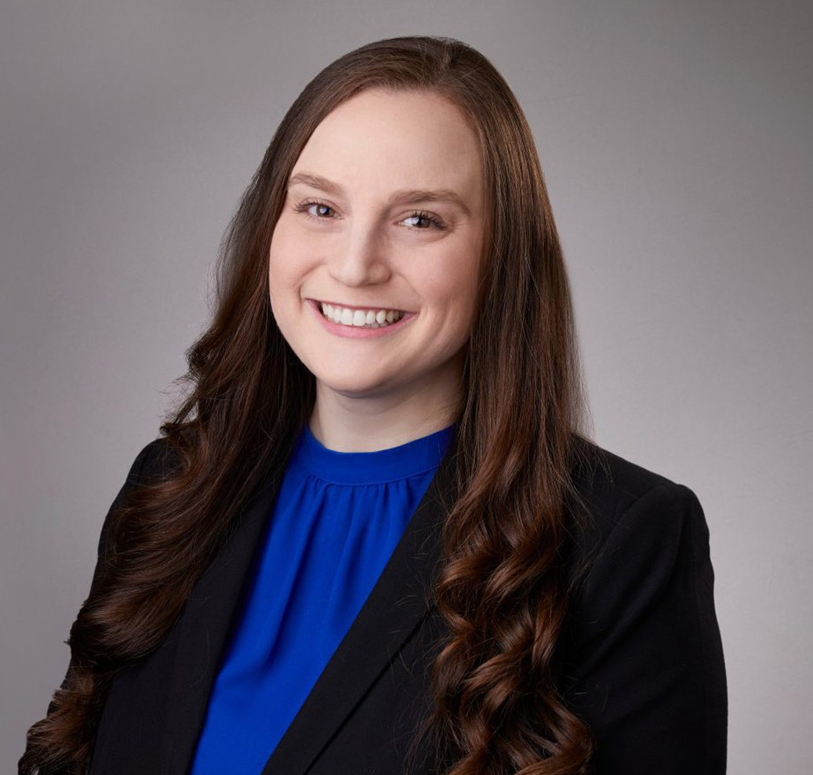
RACHEL J. GREENBERG
RACHEL J. GREENBERG
Associate
Business & Finance
San Bernardino
P: 909.890.4499
F: 909.890.9877
rgreenberg@fennemorelaw.com
“
You are braver than you believe, stronger than you seem, and smarter than
you think.
- Winnie-the-Pooh by A.A. Milne
”
Rachel Greenberg is an associate attorney who works out of our San Bernardino office. Her practice focuses on the intersection of tax law and business; she helps her clients with a broad range of services related to general corporate matters, as well as tax law and planning. Rachel’s goal is to help clients align their tax and business strategies in an effort to increase their operational efficiencies. In addition, Rachel will often assist attorneys with tax questions that arise in our Real Estate and Trust & Estates groups.
Rachel received her Bachelor’s degree in Economics from the University of California, Los
Angeles. After graduating from Chapman University’s School of Law, where she was Editor-in-Chief of the Chapman Law Review and a member of the Mock Trial Board, Rachel began her career working for PricewaterhouseCoopers in their International Tax Services practice.
Outside of work, Rachel enjoys travel and spending time with her family. She is involved in several local bar associations and is a volunteer “wish granter” for Make-A-Wish Orange County and the Inland Empire.

EDUCATION
J.D., Business Emphasis, Chapman University, Dale E. Fowler School of Law B.A., Economics, University of California, Los Angeles
AREAS OF PRACTICE

OTHER EXPERIENCE

Corporate Governance Business & Finance
Real Estate Tax Law
Trusts & Estates Estate Planning

ARTICLES AND PRESENTATIONS
Co-Author, “Understanding Disaster-Related Tax Extensions for Southern California Businesses,” San Diego Business Journal, May 30, 2025

AWARDS AND HONORS
Best Lawyers in America®, Ones to Watch, Corporate Law, Real Estate Law, Tax Law. 2026

PROFESSIONAL AND COMMUNITY ACTIVITIES
Member, Orange County Bar Association Member, UCLA Alumni Association
Alumni, Delta Delta Delta Fraternity

ADMISSIONS
California

