
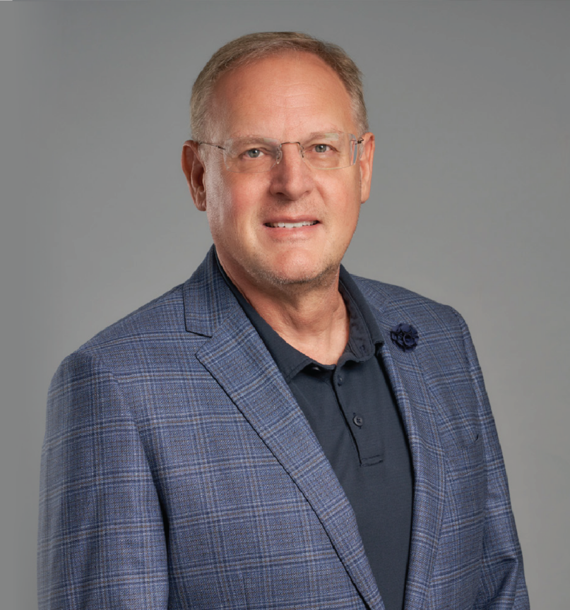
ROBERT J. KRAMER
Pronouns: he/him
Director & Chief Talent Officer

Robert J. Kramer

ROBERT J“. KRAMER
Phoenix
P: 602.916.5464 F: 602.916.5664
rkramer@fennemorelaw.com

Be kind to yourself. Be accountable, but kind. ”

Attorney Robert Kramer is a Director in the firm and our Chief Talent Officer. As a member of our firm’s C-Suite, he oversees attorney recruitment, professional development, onboarding and
retention. He’s also a passionate supporter of diversity and inclusion and works on many initiatives in support of this important part of Fennemore’s unique culture.
For more than 27 years and before taking over as the firm’s first Chief Talent Officer in 2016, Bob practiced law in the areas of environmental, water, natural resources and real estate, and has resolved legal matters relating to environmental due diligence and audits, hazardous waste
regulation, materials recycling, underground storage tanks, pretreatment requirements, Superfund sites and remedial actions and water issues. This past experience gives Bob an insider’s view into the legal profession in his work with the next generation of legal talent entering the field. Bob takes tremendous pride in helping and seeing others succeed.
Outside of the office, Bob is an avid Ohio State football and Los Angeles Dodgers fan. He enjoys travel and his most recent adventures took him to Dubai and on a tour through French Polynesia including Tahiti, Moorea and Bora Bora.

EDUCATION
J.D., magna cum laude, Arizona State University, Sandra Day O’Connor College of Law B.A., University of California, San Diego
Order of the Coif
Editor, Arizona State Law Journal, 1987-1988

AWARDS AND HONORS
Best Lawyers in America®, Natural Resources Law, 2021-2025
Best Lawyers in America®, Environmental Law, 2023-2025
AV® Preeminent™ Peer Review Rated (the highest rating available), by Martindale-Hubbell

ARTICLES AND PRESENTATIONS
Author, “The Future of Legal Talent: A People-First Approach to Recruitment,” Fennemore Blog, April 21, 2025
Interview, “Fennemore’s Chief Talent Officer: Ensuring a Diversity of Thoughts and Voices Helps Us Better Serve Our Clients,” Fennemore Blog, July 8, 2021
Quoted, “Phoenix law firm extends ASU Law scholarship, fellowship program to improve diversity in legal field,” ASU News, June 2, 2021
Quoted, “Arizona State University: Shaping The Future Of Data Privacy, Cybersecurity And Learner Empowerment At ASU’s Digital Trust Summit,” Patch, June 2, 2021
Interview, “Fenn.Talks: Recruiting Top Talent & The Summer Associate Program with Bob Kramer,” Fenn.Talks Podcast, April 22, 2021
Quoted, “2 More Firms Change Up Their Summer Associate Programs,” Law360, May 15, 2020
Quoted, “Raising the Bar: Job Prospects Look Good for Arizona’s Next Generation of Attorneys,” Phoenix Business Journal, July 25, 2018
Quoted, “How Do We Attract Young People to the Legal Industry?” AZ Big Media, December 30, 2016
Certified instructor for environmental matters with the Arizona Department of Real Estate
Previous guest lecturer on environmental issues at the Arizona State University, College of Engineering and Applied Sciences

PROFESSIONAL AND COMMUNITY ACTIVITIES
Member, Executive Council, Environmental and Natural Resources Law Section, State Bar of Arizona
Member, Natural Resources, Energy, and Environmental Law Section, American Bar Association
Past Program Chair-Central Arizona, Executive Council, Environmental and Natural Resources Law Section, State Bar of Arizona
Past Vice Chairperson, Environmental Quality Committee, Natural Resources, Energy, and Environmental Law Section, American Bar Association

ADMISSIONS
Arizona

