
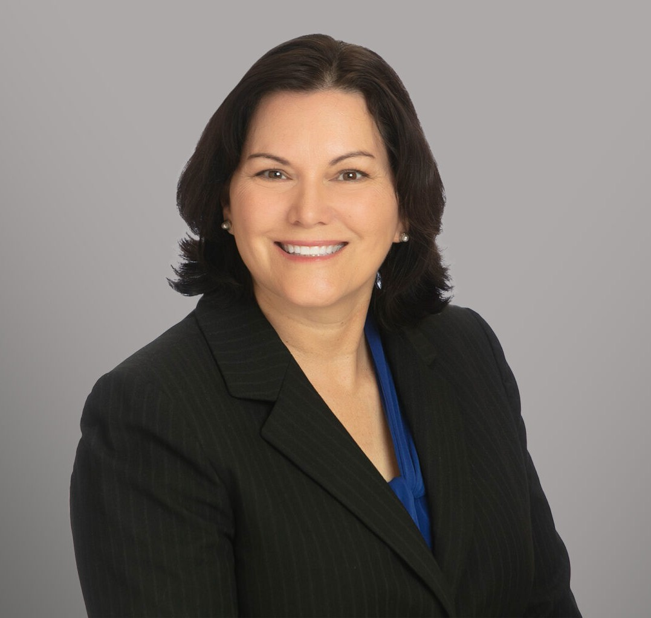
SHANNON B. SCHMOYER
SHANNON B. SCHMOYER
Director
Labor & Employment
San Antonio
P: 210.447.8035
F: 210.447.8036
sschmoyer@fennemorelaw.com
Shannon B. Schmoyer is a Director in Fennemore’s Employment & Labor practice group, based in San Antonio, Texas. With 34 years of experience, Shannon represents employers in complex labor and employment matters across Texas and the United States. Her practice includes
employment litigation, class actions, and labor arbitration, as well as counseling employers on compliance with state and federal employment laws. Shannon regularly advises management teams on strategic workforce decisions and conducts training programs for supervisors on key
employment topics such as discrimination, harassment prevention, wage and hour compliance, and employee relations. She is board-certified in labor and employment law by the Texas Board of Legal Specialization.
Shannon is best known for her experience as a trial lawyer. She has successfully tried cases across multiple jurisdictions, defending claims brought under the Americans with Disabilities Act (ADA), Age Discrimination in Employment Act (ADEA), Family and Medical Leave Act (FMLA), Fair Labor Standards Act (FLSA), Section 1981, and Title VII of the Civil Rights Act of 1964 (Title VII), along with a variety of state law employment claims. She has also successfully defended clients in unfair labor practice claims under the National Labor Relations Act (NLRA) and in administrative proceedings with both state and federal agencies.
Shannon is also an experienced appellate lawyer, representing employers in various state and federal courts of appeals, including handling appeals in the U.S. Court of Appeals for the 3rd,4th, 5th, 8th, 9th, and 11th Circuits, and in various Texas courts of appeals.
Before joining Fennemore, Shannon was a founding partner of Schmoyer Reinhard, a San Antonio-based firm focused on labor and employment, construction, and business litigation. Earlier in her career, she served as a partner at Akin Gump Strauss Hauer & Feld LLP, where she led the firm’s San Antonio labor and employment law section.

EDUCATION
J.D., Harvard Law School
B.A., University of Oklahoma, summa cum laude

Phi Beta Kappa

AREAS OF PRACTICE
Labor & Employment Business Litigation

AWARDS AND HONORS
Fellow, The College of Labor and Employment Lawyers Chambers USA, Labor and Employment (Texas), 2016 – 2025
Best Lawyers in America®, San Antonio – Employment Law – Lawyer of the Year, 2013, 2016, 2017, 2023, and 2026
Top Labor and Employment Attorney, San Antonio Magazine, 2025 2022 Top Woman Lawyer, Texas Diversity Council
Best Lawyers in America®, 2012 – 2026
Top 50 Attorney in San Antonio, Attorney Intel, 2023 Labor and Employment Star, Benchmark Litigation, 2021
2016 Women Leader in the Law, American Lawyer Media and Martindale-Hubbell Thomson Reuters Super Lawyer, Top 50 Women Lawyers in Texas, 2008, 2009, 2013, and 2014
Thomson Reuters Super Lawyer, Top 50 Lawyers in the Central and West Texas Region, 2008, 2009, 2013, 2014, and 2015
Thomson Reuters Texas Super Lawyer, 2003 – 2025 Martindale-Hubbell “AV Preeminent” rating
Top Labor and Employment Attorney, San Antonio Magazine, 2020 – 2025
Inaugural Outstanding Labor and Employment Lawyer Award, San Antonio Business Journal, 2010
San Antonio’s Best Labor And Employment Lawyers, Scene in S.A., 2006 – 2025 San Antonio’s Outstanding Women Lawyers, Scene in S.A., 2021 – 2025

ARTICLES AND PRESENTATIONS
Presenter, “Overview of Discrimination,” State Bar of Texas – TexasBarCLE 34th Annual Course – Employment Law 101, January 7, 2026
Presenter, “Claim Overview,” State Bar of Texas – TexasBarCLE 32nd Annual Course – Employment Law 101, January 10, 2024
Panelist, “The Most Brilliant Things I Have Seen the Other Side Do in Employment Litigation,” State Bar of Texas Labor and Employment Law Section 32nd Annual Labor and Employment Law Institute, August 27, 2022
Course Director, State Bar of Texas 30th Annual Advanced Employment Law Course and Employment 101 Course, April 19-21, 2022
Presiding Officer, The University of Texas School of Law 28th Annual Labor and Employment Law Conference, May 6, 2021

Presenter, “Administrative Prerequisites and Limitations,” State Bar of Texas – TexasBarCLE 29th Annual Course – Employment Law 101, January 13, 2021

PROFESSIONAL AND COMMUNITY ACTIVITIES
Chair Emeritus, Executive Council of the State Bar of Texas Labor and Employment Law Section
Fellow, Texas Bar Foundation
Past Member, The First Tee of Greater San Antonio Board of Directors Past Member, Family Service Association Board of Directors Member, San Antonio Bar Association
Member, Bexar County Women’s Bar Association Member, Harvard University Native American Program

ADMISSIONS
Texas
U.S. District Courts, Eastern District of Texas
U.S. District Courts, Northern District of Texas
U.S. District Court, Southern District of Texas
U.S. District Court, Western District of Texas
U.S. District Court, District of Colorado
U.S. District Court, Central District of Illinois
U.S. District Court, Northern District of Illinois
U.S. District Court, Northern District of Oklahoma
U.S. District Court, Western District of Oklahoma
U.S. District Court, Western District of Wisconsin
U.S. District Court, Eastern District of Wisconsin
U.S. Courts of Appeals, 3rd Circuit
U.S. Courts of Appeals, 4th Circuit
U.S. Courts of Appeals, 5th Circuit
U.S. Courts of Appeals, 9th Circuit
U.S. Courts of Appeals, 10th Circuit
U.S. Courts of Appeals, 11th Circuit

