
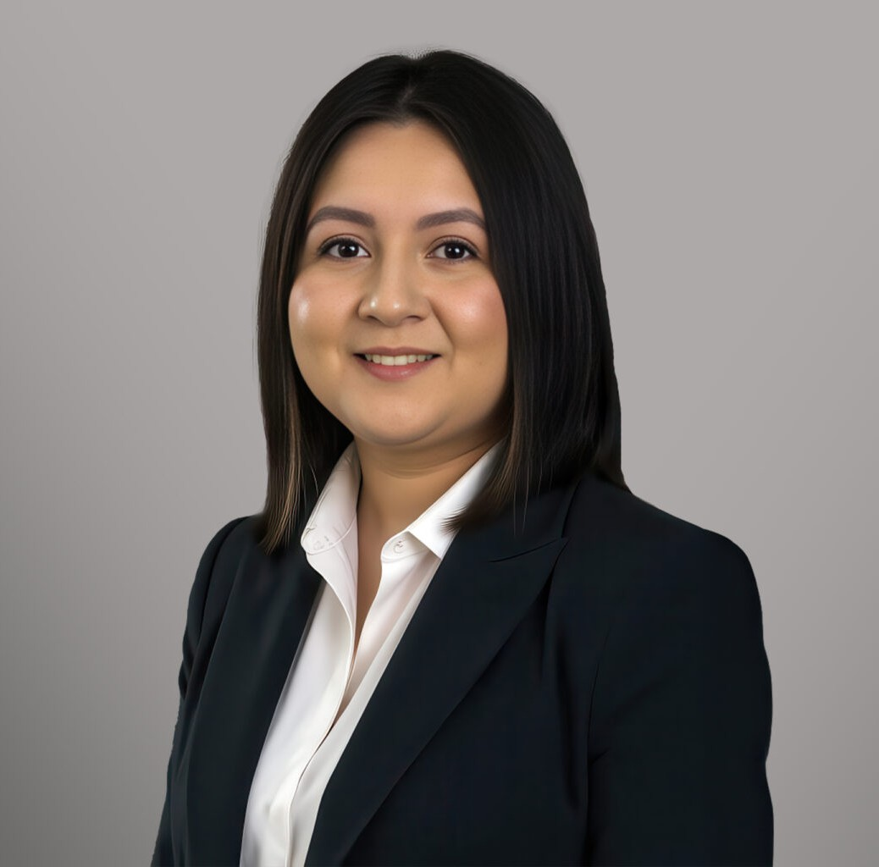
ANELEI VASQUEZ
ANELEI VASQUEZ
Paralegal
Immigration
Boise
P: 208.956.0135
P: Idaho Immigration: 208-956-0135 Washington Immigration: 509-413-1004
avasquez@fennemorelaw.com
“
Success is no accident. It is hard work, perseverance, learning, studying, sacrifice and most of all, love of what you are doing or learning to do.
Edson Arantes do Nascimento (better known as Pelé)
”
Anelei Vasquez is a paralegal in Fennemore’s Immigration practice group. She developed a passion for the immigration industry through an internship, and has expanded her knowledge and skills in not only family-based, humanitarian-based, and removal defense, but employment based cases as well including PERM, H-1B, etc.
A Portland native, Anelei earned a bachelor’s degree in criminology and criminal justice: social sciences from Portland State University. She received her paralegal certification from the American Immigration Lawyers Association.
Outside of the office, Anelei can be found hiking with her dog, swimming, and traveling.

AREAS OF PRACTICE
Immigration

EDUCATION
Paralegal Certificate, American Immigration Lawyers Association B.S., Portland State University

ARTICLES AND PRESENTATIONS
Panelist, “Balancing Life Obligations with Your Paralegal Career,” American Immigration Lawyers Association, January 30, 2026

ADMISSIONS
*Not licensed to the practice of law

LANGUAGES
Spanish

