
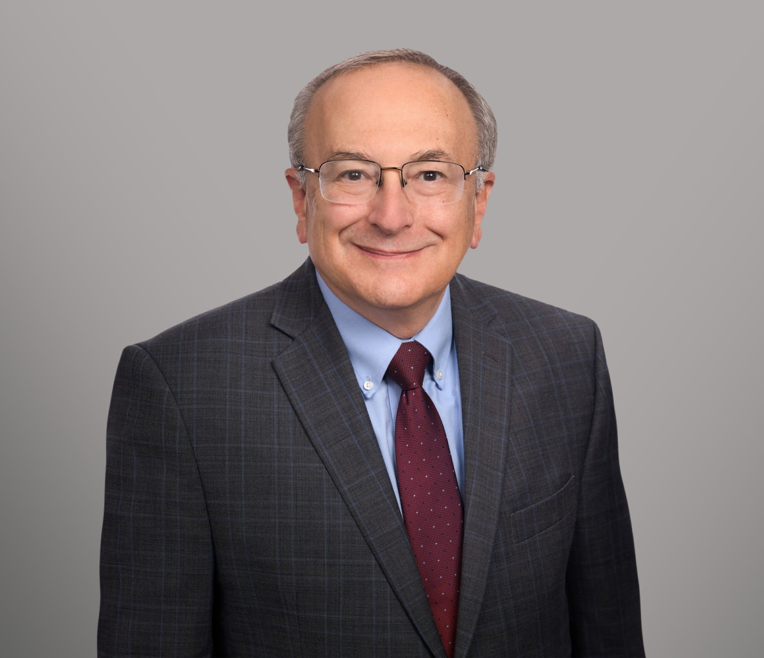
CAMERON HESS
CAMERON HESS
Director
Business & Finance
Sacramento
P: 916.273.1810
F: 916.920.5286
chess@fennemorelaw.com
Cameron L. Hess, CPA, Esq., is a Fennemore Director. He brings his unique dual experience as a Certified Public Accountant and lawyer in the firm’s transaction department. A Certified Public
Accountant with KPMG, Cameron’s diverse 41-years of experience focuses on strategic planning and advocacy for clients in real estate, business transactions, estate planning and nonprofits.
He is distinctly recognized for his federal, state, and local tax controversy work. While Mr. Hess’ past experience has included public company representation, for the last three and a half decades he has focused on providing comprehensive representation for closely held businesses and family planning. This has included mergers and acquisitions, setting up US subsidiaries, and comprehensive tax and succession planning. Mr. Hess has also continued his practice in state
tax controversy work (property, sales, and unitary income taxation) and special issue
representation, including nonprofits, international, special trusts, and family limited partnerships. Mr. Hess was previously director of the WKBKY’s nonprofit practice.
While not single industry specific, his clientele come from real estate, agriculture, manufacturing, education, and service industries. Mr. Hess has published over 200 articles, has served as an
adjunct professor at McGeorge Law School, Cosumnes River College and UC Davis. Cameron has chaired numerous professional CPA and legal tax associations, and has been a speaker before national, state and local professional associations, and government associations. Mr.
Hess has appeared before the California Franchise Tax Board.

Cameron previously served on the Board of Easter Seals Superior California and was an advisor to Easter Seals Leadership Association. He continues to serve on professional boards and conference committees to provide programming for CPAs and attorneys.

EDUCATION
J.D., University of Southern California School of Law
M.S. University of Southern California B.S., University of California, Berkeley

AREAS OF PRACTICE
Business & Finance Mergers & Acquisitions

Real Estate Tax Law
Trusts & Estates Estate Planning

AWARDS AND HONORS
AV Preeminent 5.0 Peer Review Rated by Martindale-Hubbell

ARTICLES AND PRESENTATION
Author, “Navigating unitary taxation in California for businesses and non-residents,” Sacramento Business Journal, August 1, 2024
Presenter, Corporate Transparency Act Presentation, Firm Presentation, February 15, 2024 Co-Author, Corporate Transparency Act, Firm Newsletter, January 19, 2024
Presenter, Real Estate Virtual Conference, CalCPA, January 19, 2024
Interview, How To Factor In Taxes When Considering Special Needs Trusts / (ABLE) Accounts, Financial Advisor, July 13, 2021

PROFESSIONAL AND COMMUNITY ACTIVITIES
Contributing Writer, Spidell’s California Tax Letter Member, Tax Section, American Bar Association Member, Tax Section, State Bar of California Member, Business Section, State Bar of California
Member, Tax Section, Sacramento County Bar Association Member, Business Section, Sacramento County Bar Association Chair, CalCPA Estate Planning Committee
Chair, CalCPA Chapter Real Estate Committee (RED Group) Member, Beta Alpha Pi
Member, Tax Law Journal (USC) Member, Phi Alpha Delta
Instructor, McGeorge Law School (Partnership Taxation)

ADMISSIONS
California
U.S. Court of Appeals, 9th Circuit
U.S. District Court, Eastern District of California
U.S. District Court, Central District of California
U.S. Tax Court
Certified Public Accountant

