
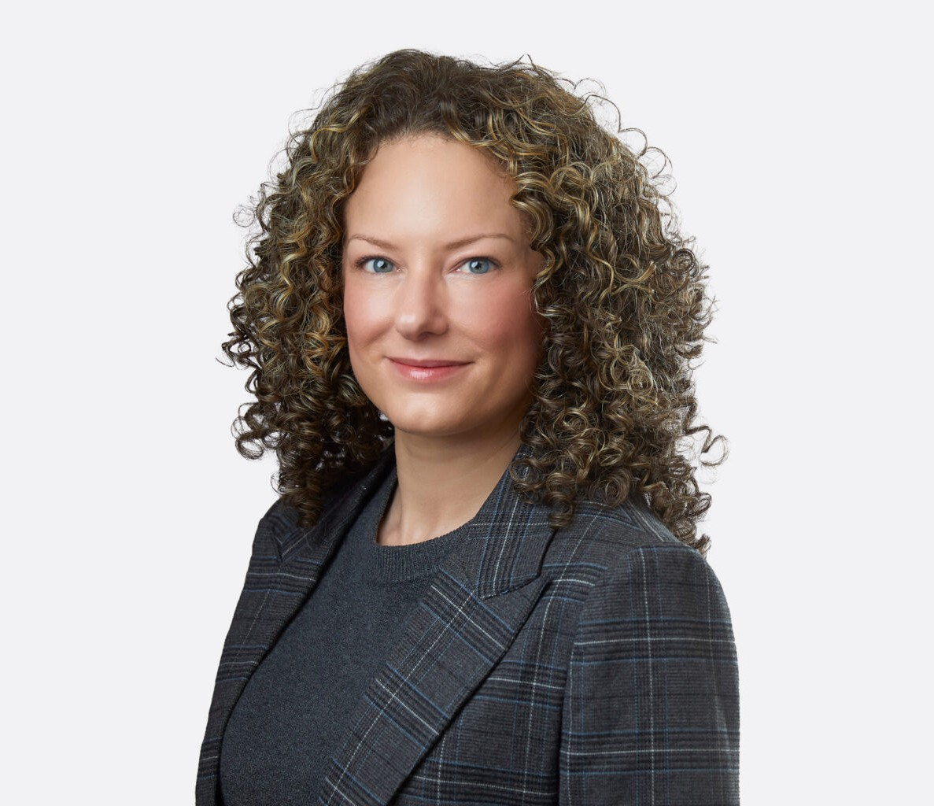
Chelsie is a trial attorney in our business litigation practice group representing enterprises and individuals in commercial and business litigation matters. With broad experience in federal and state courts, arbitration, and regulatory proceedings, Chelsie frequently represents litigants in construction disputes including claims involving defects and delays, differing site conditions, insurance and indemnification, prompt payment statutes, and liens.
CHELSIE ADAMS
Director
Business Litigation
Las Vegas
P: 702.791.8237
F: 702.791.8238
cadams@fennemorelaw.com
“
Well done is better than well said.
-Benjamin Franklin
CHELSIE ADAMS
”
A fourth-generation Nevadan with roots that run deep in her community, Chelsie has an affinity for counseling the entrepreneurs, general contractors, and subcontractors shaping the Las Vegas skyline. Drawing upon her courtroom experience, Chelsie employs a collaborative and considered approach to case management, leveraging technology to efficiently work through the discovery process and enhance courtroom proceedings.
A pop culture maven and gastronome, Chelsie is the one to ask what to stream and where to
dine. She credits her time outside the office enjoying the performing arts, spoiling her nieces and nephews, and exploring the dramatic vistas of the West with giving her the energy to create innovative solutions.
Chelsie is a proud alumna of Leadership Henderson Class of 2021.

EDUCATION
J.D., Willamette University College of Law B.A., Nevada State College
AREAS OF PRACTICE

OTHER EXPERIENCE

Litigation
Business Litigation

ARTICLES AND PRESENTATIONS
Interview, “A conversation on lessons learned & life in the law with attorney Chelsie Adams,” Fennemore Blog, March 16, 2023

AWARDS AND HONORS
Best Lawyers in America®, Ones to Watch, Commercial Litigation, Litigation – Construction, 2023-2026, Litigation – Real Estate, 2025-2026
“Legal Elite,” Nevada Business Magazine, 2018-2020

PROFESSIONAL AND COMMUNITY ACTIVITIES
Member, State Bar of Nevada
Volunteer, Legal Aid Center of Southern Nevada, Children’s Attorney Project

ADMISSIONS
Nevada

