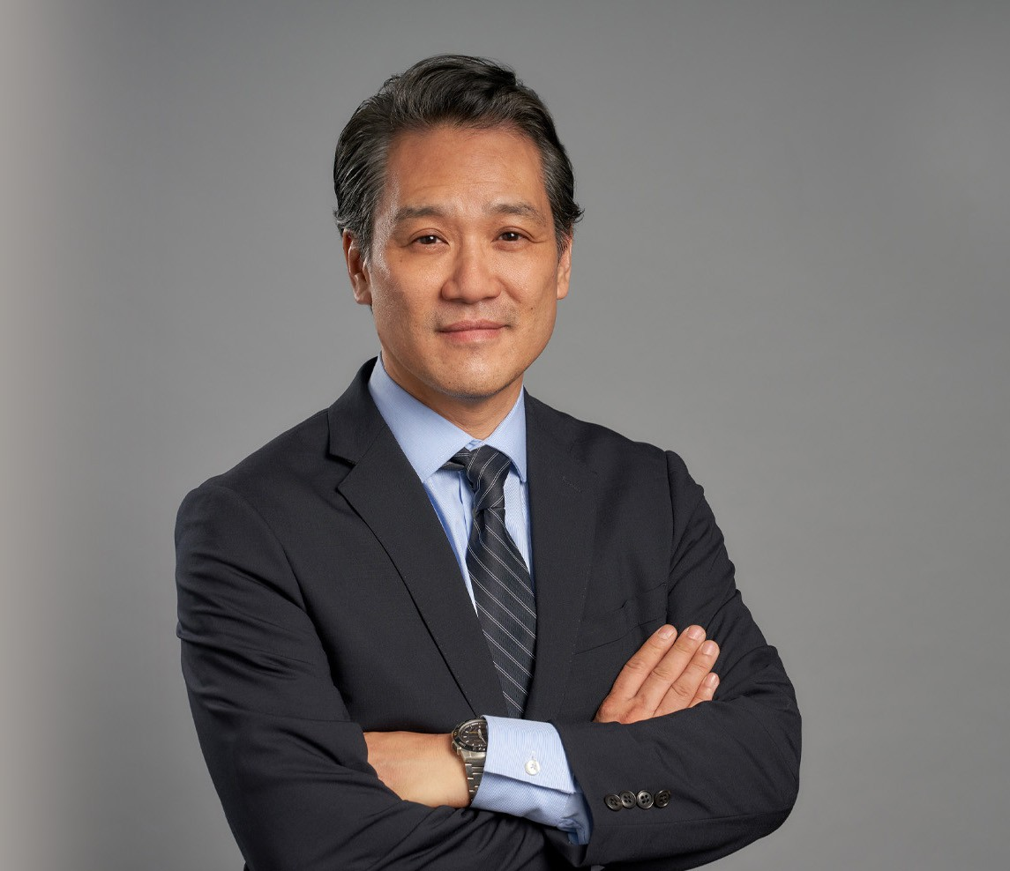

EUGENE M. PAK
Director
Intellectual Property

Oakland
P: 510.834.6600 F: 510.834.1928
epak@fennemorelaw.com

EUGENE M. PAK
An experienced counselor and litigator, Eugene provides strategic advice to his clients in both transactional and litigation matters. He acts as outside general counsel to many of his clients, and specialized intellectual property and litigation counsel to others. Eugene is a trusted advisor and vigorous advocate for his clients, helping them build and protect their businesses and
brands, and to structure favorable deals and agreements.

Eugene’s clients include apparel companies, food & beverage companies including alcohol beverage makers, restaurants and bars, technology companies, and many others. He brings a diverse background to his work, having worked at large and small firms, as in-house counsel at a technology company, and at a nonprofit public interest firm.

Intellectual Property Development, Protection and Litigation

For more than twenty-five years, Eugene has advised companies in the selection, registration and maintenance of their trademarks and copyrights both domestically and abroad. He serves as Vice-Chair of the Firm’s Intellectual Property Group. Eugene has filed or managed thousands of trademark and copyright applications and registrations worldwide. He advises companies with large, well-established international trademark portfolios, as well as newer companies that are just developing their brands. Eugene also represents clients in related areas such as advertising and marketing issues, social media issues, domain name disputes, software licensing, website terms of use, privacy policies, DMCA policies and compliance, right of publicity, trade secrets and non-compete agreements, and trademark licenses and co-existence agreements.
Eugene is also an experienced litigator, having litigated numerous IP cases and other disputes in federal and state courts. His experience includes disputes involving trademarks, trade dress,
copyrights, domain names, anti-counterfeiting, patent, trade secrets, and false advertising issues.

Food & Beverage Law, Alcohol Beverage Law, Craft Beer Law

Eugene regularly advises companies in the food and beverage industry. He serves as outside general counsel to many of his clients, advising them on a wide range of issues from entity formation, trademarks and copyrights, distribution and other contracts, regulatory matters, alcohol beverage (ABC) and labeling laws, as well as trade regulation issues (marketing and advertising, social media). Eugene frequently speaks on such issues, including at the Brewers

Association and California Craft Brewers Association’s conferences, and has been quoted in Brewbound, All About Beer, The Daily Journal, and other media outlets. He ‘tweets’ on legal and business issues facing alcohol beverage companies as @beerattorney.

Apparel & Fashion Law

Eugene is Chair of our Apparel & Fashion Law practice which advises and represents clients in the apparel, fashion, footwear, beauty, accessories, and personal care products industries. He has counseled and represented clients on intellectual property, advertising, and regulatory
issues, as well as on corporate formation and other business matters.

Business Counsel

Eugene is also an experienced business attorney. He has advised companies at all stages from start-up formation to mergers and acquisitions. Recently, he advised several breweries in their
sale or purchase of other breweries or their assets. He has also represented companies in a wide range of business and commercial matters, including class action cases, real estate disputes, unfair competition matters, California Business & Professions Code §17200 claims, and Commerce Clause issues involving beverage laws and regulations.

EDUCATION
J.D., University of California, Berkeley, School of Law B.A., University of Michigan

AREAS OF PRACTICE
Intellectual Property Business Litigation Business & Finance
Emerging Businesses & Technologies Food & Beverage
Government Relations & Regulatory Cannabis Business
General Counsel Services Apparel & Fashion

REPRESENTATIVE MATTERS

Business Transactions

Represented beverage company in Series A and Series B investment rounds. Advised craft brewery on fundraising and contract brewing issues.
Advised apparel company in spin-off of textile technology company and joint venture with large textile maker.
Advised leading apparel company on issues regarding development of program for sale of wines.
Advised restaurant chain on private label alcohol beverage sales.

Represented software company in acquisition by major international media company.
Represented SaaS company in corporate formation and licensing agreements with major financial institutions.
Advised alcohol beverage companies on alcohol beverage licensing, regulatory, and tied-house issues.
Advised textile technology company on corporate formation and intellectual property matters.
Advised craft breweries and other food & beverage companies on distribution contracts and regulatory matters.

Intellectual Property Litigation & Disputes

Represent public entity in trademark infringement litigation in federal district court
Represented music instrument maker and music organization as plaintiff in trademark infringement and counterfeiting action in federal district court.
Represented craft beverage company in class action false advertising and labeling action in federal district court.
Represented Northern California craft brewery as plaintiff in Lanham Act trademark infringement action in federal district court; obtained consent permanent injunction.
Represented a well-known Napa Valley winery in Lanham Act litigation in federal court against a Canadian wine kit manufacturer.
Represented television set-top box manufacturer in copyright infringement action involving BusyBox open source software and GNU General Public License (GPLv2).
Represented well-known manufacture of networking hardware and software products in anti-counterfeiting disputes and enforcement efforts.
Represented large international software company in anti-counterfeiting trademark and copyright litigation and enforcement matters.
Represented music instrument maker and music organization as plaintiff in trademark infringement and counterfeiting action in federal district court.
Represented building developer in copyright infringement action involving architectural drawings.
Represented natural skin care products company in trademark litigation against competitor.
Represented lifestyle apparel company in trademark infringement and TTAB cancellation proceeding involving mark and logo.
Advised cannabis accessories company in trademark enforcement matters.
Represented Bay Area cannabis company in trademark infringement case in federal district court.
Represented social gaming company in trademark prosecution and dispute matters.
Represented leading game publisher in several domain name arbitration proceedings (UDRP).
Represented leading ATM company in dispute with Korean manufacturer over ownership of trademark (ICDR arbitration).
Defended office products company in trade secret litigation involving use of customer lists and information; engaged in expedited discovery and successfully limited scope of TRO and

injunction.
Represented a well-known nonprofit organization in trademark and trade dress infringement and dilution action and related design patent infringement counterclaim.
Counsel for a newswire service in trade secret litigation; obtained a preliminary injunction requiring former employee to cease working for competitor and from using customer information.
Trial counsel for a jewelry designer in a trade dress infringement action in the Southern District of New York.
Represented an online document-sharing company in a DMCA dispute regarding copyrighted documents posted by customers.
Represented an online document delivery service in class action copyright infringement litigation involving indexing and delivery of copies of print articles.

Intellectual Property Counseling & Prosecution

Advise and represent companies on all aspects of trademark prosecution, protection, enforcement and licensing, including clients in the technology, computer game,
entertainment, food and beverage, and consumer retail products fields; handled wide range of trademark issues before the U.S. Patent and Trademark Office and Trademark Trial and Appeal Board; manage worldwide trademark portfolios and provide strategic branding advice and counsel.
Advise and represent clients on copyright issues, including registration and enforcement
issues, DMCA issues, and copyright licensing, in wide variety of fields; advise clients on right of publicity and privacy issues.
Represent several European apparel and luxury goods makers in trademark prosecution matters.
Serve as intellectual property counsel for a leading manufacturer and distributor of motorcycle parts, clothing and accessories, including handling trademark prosecution and enforcement actions worldwide.
Advised and represented a leading Korean apparel company in trademark matters in the United States.
Advised a leading computer game publisher on worldwide sweepstakes promotion in connection with the FIFA World Cup.
Advised social gaming company in various intellectual property matters and disputes including trademark prosecution, TTAB proceedings, and copyright counseling.
Negotiated a trademark license agreement relating to distribution and publication of music used in computer games.
Draft and negotiate license agreements (SLA, SaaS, ASP) for leading GIS mapping and technology provider.
Worked as in-house counsel for Silicon Valley CRM software company; drafted and negotiated license and business development agreements.
Advised client on privacy issues and policies for website and customers’ websites; negotiated licensing agreement regarding use of large business information database.

Other Litigation

Represented non-profit organization in quiet title and real estate fraud litigation regarding retail shopping plaza.
Represented state food and agriculture department in litigation regarding milk nutritional,
labeling, and pooling regulations, including claims under the Commerce Clause and Equal Protection Clause, and successful appeal to Ninth Circuit.
Counsel for a leading investment brokerage firm in an employment discrimination class action and related breach of duty of loyalty counterclaim; successfully compelled arbitration to avoid class claims, prevailed on defense of discrimination claim, and obtained damages award on firm’s breach of duty of loyalty claim.
Represented leading cereal maker in class action antitrust and unfair competition litigation; obtained summary judgment.
Defended brokerage firm in NASD arbitration involving claims of breach of fiduciary duty, “churning,” and related claims; obtained award in defendant’s favor.
Represented various employee groups in class action claims under Cal. Business & Profession Code 17200 for violations of wage and hour and other employment claims.

AWARDS AND HONORS
Alumnus of the Year Award, Korean American Bar Association of Northern California(KABANC), 2016
Best Lawyers Under 40, National Asian Pacific American Bar Association (NAPABA), 2005 Distinguished Service Award, Asian American Bar Association of the Greater Bay Area, 2005 Unity Award, Minority Bar Coalition and Korean American Bar Association, 2003

ARTICLES AND PRESENTATIONS
Author, “The Food and Beverage Industry is Brewing with Innovation: Tips on How to Protect Your Intellectual Property,” Fennemore Blog, June 13, 2024
Co-Author, “Supreme Court: Damages Not Restricted to Just Three Years in Copyright Cases,” Fennemore Blog, May 22, 2024
Speaker, “Legal Issues Facing Craft Breweries,” California Craft Brewers Association, Craft Beer Summit, March 13, 2024
Interviewer, Fireside Chat with Margaret Juhae Lee, author of “Starry Field: A Memoir of Lost

History,” Korean American Bar Association of Northern California, Annual Gala, March 1, 2024
Author, “Respectful Branding,” The New Brewer (Brewers Association),” September/October 2021
Co-Speaker, “Respectful Branding: Trademark Law and Practical IP Due Diligence” Brewers Association BA Collab Hour, with Tomme Arthur, Sam Calagione, and Marc Sorini, June 2021.
Co-Speaker, “So You Want to Be A Distiller,” Presentation for Course at Los Angeles Distillery, December 2020
Speaker, “Beer Law,” UC Davis School of Law, guest speaker for John Trinidad’s “Wine & The Law” course, April 2020
Speaker, “Distribution Contracts: The Beer Industry Pre-Nuptial Agreements,” California Craft Brewers Association Spring Conference, May 7, 2019.

Speaker, “Distribution Agreements: From Formation to Termination and Everything In-Between,” Brewers Association, Craft Brewers Conference, April 10, 2019
Organizer and Moderator, The Slants Decision,” National Asian Pacific American Bar Association (NAPABA), Western Regional Conference, November 2018
Co-Speaker, “Meet the Legal Experts,” Brewers Association, Craft Brewers Conference, with Joe Infante, Alva Mather, Marcus Reed, and Joe Davis, April 2018

PROFESSIONAL AND COMMUNITY ACTIVITIES
Allied Trade Member, Brewers Association
Allied Trade Member, California Craft Brewers Association
Former President and Founding Member, Craft Beverage Lawyers Guild Member/Mediator, Northern District of California ADR Program
Former Member, Anti-Counterfeiting Committee, Internet Committee, Information Resources Committee, Trademark Dilution Committee, Trademark Reporter Editorial Board, International Trademark Association (INTA)
Former Board Member, Co-Chair, Community Services Committee, and Co-Chair, Community Services Committee, Asian American Bar Association of the Greater Bay Area (AABA)
Former Regional Governor (Northern California) and Treasurer, International Association of Korean Lawyers (IAKL)
Former Presidents, Treasurer, and Board Member, Korean American Bar Association of Northern California (KABANC)
Former Member, California Regional Conference Organizing Committee, National Asian Pacific American Bar Association (NAPABA)

ADMISSIONS
California
U.S. Court of Appeals, Ninth Circuit Federal Courts in California

