
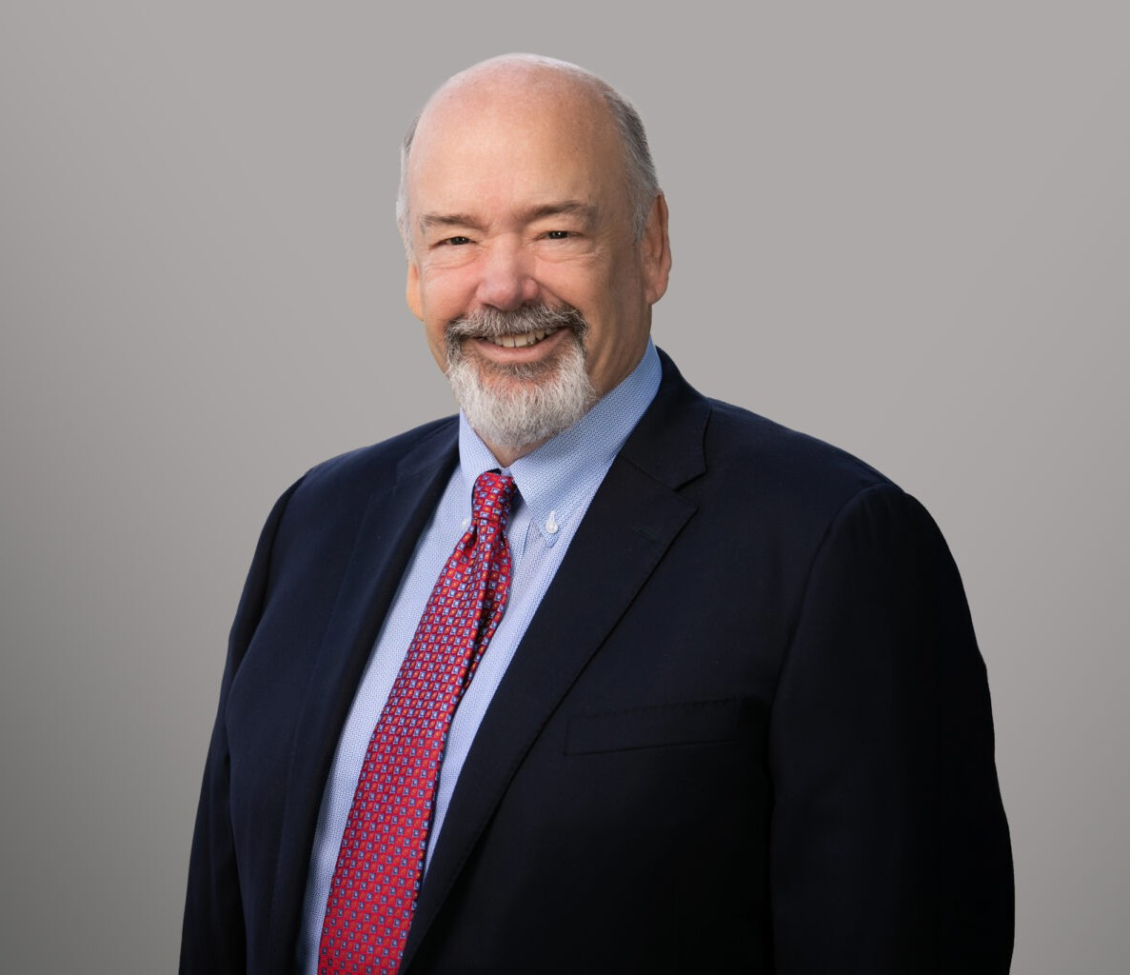
JOHN NORLING
JOHN NORLING
Director
Business & Finance
Phoenix
P: 602.916.5358
F: 602.916.5999
jnorling@fennemorelaw.com
John C. Norling is a Director in Fennemore’s Business & Finance practice group, where he provides strategic, comprehensive counsel to businesses, business owners, and individuals. With more than thirty years of experience, John assists clients with all facets of their operations — from day-to-day business matters to long-term organizational planning. His practice encompasses corporate transactions, real estate, business entity structuring, mergers and acquisitions, and compliance with federal, state, and administrative requirements. He is also well-versed in
contract negotiation and drafting, in a wide variety of areas including advertising and regulatory compliance, mergers & acquisitions, real estate transactions, commercial loan transactions, and other commercial matters.
A recognized authority in the automotive dealership sector, John represents dealers nationally. His automotive practice includes guiding clients through dealership acquisitions and sales,
dealership start-ups or “add-points,” manufacturer and finance relationships, ownership succession, operational compliance, consumer matters, and regulatory issues relating to
advertising, privacy, and consumer protection. He serves as outside general counsel to multiple dealer associations, including the Arizona Automobile Dealers’ Association, Valley Chevrolet Dealers Advertising Association, Valley Honda Dealers Marketing Association, Tucson Chevy Dealers Local Marketing Association, and several other industry-related associations. As general counsel, he advises on state and federal regulatory schemes such as the Red Flags Rule, the Safeguards Rule, Privacy Rule, and franchise statutes.
In addition to his work in the automotive sector, John serves as outside general counsel to entrepreneurial and family-owned businesses in diverse industries. His guidance focuses on preventative legal counseling and includes contract negotiation, business structuring, shareholder/member relations, asset and real estate acquisition and disposition, risk
management, and long-range succession planning. John is known for taking a proactive approach to legal counseling, helping clients avoid disputes through strong documentation and thoughtful risk mitigation.

EDUCATION
J.D., The Ohio State University
Ohio State Journal Dispute Resolution B.A., Wichita State University, cum laude

Athletics Director Honor Roll Scholarship Athlete, Football
AREAS OF PRACTICE

OTHER EXPERIENCE
Automobile Dealerships Business & Finance
Real Estate
General Counsel Services Mergers & Acquisitions

REPRESENTATIVE MATTERS
Lead counsel in transactions involving the sale or acquisition of automobile dealerships, powersports dealerships, and related real estate, ranging from $1 million to close to $200 million in several states, including Arizona, California, Nevada, Colorado, Texas, Georgia, and North Carolina.
Former branch counsel for one of the country’s largest captive automobile finance companies, handling the documentation of lending relationships and enforcing loan documents.
Advises automobile dealers with consumer issues relating to after-market and after-sales services and disputes.
Review and drafts legislation designed to protect the interests of franchised new motor vehicle dealers throughout the State of Arizona.
Serves as outside general counsel to businesses in a wide range of industries, assisting in all aspects of their operations.
Advises new motor vehicle dealers on compliance matters, including Federal and State regulatory matters involving advertising, the Red Flags Rule, the Safeguards Rule, the Privacy Rule, and other Federal and State regulatory promulgations.
Served as outside general counsel to one of the largest family-owned landscaping material production and sales companies in the Western United States, advising on matters ranging from the negotiation and preparation of vendor contracts to the acquisition and divestiture of real estate and culminating in the sale of the multi-state operation to a private equity group.
Serves as a trusted advisor to businesses and takes the time to learn and understand clients’ businesses to better advise them with regard to their particular situations.

AWARDS AND HONORS
AV Preeminent Peer Review Rating, Martindale-Hubbell
Best Lawyers in America®, Business Organizations (including LLCs and Partnerships), 2025-2026; Closely Held Companies and Family Businesses Law, 2021-2026; Commercial Finance Law,
2024-2026; Corporate Law, 2019-2026; Real Estate Law, 2014-2026
Best Lawyers in America©, Phoenix Lawyer of the Year, Real Estate Law, 2019
Phoenix Business Journal, Most Admired Leaders, 2020

Arizona Business Leaders Magazine, AzBusiness Leaders, Management, 2020 Arizona’s Finest Lawyers, Corporate and Real Estate Law, 2009-2012 Arizona’s Top Rated Lawyers, Corporate and Real Estate Law, 2012

ARTICLES AND PRESENTATIONS
Author, “Legal-Ease: Your Lawyer as Your Business Consultant,” Greater Phoenix InBusiness Magazine, June 1, 2024
Featured, “John C. Norling: The True Measure of Success,” Attorney at Law Magazine, January 26, 2021
Featured, “Phoenix law firm gives ASU Law grads meaningful opportunities to work where they studied,” Arizona State University, July 27, 2020
Featured, “The College Athletes of Jennings, Strouss & Salmon: Playing the Game of Law,” Attorney at Law Magazine, June 26, 2020
Quoted, “Arizona Legal Services Institution is Proud to Continue Support of ASU Law,” Arizona State University Sandra Day O’Connor College of Law, 2019
Interview, “4 Ps of Brand Endorsements to Make the FTC Happy,” AdWeek, June 22, 2015
Featured, “What new online advertising rules mean for Phoenix small businesses, Phoenix Business Journal, June 18, 2015
Author, “Is Your Ad Legal? Digital Advertising Raises Additional Issues for Marketers,” AdWeek, January 21, 2015
Six Legal and Regulatory Risks CMOs Can’t Afford To Ignore, Contributor, CMO.com, 2015
Navigating the Advertising Minefield: Businesses Must Be Diligent When Formulating Advertising Campaigns, Co-author, Client Alert, 2015
Updated FTC Guidelines on Internet Advertising & Marketing, Interview, Arizona Horizon, 2015

PROFESSIONAL AND COMMUNITY ACTIVITIES
Member, Board of Visitors, James E. Rogers College of Law, University of Arizona Member, National Association of Dealer Counsel
Former Board Member, Herberger Theater Center
Former Board of Trustees, Arizona Center of Nature and Conservation/Phoenix Zoo Former Board Member, Sandra Day O’Connor Institute for American Democracy Former Member, State Bar of Arizona, Rules of Professional Conduct Committee Former Member, Association for Attorneys and Executives in Corporate Real Estate Former Member, Scottsdale Airpark Committee
Former Member, Economic Development Advisory Council

ADMISSIONS
Arizona
U.S. Court of Appeals, Ninth Circuit
U.S. Tax Court

