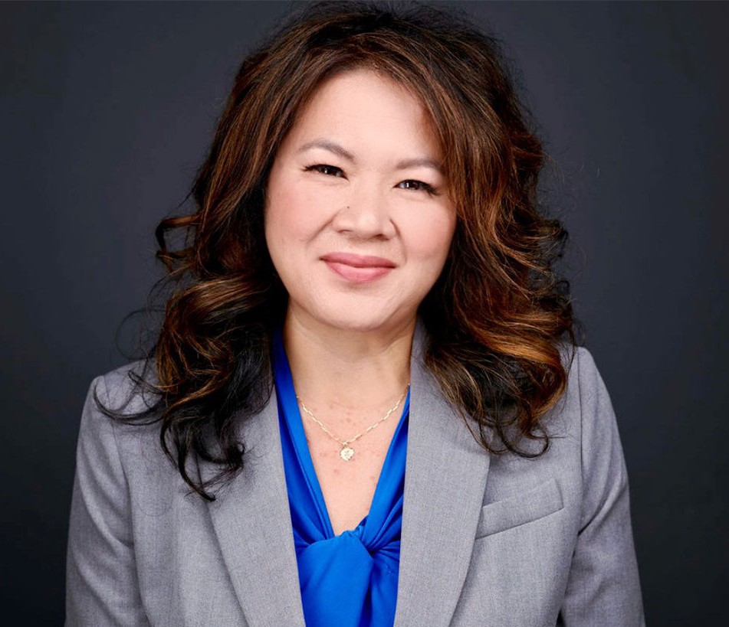

JUNE MONROE
Director
Agribusiness

Orange County
P: 949.430.3420 F: 949.752.0953
jmonroe@fennemorelaw.com

JUNE MONROE
June Monroe is a director in Fennemore’s Orange County office and a member of the firm’s Agribusiness and Employment Law Practice Groups. She represents produce marketers, growers, distributors, and employers across the agricultural industry, combining deep industry knowledge with practical business insight.
June’s practice spans both transactional and litigation matters in agribusiness and employment
law. She drafts and negotiates complex contracts, marketing agreements, packing agreements, and secured transactions, and litigates disputes in federal and state courts, including bankruptcy proceedings. She is nationally recognized for enforcing produce suppliers’ statutory rights under the Perishable Agricultural Commodities Act (PACA), having recovered millions of dollars in multi-party trust and bankruptcy actions. She also assists agribusiness marketers in perfecting security interests in growing crops under the Uniform Commercial Code and Federal Food Security Act.
In her employment law practice, June advises employers on compliance, investigations, and litigation defense. She represents companies before the U.S. Department of Labor, the California Labor Commissioner, and state and federal court, and has successfully defended wage and hour, discrimination, and unemployment benefit claims. She routinely drafts employment
contracts, employee handbooks, and workplace policies, and counsels clients on hiring, classification, wage and hour compliance, leave laws, and terminations.
June’s path to law was anything but traditional. She began her career as a receptionist before rising to legal assistant and, as a single mother of two, earned her law degree while working full-time. Her perseverance and empathy continue to shape her client relationships and leadership approach.
June is the immediate past Chair of the Agribusiness Committee of the Business Law Section of the California Lawyers Association.
Outside of work, June is a passionate painter whose art celebrates the fruits and vegetables of California’s agribusinesses and often gifting her pieces to clients as a reflection of the vibrant industry she serves.
Agribusiness
Labor & Employment

Business Litigation

EDUCATION
J.D., Concord Law School
B.A., California State University, Fullerton

AREAS OF PRACTICE
Agribusiness
Labor & Employment Business Litigation

PROFESSIONAL AND COMMUNITY ACTIVITIES
Member, State Bar of California
Member, Law Advisory Council, Concord Law School at Purdue University Global
Past Chair of the Agribusiness Committee; Business Law Section, California Lawyers Association
Past Vice-Chair of Programs of the Agribusiness Committee; Business Law Section, California Lawyers Association
Past Vice-Chair of Publications of the Agribusiness Committee; Business Law Section, California Lawyers Association
Member, Orange County Women Lawyers Association

AWARDS AND HONORS
Recipient, Orange County Women Lawyers Association’s Diversity Bar Stipend Scholarship, May 2012

ARTICLES AND PRESENTATIONS
Co-Author, “The ‘No Tax’ Overtime Myth: Employer Payroll and Reporting Obligations Under the One Big Beautiful Bill Act Explained,” Fennemore Blog, February 16, 2026
Co-Author, “New Year, New Rules: Key California Employment Law Updates For 2026,” Fennemore Blog, December 31, 2025
Co-Author, ““Stay-or-Pay” No More: California’s New Limits on Training and Retention Agreement Payback,” Fennemore Blog, December 10, 2025
Speaker, “Harvesting Clarity: Get Clarity on Grower’s Agent and Commission Merchant
Obligations” and “Reaping Super Priority Creditor Status with the PACA Trust,” Fresh Produce & Floral Council, 2025 Harvest Forum and Fair
Author, “Protect Your Harvest: A Supplier’s Checklist to Avoid Produce Buyer Fraud,” San Diego Business Journal, June 16, 2025
Author, “KEEP THE BAD APPLES OUT: 5 Steps Fresh Produce Suppliers Should Take to Avoid Buyer Scams,” Fennemore Blog, May 5, 2025
Co-Author, “A Canadian Produce Trust Law, Eh?” Fennemore Client Alert, January 17, 2025.

Author, “Finding Work-Life Balance as a Legal Professional,” Fennemore Blog, December 11, 2024
Speaker, “Fact or Fiction: Employment and Ag Law Issues,” Fresh Produce & Floral Council, May 2024 Expo.
Speaker, “Demystifying PACA: Navigating Compliance and Best Practices in the Produce Industry,” National Agricultural Law Center webinar, April 17, 2024
Speaker, “Playing By the Non-Compete Rules,” Western Growers Webinar, April 17, 2024.
Author, “Webinar navigates Perishable Agricultural Commodities Act,” The Sentinel-Record, April 15, 2024
Author, “Ten Steps to Fight Freight Fraud,” Fennemore Client Alert, April 5, 2024
Author, “Thursday Thoughts with June Monroe: Employment Changes Taking Effect in the Agribusiness Industry in 2024,” Fennemore Blog, March 21, 2024
Interview, “PACA LAW with June Monroe of Fennemore Law,” The Produce Industry Podcast with Patrick Kelly, Episode 376, January 14, 2024
Featuring, “CalBar 8.3 “Snitch Rule” – Required Misconduct Reporting Featuring,” Orangecountylawyers.com, July 17, 2023
Author, “It’s berry hard to believe, but growers and marketers may not be jointly liable for laborers’ wages, even in California,” Fennemore Client Alert, June 14, 2023
Author, “It’s berry hard to believe, but growers and marketers may not be jointly liable for laborers’ wages, even in California,” California Lawyers Association, June 14, 2023
Speaker, “Veggie Wars” seminar, National Agricultural Law Center, Western Agricultural & Environmental Law Conference, May 4-5, 2023
Speaker, “Immigration Law for Agribusiness Employers” webinar, California Lawyers Association, Business Law Section, Agribusiness Committee, March 21, 2023
Interview, “If you want it, go get it,” Fennemore Blog, December 8, 2022
Featuring, “OCWLA Featured Member, June Monroe,” Orange County Women Lawyers Association, November 14, 2022
“PACA Trust,” On-Demand Webinar for The Blue Book Services, Inc.’s New Hire Academy

ADMISSIONS

California
U.S. District Court, Northern District of California
U.S. District Court, Eastern District of California
U.S. District Court, Central District of California
U.S. District Court, Southern District of California

