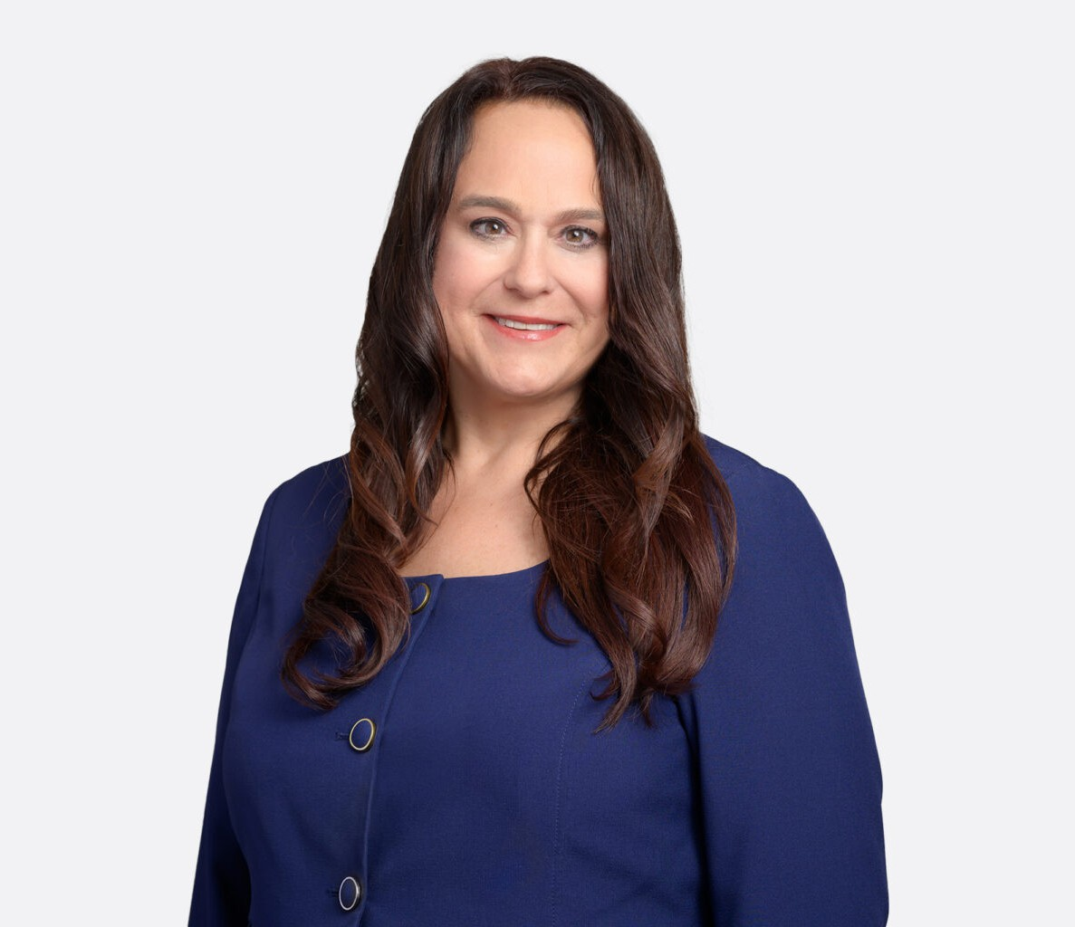

KRISTIN MIHELIC
Of Counsel
Financial Restructuring

San Diego
P: 619.595.3205 F: 619.231.4372
kmihelic@fennemorelaw.com

KRISTIN MIHELIC
Kristin Mihelic is a veteran bankruptcy attorney and litigator representing debtors, creditors, lenders, franchisors, trustees, and committees in bankruptcy, restructuring, and complex commercial litigation matters.
Prior to joining Fennemore, Kristin was a Trial Attorney with the U.S. Department of Justice, U.S. Trustee Program in San Diego and Santa Ana, where she oversaw civil enforcement and Chapter 11 cases. Her work included prosecuting civil actions involving abuse of the bankruptcy system, litigating contested matters and trials, supervising chapter 11 cases, and analyzing
complex financial and corporate restructuring issues to ensure compliance with the Bankruptcy Code and applicable law.
In addition to her work with the U.S. Trustee Program, Kristin was a Special Assistant U.S. Attorney with the U.S. Attorney for the Southern District of California, where she handled fraud investigations and felony reactive cases tied to the U.S.–Mexico border. In this role, she managed cases from inception through sentencing, conducted evidentiary hearings in District Court, and participated in grand jury presentations. Earlier in her career, Kristin practiced at national and regional law firms representing debtors, creditors, trustees, and committees in chapter 7 and chapter 11 matters across the country, as well as in related commercial and real estate litigation. Her experience includes restructuring negotiations, contested plan confirmation proceedings, avoidance actions, insurance insolvency matters, and high-stakes arbitration and trial work.
Kristin is also active in legal education and professional leadership. She is currently serving a three-year term on the Ninth Circuit Judicial Conference Executive Committee and served a three-year term as a Lawyer Representative for the U.S. District Court for the Southern District of California. She has served as an adjunct professor at multiple law schools, teaching subjects including bankruptcy law, litigation skills, legal writing, and appellate advocacy, and is a
frequent speaker and program moderator for bar associations and professional organizations on bankruptcy, ethics, and commercial litigation topics. She has held numerous leadership roles within local and statewide legal organizations and has been recognized by regional publications for her contributions to the legal community.

EDUCATION
J.D., Boston University School of Law
Boston University Public Interest Law Journal

Co-Director and Judge-Advisor, Esdaile Moot Court Board Jessup International Law Moot Court Competition
News Editor and Columnist, The Law Register B.A., Northwestern University

AREAS OF PRACTICE
Financial Restructuring Cannabis Business

REPRESENTATIVE MATTERS
Successfully tried to verdict objection to discharge adversary proceeding in three day trial resulting in the denial of discharge of over $500,000 in unsecured debts
Litigated chapter 11 Ponzi scheme cases for Trustee appointment in chapter 11 corporate and individual cases subsequent to which the principal was charged with 84 counts of fraud and elder abuse and entered a guilty plea
Obtained waivers of discharge from debtors following litigation in several cases, resulting in over $75,000,000 in unsecured debts not discharged
Litigated marijuana-adjacent chapter 11 case, resulting in dismissal of chapter 11 case filed by landlord of marijuana dispensary
Litigated over 100 contested motions to convert chapter 11 cases to chapter 7 on various grounds, including plan feasibility and gross mismanagement of estate
Represented creditors in a variety of core restructuring matters, including cash collateral agreements for secured lenders, administrative claims for reclamation and post-petition expenses, and plan confirmation objections
Served as the firm’s lead handling attorney for creditor representation in the Kmart Corporation bankruptcy, handling matters for lenders, suppliers, landlords, and utility companies
Managed over 50 preference defense claims in amounts between $100,000 and $11 million, resulting in settlements representing a fraction of the dollar amounts of the claims
Chapter 11 creditor representation: WorldCom; FINOVA Corporation; UAL Corporation; marchFirst, Inc.; Lodgian, Inc.; Houlihan’s, Inc.; Teleglobe Communications Corporation; Hechinger Investment Corporation; TWA post-confirmation estate; Trailmobile Trailer, Inc.;
Contifinancial Corporation; Bangor & Aroostock Railroad Company; Purely Cotton, Inc.; RHC Spacemaster, Inc.; Anicom, Inc.; Eagle Foods Center, Inc.; and Olympus Healthcare Group. Additional representative clients of public record included: U.S. Foodservice, Inc.; Equity Office Properties, LLC; LaSalle Bank, N.A.; Bank One, N.A.; Airlines Reporting Corporation; American National Bank; GE Capital Services; Heller Financial Leasing, Inc.; Siemens Building Technologies, Inc.; CIT Communications Finance Corporation; Bally Total Fitness Corporation; and Alliant Foodservice, Inc.
Represented creditors committee and liquidating trust in medical provider chapter 11 case
Represented franchisors in franchisee bankruptcy cases and managed issues regarding assumption and cure of intellectual property agreements
Served as second chair in three complex and sizable reinsurance arbitration proceedings involving fraud and misrepresentation actions

Served as second chair in a $22 million construction delay claim including substantial economic losses
Led litigation teams of attorneys and support staff in commercial and real estate litigation
Conducted an evidentiary hearing for the imposition of sex offender conditions in connection with supervised release
Managed approximately 50 felony cases in plea agreements and sentencings
Worked with the Major Frauds Section of the U.S. Attorneys Office as a Special Assistant U.S. Attorney to investigate investment schemes

AWARDS AND HONORS
Justice in Action Award, South Asian Bar Association of San Diego, 2025 San Diego Business Journal Woman Of Influence In Law
San Diego Magazine Leader In Celebrating Women

ARTICLES AND PRESENTATIONS
Panelist, “One Year Later: Lessons Learned From The Snitch Rule,” Federal Bar Association — Los Angeles Chapter, November 15, 2024
Panelist, “Navigating the New Rule of Professional Conduct 8.3,” Federal Bar Association — Los Angeles Chapter, October 20, 2023
Producer and Moderator, “The Future of Student Loan Forgiveness and Dischargeability: A Conversation with Dean Erwin Chemerinsky,” California Lawyers Association, August 14, 2023
Panelist, “Special Topics in Chapter 11 Practice: Navigating Your Case to Confirmation, Insolvency Law Committee,” California Lawyers Association, July 14, 2022
Panelist, “Chapter 11: Back to the Basics,” San Diego Bankruptcy Forumm December 7, 2021
Producer and Moderator, “Bankruptcy Primer for Small Businesses,” Insolvency Law Committee of the California Lawyers Association, June 24, 2021
Producer and Moderator, “One Year Later: Retrospection on Sub-Chapter V Bankruptcy Practice,” Insolvency Law Committee, California Lawyers Association, April 22, 2021
Panelist, “The Small Business Reorganization Act: A Primer and Path for the Future (Part II),” San Diego Bankruptcy Forum, June 16, 2020
Producer and Moderator, “The Small Business Reorganization Act: A Primer and Path for the Future (Part I),” San Diego Bankruptcy Forum, May 28, 2020

PROFESSIONAL AND COMMUNITY AFFILIATIONS
Adjunct Professor, Litigation and Transactional Skills, University of San Diego School of Law, 2019-Present
Adjunct Professor, Bankruptcy Law, California Western School of Law, 2017
Guest Lecturer, Trial Advocacy, Rutgers University School of Law at Camden, 2009
Adjunct Professor, Legal Writing and Appellate Advocacy, John Marshall Law School, 2000-2002
Member, Ninth Circuit Judicial Conference Executive Committee, 2025- Present

Former Lawyer Representative for the U.S. District Court for the Southern District of California, 2022-2025
Member, History Committee for the U.S. District Court of the Southern District of California, 2024-Present
Professional Development Committee, Federal Bar Association
Executive Committee Member and Former Vice-Chair, Business Law Section — California Lawyers Association
Board of Directors, San Diego Bankruptcy Forum
Board of Directors, International Women’s Insolvency & Restructuring Confederation — Southern California Network
Former President, Northwestern University Club of San Diego
Former Co-Chair, Education Sub-Committee, Insolvency Law Committee, California Lawyers Association
Former Board Member and Pupilage Leader, James King Bankruptcy Inn of Court Former Chair, DEI Strategic Committee, Junior League of San Diego
Former Co-Chair, Diversity Committee, Business Law Section — California Lawyers Association Former Chair, Diversity Celebration Sub-Committee, Los Angeles Bankruptcy Forum

ADMISSIONS
California New York
New Jersey
U.S. District Court for the Southern District of California

