
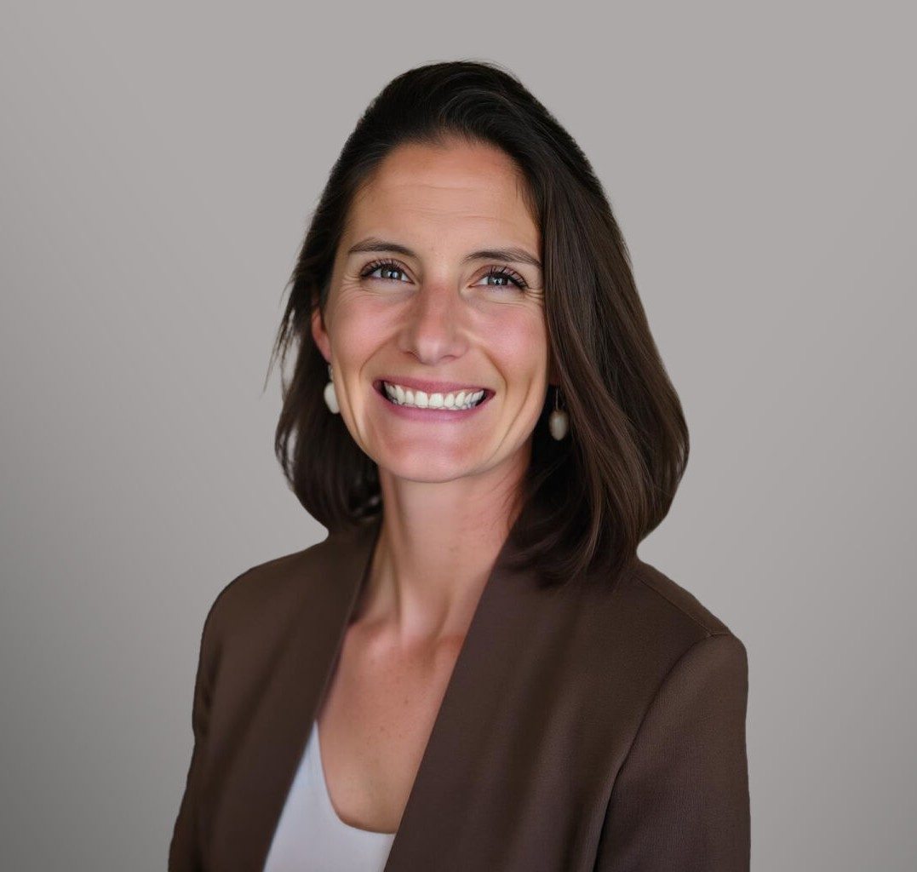
LINDSEY MORGAN
LINDSEY MORGAN
Of Counsel
Business Litigation
Coeur d’Alene
P: 208.956.0137
F: 602.916.5999
lmorgan@fennemorelaw.com
Lindsey Morgan is an Of Counsel Attorney in Fennemore’s Business Litigation practice group. She focuses her practice on the defense of real estate and insurance professionals, complex business and ownership disputes, and commercial litigation involving significant financial and operational risk. She regularly represents businesses and individuals in disputes involving fiduciary duties, professional liability, insurance coverage, and control or ownership conflicts. Her clients include national real estate brokerages, insurance carriers and brokerages, and public utilities. She is admitted to practice in California, Washington, and Idaho.
Prior to joining Fennemore, Lindsey litigated complex commercial matters in California and Washington and served as Outside General Counsel for closely held businesses and
professionals, advising on litigation risk, governance issues, and dispute avoidance. She has extensive experience representing insurers and insureds in insurance coverage litigation and defending real estate brokerages and their employees and agents in civil litigation. Her coverage experience informs her litigation strategy and allows her to advise clients on risk allocation and dispute prevention alongside active litigation. Lindsey holds an inactive real estate broker license in both Idaho and California, offering industry insight without competing with her clients’ interests.
Lindsey is an active member of the Rotary Club of Coeur d’Alene, where she serves as co-chair of the grants committee. As part of her service project through the Idaho Academy of
Leadership for Lawyers, she is developing Coeur Foundations, a community-focused initiative that helps small and mid-sized nonprofits in North Idaho build strong legal and governance infrastructure, enabling effective leadership and long-term organizational stability.
Outside of her practice, Lindsey enjoys CrossFit, golf, and gardening, and tries to keep up with her sons.

EDUCATION
J.D., University of Southern California Gould School of Law B.A., University of California, Los Angeles

AREAS OF PRACTICE

Business Litigation

REPRESENTATIVE MATTERS
Represented national and regional real estate brokerages, insurance brokerages, and individual professionals in high-exposure errors and omissions and professional liability matters, including pre-litigation risk assessment, coverage analysis, and trial defense.
Defended corporate clients in multi-million-dollar commercial real estate disputes involving complex causation, insurance allocation, and cross-jurisdictional issues.
Served as defense counsel for a privately owned public utility in San Francisco, managing dozens of coordinated property damage and personal injury claims.
Obtained summary judgment for a national real estate brokerage and its agent in a non-disclosure action in Alameda County, California.
Defended a corporate executive on appeal in a breach of contract action involving international jurisdiction and enforcement of foreign judgments.
Represented a national real estate brokerage and a high-profile individual agent in a multi-million-dollar commission dispute.
Acted as liaison counsel for insurer defendants in Montrose v. Canadian Universal Insurance Co., a pollution allocation matter decided by the California Supreme Court addressing horizontal versus vertical allocation at the excess insurance level.

ARTICLES AND PRESENTATIONS
Contra Costa Association of Realtors – Risk Management Seminar presentation, 2019-2020 North Idaho College Nursing Program – guest lecturer (“Legal Accountability”), Feb. 2024

PROFESSIONAL AND COMMUNITY ACTIVITIES
Member, 2025-2026 class of the Idaho Academy of Leadership for Lawyers (IALL) Co-Chair, Grants Committee, Rotary Club of Coeur d’Alene
Member, Idaho Women Lawyers
Member, Magnet Committee, Sorensen Magnet School

ADMISSIONS
Idaho (state and federal) California (state and federal) Washington (state and federal) Ninth Circuit

