
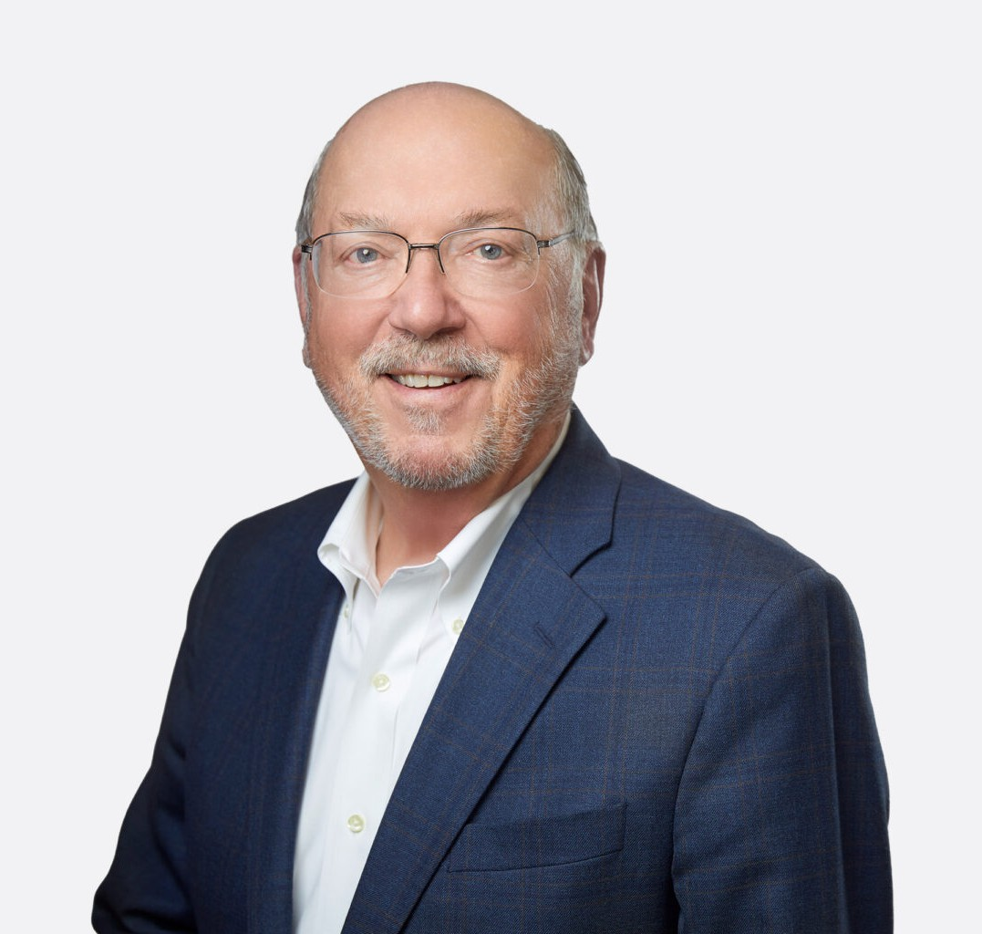
MICHAEL E. BUCKLEY
MICHAEL E. BUCKLEY
Of Counsel
Real Estate
Las Vegas
P: 702.692.8006
F: 702.692.8086
mbuckley@fennemorelaw.com
Michael E. Buckley’s practice involves commercial real estate transactions with an emphasis on commercial mortgage loans, including construction loans, workouts and foreclosures; acquisitions and dispositions of commercial properties, from vacant land to shopping center properties and golf courses; commercial leases, including ground leases; and master-planned communities. He has experience in land use issues, municipal development agreements and residential and mixed-use projects CC&Rs. His clients have included financial institutions and other lenders, developers, public entities and nonprofits.
As a founding member and chair of the Real Property Section of the State Bar of Nevada, Michael has been instrumental in the enactment of the Section’s legislative proposals and Nevada’s enactment of uniform laws such as the Uniform Commercial Real Estate Receivership Act (2017).
Michael remains close to his English major roots and Jesuit education. As one of nine children, he is the family historian. He spent a year abroad living outside Cambridge, England and traveling Europe with his wife and four children. He is a published poet (Sandstone & Silver, an anthology of Nevada poets [Zeitgeist Press, 2019]). Michael served for several years as a board member of Stillpoint Center for Spiritual Development, an important contributor to the “other” Las Vegas.
Michael enjoys traveling, having accompanied his father on Hilton Foundation funded projects in Haiti, Western Africa, Poland, Brazil, and Vietnam.

EDUCATION
J.D., Santa Clara University School of Law, cum laude
B.A., University of California, Los Angeles

AREAS OF PRACTICE

OTHER EXPERIENCE

Real Estate Finance and Lending Real Estate Litigation

Real Estate
Eminent Domain

REPRESENTATIVE CASES
Lender’s counsel on a $100 Million construction loan for redevelopment of former downtown Reno hotel property.
Represented lender in connection with a defaulted $50 Million New York loan secured by
Nevada and Florida real estate with Pennsylvania guarantors. Commenced and completed non-judicial Nevada foreclosure without significant delays and participated with firm litigation counsel in suit against the guarantors in Nevada involving significant 2011 Nevada foreclosure and guaranty law amendments subject to a variety of interpretations. Initiated draft
settlement agreement providing for uncontested foreclosures or deeds in lieu and an agreed upon deficiency.
Represented the University of Nevada, Las Vegas (UNLV) in the negotiation of an Exclusive Negotiation Agreement (ENA), subsequently approved by the Board of Regents. The ENA provided for a period during which UNLV and Majestic Realty Co., a California developer, would negotiate the terms and conditions under which Majestic, which had prior experience in developing and constructing similar facilities, would develop and construct an on-campus mega event stadium and related hospitality and retail facilities. The ENA provided for a process by which the terms and conditions of various implementing agreements would be negotiated and agreed to in phases, as well as the means to terminate the negotiations.
Represented the developers of high rise condominium projects adjacent to the Las Vegas
Strip (Panorama Towers) and in downtown Las Vegas (Newport Lofts and Juhl). Representation included preparing and negotiating agreements for the acquisition of the various sites; preparation of the declaration and various documents creating the condominium associations and the sale of condominium units, including public offering statement, HUD ILSA registrations, and end user purchase and sale agreements. Representation also included negotiation of first mortgage and mezzanine financing loans for the projects, as well as
subsequent loan modifications. Portions of the Juhl site in downtown Las Vegas were acquired from the City of Las Vegas through a Disposition and Development Agreement (DDA) and were additionally subject to easement and encroachment agreements with the City for the use of public airspace.
Represented the owner and developer of Aliante following its acquisition of the 1905 acre site in a BLM land auction. Aliante is a mixed use master planned community in North Las Vegas,
Nevada which includes approximately 6,500 homes, commercial shopping centers and a resort hotel/casino. Representation over the period of the community’s development and sale included preparing and negotiating the option and sale contracts between the master developer and the various homebuilder purchasers; preparing and negotiating the
development covenants for the homebuilder’s parcels; preparation of the master declaration and related master association documents; and representing the master developer in connection with the bank financing for the community. Similar clients and projects included representation of the developers of Seven Hills, MacDonald Highlands and Tuscany, each of which included an onsite golf course.
Represented a national homebuilder in its negotiation of the proposed form of annexation and parks agreements with the City of Henderson. These agreements were negotiated in advance of a BLM auction of undeveloped land within the City in contemplation of the homebuilder becoming the successful bidder.

Represented a bank in connection with its leasehold mortgage financing of phase one of a golf course development owned and operated by a local Indian tribe in Las Vegas. Later representation included the same and different banks in connection with the financing of additional phases of the golf course development as well as equipment and working capital loans for the tribe.

AWARDS AND HONORS
Best Lawyers in America®, Real Estate Law, 1987-2026
Best Lawyers in America®, Commercial Finance Law, 2022-2026
Best Lawyers in America®, Banking and Finance Law, 2023, 2025, and 2026
Chambers USA, Leading Lawyers for Business, 2013-2024
Top Lawyers, Vegas Inc., 2013, 2021
Mountain States Super Lawyers®, Real Estate, 2007-2025, Eminent Domain, 2025 “Legal Elite,” Nevada Business Magazine, 2015
Nevada’s Best Lawyers®, 2013
Volunteer of the Year, State Bar of Nevada, 2013

Who’s Who Legal: The International Who’s Who of Business Lawyers, 2013
Mountain States Super Lawyers®, Top 100 Attorneys, 2012

International Who’s Who of Real Estate Lawyers, 2012
Top 100 Attorneys in the Mountain States, Salt Lake Magazine, July 2012
Mountain States Super Lawyers®, Top 75 Attorneys, 2011
AV® Preeminent™ Peer Review Rated (the highest rating available), by Martindale-Hubbell

ARTICLES AND PRESENTATIONS
Co-Author, “Business Contracts in 2025: Straightforward Answers for Nuanced Situations,” Fennemore Blog, August 14, 2025
Author, “Real Estate Loan Drafting Guidance: Nevada,” Thomson Reuters, April 2025
Author, “Commercial Real Estate Brokerage Laws and Customs: Nevada,” Thomson Reuters, April 2025
Author, “Real Estate Leasing: Nevada,” Thomson Reuters, April 2025
Author and Lead Editor, Nevada Real Property Practice and Procedure Manual, State Bar of Nevada, 2d Edition (2025), 1st ed. (2021)
Presenter, The Law of Easements, Nevada Land Laws, Halfmoon Seminars, December 2024. Presenter, Nevada Real Estate Transaction Documents A-Z, NBI, December 2024.
Presenter, Hang 10: Riding the Wave in Troubled (Loan) Waters, State Bar of Nevada Annual Meeting, June 2024.
Presenter, Nevada Real Estate Law Updates 2023, NBI, September 2023.
Author, “Making it Work: Golf Course Conversions,” Nevada Lawyer, September 2018

Speaker, “Drones: Real Estate Issues and Privacy,” 2017 State Bar of Nevada Annual Meeting, June 30, 2017
Co-author, “Creation of ‘The Commission’… How? When? And Why?” Community Interests, May 2017

PROFESSIONAL AND COMMUNITY ACTIVITIES
Member, American Bar Association (Real Property, Trust and Estate) Fellow, American Bar Foundation
Member, State Bar of Nevada (Real Property, Construction Law and Business Law Sections; Chair, Executive Committee, Real Property Section)
Fellow, American College of Real Estate Lawyers, member and former chair, Land Use and Environmental and Public Policy Committees
Fellow, American College of Mortgage Attorneys
Fellow, American College of Commercial Finance Lawyers
Board Member and Secretary, Stillpoint Center for Spiritual Development, 2004–2023
Commissioner and Chair, State of Nevada Commission on Common Interest Communities and Condominium Hotels, 2003-2012
Commissioner and Chair, Las Vegas City Planning Commission, 1994–2002, 2009

ADMISSIONS
California Nevada

