
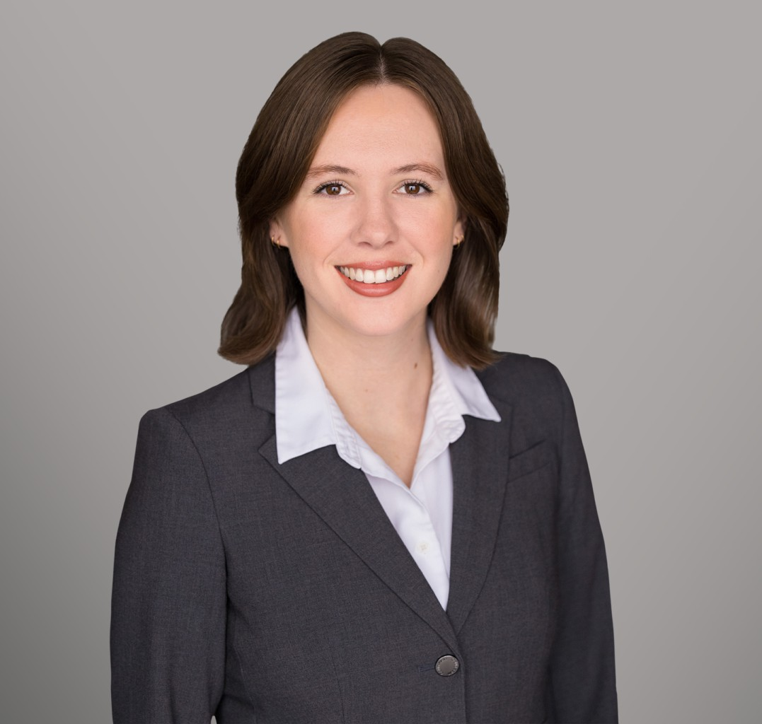
MIRANDA FREEMAN
MIRANDA FREEMAN
Associate
Business & Finance
Sacramento
P: 916.920.5286
F: 916.920.5286
mfreeman@fennemorelaw.com
Miranda Freeman, an associate attorney, practices taxation, estate planning, and trust administration. She stands out for her adeptness in advanced tax minimization strategies,
integrating these techniques into her estate planning practices to efficiently reduce tax liabilities for her clients. This expertise ensures that clients’ wealth transfer and estate planning goals are met with favorable tax outcomes.
In addition, Ms. Freeman excels in the formation and administration of trusts. Her knowledge in this area allows for effective management and distribution of assets, providing clients with peace of mind and ensuring their estate plans are executed as intended.

EDUCATION
J.D., University of the Pacific, McGeorge School of Law B.A., University of California, Santa Cruz

AREAS OF PRACTICE
Business & Finance Tax Law

AWARDS AND HONORS
Best Lawyers in America®, Ones to Watch, Tax Law, Trusts and Estates, 2026
Northern California Super Lawyers Rising Star®, Estate & Probate, 2025 Top 16 Oral Advocate

ARTICLES AND PRESENTATIONS
Speaker, “Estate Planning for the Real Estate and Agricultural Property Owner (E&G),” 2025 California All-Tax Conference, California Lawyers Association, November 14, 2025

PROFESSIONAL AND COMMUNITY ACTIVITIES

Sports & Entertainment Law Society, Treasurer, 2020-2021 Vice President, 2021-2022

ADMISSIONS
California

