
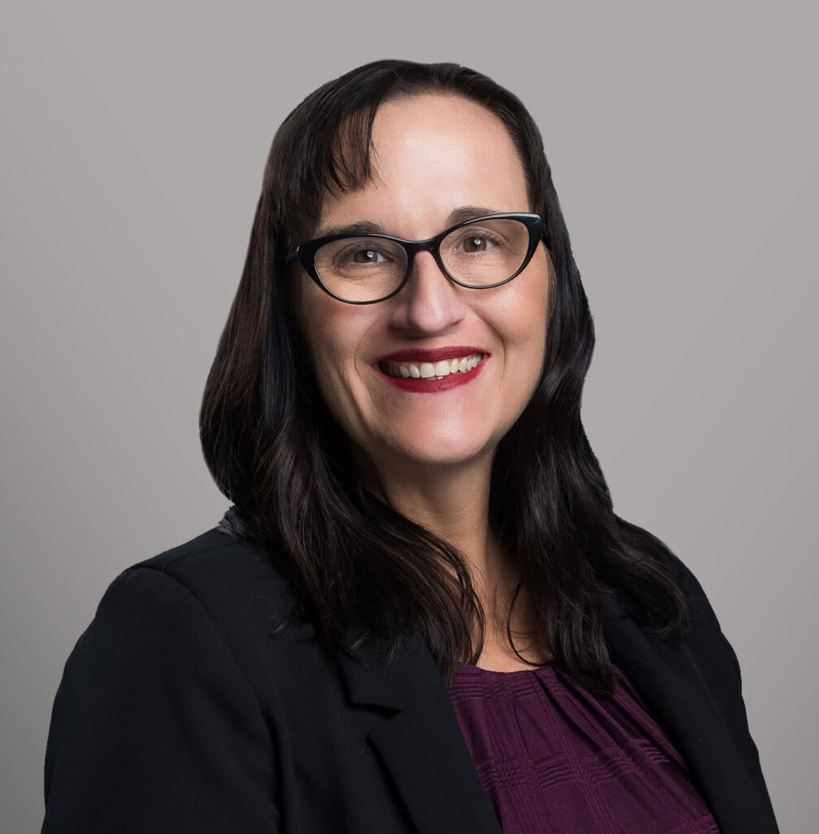
SHANNON S. PIERCE
SHANNON S. PIERCE
Pronouns: she/her
Director
Labor & Employment
Reno
P: 775.788.2260
F: 775.788.2279
spierce@fennemorelaw.com
Shannon practices primarily in the areas of employment defense and commercial litigation. Licensed in both Nevada and California, she has more than 20 years of experience litigating on behalf of management concerning claims of employment discrimination, wrongful termination, leaves of absence, and other traditional employment and commercial litigation.
On the cutting edge of both technology and the changing business culture, Shannon enjoys the creative process of partnering with clients, helping them comply with employment regulations and maintaining positive workplace environments. She helps her clients develop comprehensive strategies for preventing and defending claims filed by employees.
Shannon is also known for representing companies in offensive and defensive litigation concerning employee mobility, predatory workforce raiding, trade secret misappropriation, and restrictive covenant litigation. Her unique knowledge of computer forensics enables her to assist management in quickly identifying and addressing corporate data theft by employees.

EDUCATION
J.D., Santa Clara University School of Law
B.S., California Polytechnic State University, San Luis Obispo Order of the Coif
AREAS OF PRACTICE

OTHER EXPERIENCE

Aviation, Aerospace and Autonomous Systems Litigation
Labor & Employment Business Litigation

AWARDS AND HONORS
Best Lawyers in America®, Employment Law – Management, 2025 “Legal Elite,” Nevada Business Magazine, 2016-2020
Benchmark Litigation, Under 40 Hot list, 2018 Witkin Award, Employment Law

ARTICLES AND PRESENTATIONS
Author, “Workplace Speech as a Safety Issue: New Guidance from the Federal Bench,” Fennemore Blog, November 18, 2025
Author, “Pronoun War: What Trump EEOC’s Erasure of ‘Gender Ideology’ Means for Some Employers,” HR Daily Advisor, March 7, 2025
Author, “Pronouns: What Nevada employers need to know in a rapidly changing landscape,” Fennemore Article, February 13, 2025
Author, “FTC Says Noncompetes Are Over, Mostly, and Now Courts Will Decide,” HR Daily Advisor, July 10, 2024
Author, “Noncompetes Banned in the U.S.: What businesses need to know,” Northern Nevada Business Weekly, June 5, 2024
Interview, “Non-compete contracts under question,” ABC8, May 6, 2024
Featuring, “Sparks police officer First Amendment lawsuit pits employer rights vs. employee free speech, Fox 11, October 14, 2023
Co-Author, “Businesses using AI in hiring could be on the hook for discrimination as EEOC cracks down,” inBusiness, October 1, 2023
Co-Author, “SCOTUS Subtly Redefines the Landscape of Workplace Religious Accommodations,” HR Daily Advisor, August 23, 2023
Featuring, “Is Your Business Ready for EEOC’s Scrutiny of AI Hiring Technology?” HR Daily Advisor and AZ Big Media, July 5, 2023
Author, “Businesses using artificial intelligence in hiring could be on the hook for discrimination,” Free Press Point of View, July 1, 2023
Co-Author, “Disability Accommodations in Post-Pandemic Work-from-Home World,” HR Daily Advisor, June 14, 2022
Author, “5 keys to accommodating remote workers’ disabilities,” HR Laws, April 12, 2022
Quoted, “Vaccine reaction: What impacts might mandates have on Nevada employers?” Northern Nevada Business Weekly, November 15, 2021
Co-author, “Legislative Session Brings Key Changes to Nevada Non-Compete Law,” Fennemore Client Alert, June 14, 2021
Quoted, “What Rights Do Employers Have In Regards to Mask Mandate?” 2 News, May 16, 2021
Quoted, “Reno businesses react, change rules after CDC’s mask guidance,” News 4, May 14, 2021
Quoted, “Are vaccine incentives legal?” KTVN 2 News, April 16, 2021

Quoted, “Lawyer warns of risk in employee vaccination programs,” KOLO 8, March 18, 2021
Quoted, “The Abbi Agency Celebrates Women Leaders During Women’s History Month,” The Abbi Agency, March 16, 2021
Quoted, “Are COVID-19 vaccine incentives cause for discrimination?” Fox 11, Fox 4, March 14, 2021
Author, “Should COVID-19 vaccine be required at work?” Reno Gazette Journal, January 14, 2021
Quoted, “Reno attorneys, HR Experts weight in on concept of mandatory COVID vaccine for companies, employees,” Northern Nevada Business Weekly, December 28, 2020
Quoted, “Can employers require workers to vaccinate?” KOLO 8 News, December 7, 2020 Author, “Tips for evaluating job performance during pandemic,” HR Laws, September 29, 2020 Author, “Pondering George Floyd’s impact as workplaces reopen,” HR Laws, June 5, 2020 Editor, Nevada Employment Law Letter, June 4, 2020
Co-author, “Tips on returning employees to work after the pandemic,” Nevada Employment Law Letter, June 1, 2020
Co-author, “A refresher on Nevada personnel file rules in wake of COVID-19,” Nevada Employment Law Letter, June 1, 2020
Interview, “Face the State: Returning to work post-pandemic,” KTVN, May 20, 2020 Quoted, “Getting back to business safely,” KOLO 8 News, May 22, 2020
Interview, “Vegas restaurant removes COVID-19 waiver after pushback,” KTNV, May 11, 2020
Quoted, “Businesses Beginning to Reopen, But Not All Workers Ready to Go Back,” HR Daily Advisor, May 4, 2020
Co-author, “COVID-19: Health Plan Coverage For Furloughed Employees,” Fennemore Client Alert, March 26, 2020
Interview, “Families First Coronavirus Response Act and What It Means For Employers and Employees,” KKOH-AM, March 23, 2020
Co-author, “Understanding the Emergency Family Medical Leave Expansion Act and Emergency Paid Sick Leave in the Families First Coronavirus Response Act,” Fennemore Client Alert, March 20, 2020
Interview, “What’s Next for Local Businesses Closed by the Coronavirus?” KKOH News Talk, March 19, 2020
Co-author, “Frequently Asked Questions About the Coronavirus in the Employment Setting,” Fennemore Client Alert, March 17, 2020
Co-author, “Nevada AG Joins Push to Add ERA to U.S. Constitution,” HR Laws, February 13, 2020
Author, “Invite #MeToo Your Holiday Party,” Nevada Employment Law Letter, November 2019
Co-author, “Under The Radar: Mental Disability Buzzwords You Might Be Missing,” Nevada Employment Law Letter, October 2019
Co-author, “Can’t We All Just Eat Our Cake and Get Along?” Biz Nevada Magazine, October 2018

Author, “California Supreme Court Decision Announces a New Independent Contractor Test,” Fennemore Client Alert, May 9, 2018
Interview, “Power Pundit Panel,” Nevada Newsmakers, January 9, 2018
Quoted, “Pay Transparency Push Intensifies, Regardless of Politics,” Bloomberg Law Daily Labor Report, February 14, 2017
Quoted, “Attorney: Use ‘Common Sense’ When Asking for Time Off to Vote,” Las Vegas Sun,
November 4, 2016
Interview, “Paid Time Off to Vote,” KOLO 8 News, November 4, 2016
Quoted, “Shine Light on Pay Practices Strategically,” Bloomberg BNA, September 23, 2016
Co-author, “Offers of Judgement: Can the Prevailing Party Ever Recover Attorneys’ Fees in Federal Court?” Nevada Lawyer, September 2016
Author, “Family and Medical Leave: To Pay or Not to Pay and Closing the Gender Gap in Parental Leaves of Absence,” Bloomberg BNA Daily Labor Report, 2016

PROFESSIONAL AND COMMUNITY ACTIVITIES
Member, Executive Committee, Litigation Section, State Bar of Nevada Member, State Bar of Nevada
Member, State Bar of California
Member, Washoe County Bar Association

ADMISSIONS
California Nevada
U.S. Court of Appeals, Ninth Circuit

