
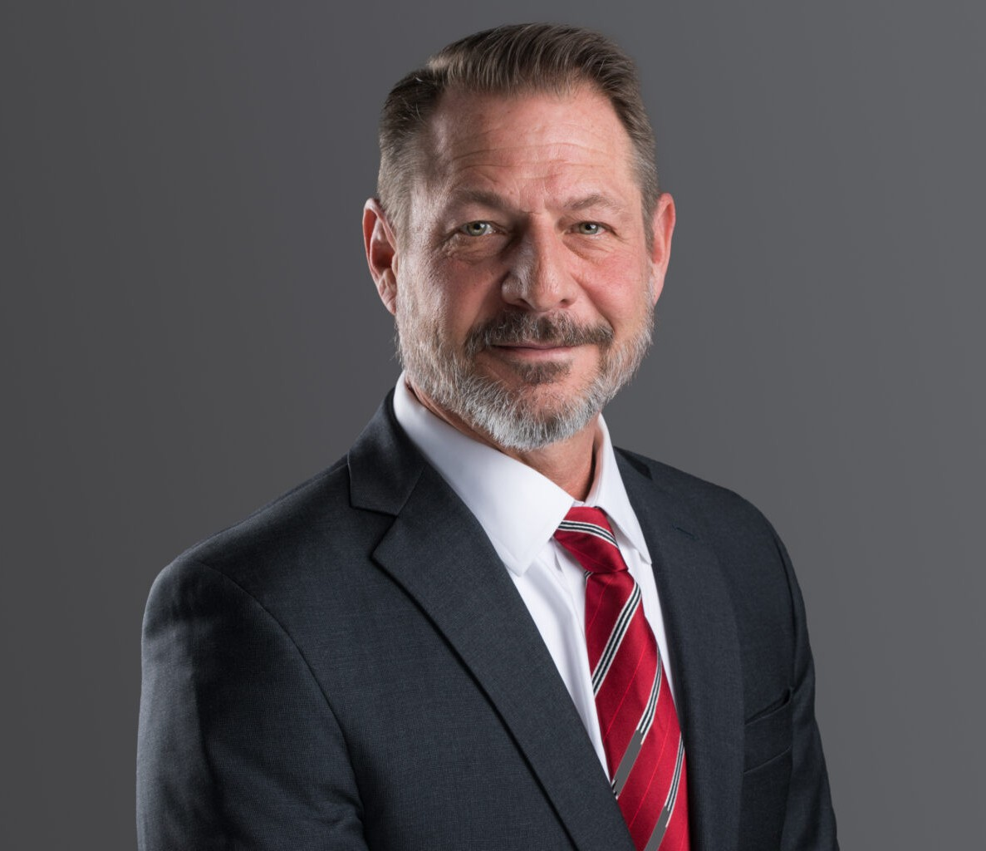
WILLIAM G. KLAIN
WILLIAM G. KLAIN
Director
Business Litigation
Phoenix
P: 602.916.5308
F: 602.916.5999
wklain@fennemorelaw.com
With an impressive career spanning over 30 years, Bill Klain represents his clients in a broad range of business disputes and in the formation and governance of corporations, partnerships and limited liability companies. A distinguished figure in the fields of Arizona commercial litigation and corporate law, Bill helps his clients successfully navigate and resolve their disputes involving business divorces and dissolutions, fiduciary breaches, business torts, sales contracts, buy-sell agreements, non-compete, non-solicitation, and non-disclosure agreements, civil appeals, and a variety of other complex civil legal matters. He is also an experienced private mediator and arbitrator, helping parties reach private resolutions of their civil matters,
Bill’s practice is defined by his dedication and commitment to his clients, impressive legal knowledge, and extensive courtroom and trial experience. His track record of success in commercial litigation has earned him a reputation as a formidable advocate for those
navigating the intricate landscape of business disputes. Bill’s deep understanding of corporate structures and governance enables his clients to establish and maintain their enterprises with
confidence.

Bill’s commitment to the legal profession is further exemplified by his active involvement in Arizona’s legal community. He serves as a member of the Arizona Judicial Council’s Committee on Superior Court and the State Bar of Arizona’s Civil Practice and Procedure Committee.
Previously, he chaired the Arizona Supreme Court’s Task Force on the Rules of Civil Procedure and served on the Court’s Advisory Committee on Rules of Evidence, Civil Justice Reform
Committee, and Business Court Advisory Committee, which developed Arizona’s Commercial Court. His involvement in these initiatives has provided Bill with a deep understanding of civil procedure and processes which he brings to bear for his clients in their matters.
With Bill Klain as your attorney, you gain a trusted legal partner who combines a wealth of experience with a tireless devotion to his clients. Whether you are facing complex litigation or require legal guidance in your business endeavors, Bill is an advocate and counselor you can depend on to protect your interests and guide you through every step of the legal process.

EDUCATION
J.D., University of Denver
B.A., University of Richmond

AREAS OF PRACTICE

OTHER EXPERIENCE

Business divorces and dissolutions Fiduciary breaches
Business torts Sales contracts
Buy-Sell agreements Civil appeals
Non-compete, non-solicitation, and non-disclosure agreements Various other commercial disputes
Receiverships Injunctions Trade Secrets
Failed commercial transactions Business Litigation

AWARDS AND HONORS
Best Lawyers in America®, Lawyer of the Year, Bet-the-Company Litigation, 2025 Super Lawyers: “Top 50 Arizona,” 2018, 2022-25; Business Litigation, 2012-2025
The Best Lawyers in America®, Commercial Litigation, Bet-the-Company Litigation, 2015-2025 AV-Preeminent® Rating, Martindale-Hubbell®
Top 100 Lawyers in Arizona, AZ Big Media, 2019, 2023, 2025-2026
“Top Lawyer,” Phoenix Magazine, 2022, 2023
Chief Justice’s Outstanding Contribution to the Arizona Courts Award, 2016 State Bar of Arizona “Volunteer of the Month,” April 2016
Arizona’s Finest Lawyers (Sustaining Member), 2014-present State Bar of Arizona “Member of the Year,” 2013
Award of Excellence, Scottsdale Bar Association, 2012
State Bar of Arizona: President’s Award (Contributions to Civil Practice and Procedure), 2008

ARTICLES AND PRESENTATIONS
Panelist, “AI: The Good, the Bad, and the Ugly,” State Bar of Arizona, January 2026
Co-Author, “Disgorgement Without Harm? Ninth Circuit Sets New Stakes for Public Companies and Investors Across the Western United States,” Fennemore Blog, November 24, 2025
Faculty, Arizona College of Trial Advocacy, State Bar of Arizona, July 2023 and 2025
Panelist, “Current Issues in Civil Litigation,” State Bar of Arizona Convention, June 2025

Author, “Arizona’s Commercial Court is tailor-made for business litigants,” Phoenix Business Journal, April 4, 2025
Featured, “Top 100 Lawyers,” AZBusiness Magazine, January 2025
Panelist, 2025 Civil Procedure Update, State Bar of Arizona, January 2025
Panelist, 2024 Civil Practice and Procedure Symposium, State Bar of Arizona, November 2024 Co-Author, “Seven Significant Differences Between Arizona and Federal Civil Procedure in
2024,” Fennemore Blog, June 20, 2024
“Meet the New Rules, (Not the) Same as the Old Rules ,” Arizona Attorney (State Bar of Arizona), December 2016
“Employee Misuse of Confidential Information,” December 2014
“A Long and Winding Road: How We Reached the 2014 Amendments,” Arizona Attorney (State Bar of Arizona), February 2014
“Fixing Holes Where the Rain Gets In: Seven Recent Arizona Civil Rule Amendments Dissected,” Record Reporter, February 2014
“Restrictive Covenants in Employment Agreements,” January 2014 “Customer List: Not Necessarily a Trade Secret,” November 2013
“Significant Differences Between Arizona and Federal Civil Procedure,” May 2013
“In a Lawsuit Arising from an Online Transaction, Where Should an Unhappy Buyer File Suit?”

September 2010
“Much Ado About Cullen: Twombly Not Arizona Law … for Now, ” Arizona Attorney (State Bar of Arizona), December 2009
“Asset Transfers and the Doctrine of Successor Liability,” August 2008
“Goodbye Peremptory Challenges: Underlying Rational, Experience to Date, and Strategic Considerations” (seminar co-chair and panelist), State Bar of Arizona “CLE by the Sea,” July 2023
“Sun Tzu and von Clausewitz in the Courtroom: Shaping the Battlefield through Dispositive Motions and Realizing that No Battle Plan Survives First Contact with the Enemy” (seminar cochair and panelist), State Bar of Arizona “CLE by the Sea,” July 2023
“’Toto, I’ve a Feeling We’re Not in Superior Court Anymore’: Contrasting State and Federal Trial Practice and How to Avoid Losing your Appeal Before it Starts” (seminar co-chair and
panelist), State Bar of Arizona “CLE by the Sea,” July 2023
“Civil Practice Update” (panelist), State Bar of Arizona, January 2023
Judicial Conference Advisory Committee on Evidence Rules (panelist), Fall Meeting, 2022 Civil Practice and Procedure Symposium (panelist), State Bar of Arizona, September 2022
“Complex Civil Litigation and Tier 3 Cases in Commercial Court: Everything You’ve Always Needed to Know, But Were Afraid to Ask!” (panelist), Maricopa County Bar Association,
October 2021
“Where the Rubber Meets the Road: How the 2017 and 2018 Civil Rules Changes Are Impacting Litigation” (panelist), State Bar of Arizona, January 2019
“War Stories: Senior Litigators’ Tales from the Trenches and Lessons Learned” (co-presenter), Maricopa County Bar Association Litigation and Real Estate Sections, December 2018

“2018 Civil Practice and Procedure Symposium” (seminar co-chair and panelist) State Bar of Arizona, April 2018
“Proportionality Takes Center Stage: The 2018 Revisions to the Arizona Rules of Civil Procedure” (co-presenter), Arizona Attorney General’s Office, Maricopa County Attorney’s Office, and
Sandra Day O’Connor Inn of Court, Spring 2018
“2018 Civil Justice Reforms: Case Management, ESI, and More” (panelist), State Bar of Arizona,
January 2018
“Meet the New Rules: The Restyled Arizona Rules of Civil Procedure” (seminar chair and panelist), State Bar of Arizona “CLE by the Sea,” July 2017
“Better, Faster, Cheaper: Case Management Reforms Coming to a Court Near You” (panelist),
State Bar of Arizona “CLE by the Sea,” July 2017
“The Changing Federal Rules: Proportionality and More” (seminar chair and panelist), State Bar of Arizona “CLE by the Sea,” July 2017
“Under New Management: Case Management Reform Rule Changes” (panelist), State Bar of Arizona Convention, June 2017
“Evidence Law Update” (panelist), State Bar of Arizona Convention, June 2015-2018
“2017 Civil Rules Changes: What Every Litigator Needs to Know” (co-presenter), Maricopa County Bar Association, February 2017
“A Time of Change: The 2017 ARCP Revisions” (panelist), Scottsdale Bar Association, February 2017
“2017 Civil Rules Update” (co-presenter), Arizona Attorney General’s Office, February 2017 “Evidence Law Update Reprise” (panelist), State Bar of Arizona, February 2017
“A Time of Change: The 2017 ARCP Revisions, and Proposals for 2018” (faculty member), State Bar of Arizona, January 2016
“Civil Law Updates” (faculty member), Arizona Judicial Conference, June 2016
“Where We’re Going, We Still Need Rules: Back to the Future in Civil Litigation” (panelist), State Bar of Arizona Convention, June 2016
“Sea Changes in the Federal and Arizona Rules of Civil procedure: The Winter 2016 Civil Rules Update” (panelist), State Bar of Arizona, February 2016
“2015 Amendments to the Arizona and Federal Rules of Civil Procedure,” Chair and Co-

Presenter, Arizona Attorney General’s Office, January 2016
“Civil Litigation Rules and Case Law Update” (panelist), State Bar of Arizona Convention, June 2015
“2015 Civil Practice and Procedure Symposium,” State Bar of Arizona, Seminar Chair and Panelist, April 2015
“The Rules They Are A-Changin’ (Again): 2015 Arizona Civil Rules Update,” State Bar of Arizona, Panelist, January 2015

PROFESSIONAL AND COMMUNITY ACTIVITIES
American Bar Association
State Bar of Arizona: Civil Practice and Procedure Committee (Chair, 2011-2014; member, 2000-present); Ethical Rule 1.15 Task Force; Business Section

Committee on Superior Court, Arizona Judicial Council (State Bar of Arizona Representative) Coach, Veritas Preparatory Academy Mock Trial Team, 2020-2025
Adjunct Professor, Civil Pretrial Practice, Sandra Day O’Connor College of Law, Arizona State University, 2018-2022
Advisory Committee on Rules of Evidence, Arizona Supreme Court, 2012-2018 Committee on Civil Justice Reform, Arizona Supreme Court, 2017
Task Force on the Arizona Rules of Civil Procedure, Arizona Supreme Court: Co- Chair, 2014-2016
Business Court Advisory Committee, Arizona Supreme Court, 2015 Commercial Court Review Committee, Arizona Supreme Court, 2018
Case Management and Trial Setting Task Force, Administrative Office of the Court, 2013 Commercial Court Practices and Procedure Committee, Maricopa County Superior Court Civil Study Committee, Maricopa County Superior Court
Committee on Civil Rules of Procedure for Limited Jurisdiction Courts, Arizona Supreme Court, 2011-2012
State Bar of Colorado
Past President, Scottsdale Bar Association Member, Maricopa County Bar Association Thurgood Marshall Inn of Court

ADMISSIONS
Arizona Colorado
U.S. District Court, District of Arizona
U.S. Court of Appeals, Ninth Circuit

