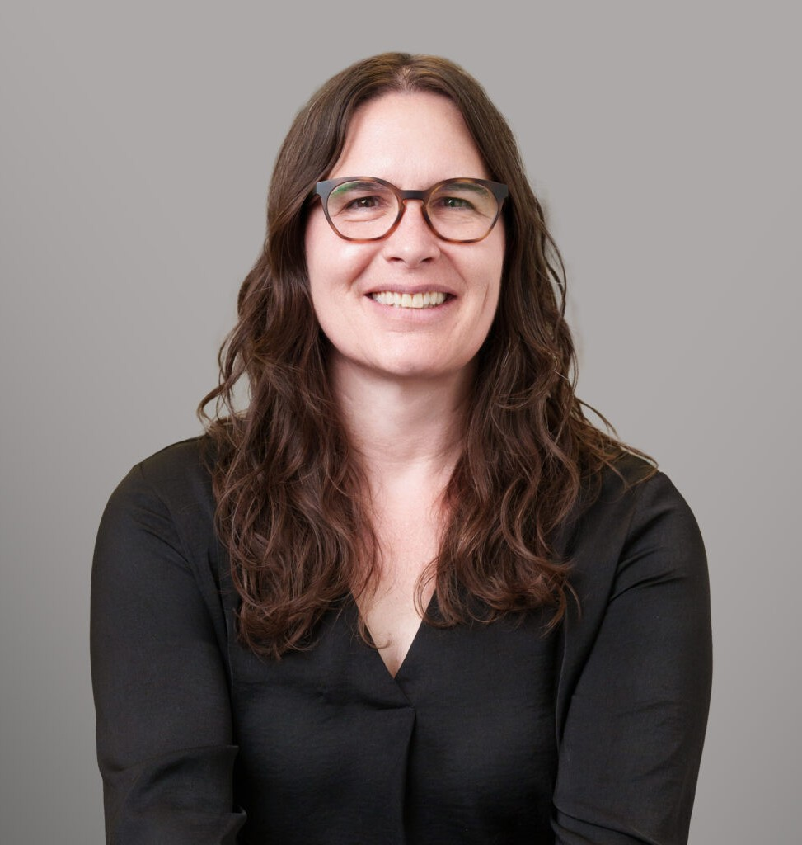

ALYCIA MOSS
Director
Immigration

Coeur d’Alene
P: 208.956.0135
P: Idaho Immigration: 208-956-0135 Washington Immigration: 509-413-1004
F: 208.956.0139
amoss@fennemorelaw.com

ALYCIA MOSS
Alycia Moss is a Director in Fennemore’s Immigration practice group, focusing her practice on guiding businesses, families, and individuals through the complexities of U.S. immigration law. With more than a decade of immigration experience, she has represented clients before the United States Citizenship & Immigration Services (USCIS), Immigration and Customs Enforcement (ICE), Customs and Border Protection (CBP), the Executive Office of Immigration Review (EOIR), the Board of Immigration Appeals (BIA), the Administrative Appeals Office (AAO), the Board of Alien Labor Certification Appeals (BALCA), and federal courts.
Alycia assists employers across all industries with petitions, visas, immigration compliance, and labor certifications, as well as guiding entrepreneurs and advocating for individuals seeking family- and employment-based immigration solutions. Before joining Fennemore, Alycia built and managed a successful immigration practice. She is licensed to practice law in Idaho and
Washington, as well as Canada, where she is a Barrister & Solicitor.

Alycia earned her law degree from the University of Idaho College of Law, where she was vice president of the student government, a law clerk for the U.S. State Department’s Ambassador for War Crimes Issues, and a published author in the Michigan State International Law Review. She graduated magna cum laude from the University of Colorado at Denver with a degree in history, and also studied abroad at St. Petersburg State University in Russia and at Skope Law School in
Macedonia.

A dedicated member of the legal and business communities, Alycia has held leadership roles with the American Immigration Lawyers Association (AILA), including serving as Chair of the Eastern Washington Committee, Chair of the Idaho Chapter, Chair of the Idaho Congressional Liaison Committee, and as a member of the AILA Board of Governors. She is also active in numerous bar associations and civic organizations.
Beyond the office, Alycia enjoys the outdoors and spending time with her daughters. If she were not practicing law, she would happily be leading trips as a backpacking guide.

EDUCATION

J.D., University of Idaho College of Law

NW Institute for Dispute Resolution, Criminal & Civil Meditation Programs B.A., University of Colorado, magna cum laude

AREAS OF PRACTICE
Immigration Cannabis Business

AWARDS AND HONORS
Tribute to Women and Industry (TWIN) Award, 2025 Denise O’Donnell Day Pro Bono Award, 2017
Spirit of the Class Award, University of Idaho College of Law, 2005

ARTICLES AND PRESENTATIONS
Co-Author, “New Rules for H1-B Visas – Employers Take Note,” Greater Phoenix InBusiness Magazine, March 2026
Co-Author, “Fiscal Year 2027 H-1B Cap Lottery: What Employers Should Know (Quick Guide),” Fennemore Blog, February 26, 2026
Panelist, “Balancing Life Obligations with Your Paralegal Career,” American Immigration Lawyers Association, January 30, 2026
Co-Author, “What Canadian Citizens Should Know Before Traveling to the United States,” Fennemore Blog, January 30, 2026
Presenter, “Overview of Hernandez v. Bondi,” University of Idaho, January 27, 2026
Co-Author, “H-1B Cap Lottery Update: Higher Wages Get More “Entries” Starting FY 2027,” HRO Today, January 20, 2026
Co-Author, “How hiring skilled foreign talent just got more complicated for employers,” AZ Big Media, January 19, 2026
Co-Author, “H-1B Cap Lottery Update: Higher Wages Get More “Entries” Starting FY 2027,” Fennemore Blog, January 13, 2026
Co-Author, “Business Immigration in 2025–2026: Key Takeaways for Employers,” Fennemore Blog, December 9, 2025
Author, “Federal Court Reverses EB-5 Fee Increases, Re-shifting the Investor Visa Landscape,” Fennemore Blog, December 1, 2025
Author, “What Employers Need to Know About the $100K H-1B Visa Fee,” Fennemore Blog, December 1, 2025
Author, “A Guide to the Trump Gold Card Program,” Fennemore Blog, November 7, 2025
Author, “Client Alert: What Employers Need to Know About the $100K H-1B Visa Fee,” Fennemore Blog, September 23, 2025
Speaker/Contributor, Gonzaga Law School’s Immigration Clinic Speaker/Contributor, University of Idaho’s Immigration Clinic

Presenter, Idaho Judicial Conference, “Crossroads of Justice: How Immigration Law Intersects with State Courts”, 2025
Presenter, SCG Legal Conference, “Coming to America: Immigration Options”, 2023
Presenter, “The Intersection of Criminal Law and Immigration”, Kootenai County Public Defender’s Office, 2019
Speaker, Access to Justice Conference, Spokane, WA, 2019
Presenter, “Human Resources regarding I-9 Compliance”, Idaho Department of Labor, 2018 Speaker, 2nd Annual AILA Idaho Chapter Annual Conference, 2018
Presenter, “CLE Navigating Immigration Consequences and Complications”, Spokane County Bar Association, 2019
Presenter, H-2B Training, Centro de Comunidad y Justicia, 2019 Author, “Strength in Numbers,” The Inlander, July 12, 2018
Presenter, “How to become a citizen”, Idaho League of Women Voters, 2018
Presenter, I-9 Compliance, Human Resources Network of North Idaho (HRNNI) Meeting, 2018 Speaker, Families Together Rally, Coeur d’Alene, Idaho, 2018
Presenter, Spokane County Bar Association CLE, 2017 Speaker, First District Bar Association, 2017
Presenter, Idaho Association of Criminal Defense Attorneys Conference, 2017 Speaker, “Immigration Dilemmas in Our Backyard,” Progressive Dinners, 2017 Speaker, Kootenai County Democrat Club, 2017
Speaker, Boundary County Farmworkers Know Your Rights Event, 2017
Presenter, Immigration Law CLE, First District Bar Association, Coeur d’Alene, Idaho, 2017

PROFESSIONAL AND COMMUNITY ACTIVITIES
Member, American Immigration Lawyers Association (AILA) Member, Washington and Idaho Regional Sections of AILA Member, Idaho State Bar Association
Member, Idaho First District Bar Association Member, Washington State Bar Association Member, Kootenai County Chamber of Commerce Member, John P Gray Bench Bar Forum
Member, Idaho Academy for Leadership for Lawyers (IALL), Class of 2018-2019
Volunteer, Annual Lobbying of Congress regarding immigration laws (National Day of Action) Volunteer, Alternative Dispute Resolution, 2005
Board Member, Share Our World
Volunteer, Idaho Volunteer Lawyer’s Program Volunteer, Idaho State Bar Professional Conduct Board Idaho State Bar Exam Grader

Committee Chair, AILA Eastern Washington
Member, AILA Washington Congressional Liaison Committee Chair, AILA Idaho
Co-Chair, AILA Idaho Congressional Liaison Committee Co-Chair, AILA Idaho’s Conference Committee Member, AILA Board of Governors
Volunteer, Annual Citizenship Days, Washington and Idaho

ADMISSIONS
Idaho Washington
Idaho Federal District Court 9th Circuit Court of Appeals
U.S. Supreme Court
Canada, Barrister & Solicitor

