
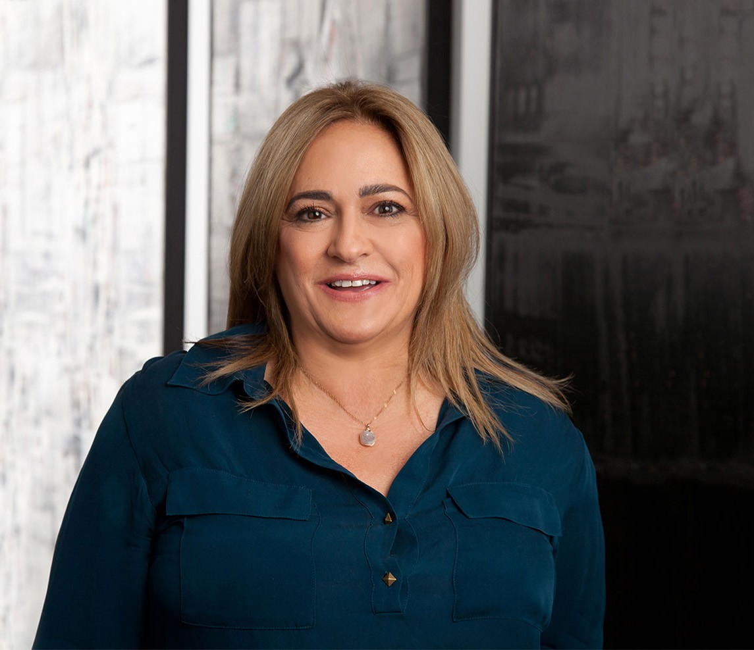
BRUNA E. PEDRINI
BRUNA E. PEDRINI
Director
Labor & Employment
Phoenix
P: 602.916.5487
F: 602.916.5687
bpedrini@fennemorelaw.com
Bruna focuses her practice on education law and employment law, with a particular emphasis on compliance, administrative investigations, accessibility and anti-discrimination issues. She brings extensive, high-level experience advising educational institutions and employers, including K-12 public charter schools, colleges, universities, and corporate clients, on compliance with
federal, state, and local laws such as the ADA, Title IX, Title VI, and Title VII and Fair Housing laws.

Bruna represents educational institutions in a wide range of matters, including student and
employment law matters involving discrimination and retaliation complaints, sexual misconduct investigations, policy development and implementation, and compliance reviews. She also
advises employers on workplace accessibility, anti-discrimination policies, and diversity initiatives, ensuring compliance with laws governing fair treatment in hiring, promotion, and workplace
practices.

In addition, Bruna conducts training for executives, managers, and employees on anti-discrimination and accessibility laws, as well as workplace diversity and inclusion strategies.
Bruna is skilled in Alternative Dispute Resolution (ADR) methods, including mediation and
arbitration, helping clients resolve conflicts efficiently while minimizing costs and preserving relationships. Her innovative problem-solving approach helps employers and educational institutions create inclusive environments and address areas for improvement.
Bruna has written federal grants and administered and managed compliance with federal grant standards for state and local entities and subcontractors. In her role as counsel for public and private educational institutions she handles relocation support and stipend payments. She also advises in contract and procurement issues related to the granting and disbursement of funds and reporting requirements related to federal grant implementation.
Previously, Bruna served as Chief Counsel of the Civil Rights and Conflict Resolution Section for the Arizona Attorney General’s Office and was a Visiting Professor at the Sandra Day O’Connor College of Law.

EDUCATION
J.D. University of Minnesota Law School
M.A. University of California, Los Angeles

B.A. University of Iowa
Associate Editor, Minnesota Law Review, 1984-1987

AREAS OF PRACTICE
Labor & Employment Real Estate
ADA and Accessibility

AWARDS AND HONORS
AV® Preeminent™ Peer Review Rated (the highest rating available), by Martindale-Hubbell
Best Lawyers in America®, Labor Law – Management, 2025

ARTICLES AND PRESENTATIONS
Co-Author, “Update: U.S. Department of Education Final TITLE IX Regulations Effective August 1 Increase Scope Against Sex Discrimination,” Fennemore Blog, September 11, 2024
Co-Author, “Update: U.S. Department of Education Final TITLE IX Regulations Effective August 1 Increase Scope Against Sex Discrimination, Key Facts About TITLE IX Training,” Fennemore Blog, September 11, 2024

Featuring, “Thursday Thoughts,” Fennemore Blog, October 5, 2023
Co-Author, “Businesses using AI in hiring could be on the hook for discrimination as EEOC cracks down,” inBusiness, October 1, 2023
Featuring, “9th U.S. Circuit ruling: AZ students can be disciplined for certain off-campus, social media posts,” Arizona Capitol Times, KJZZ and AZ Central, January 13, 2023
Quoted, “Self-Checkouts Often Inaccessible to Disabled Shoppers,” The Food Institute, December 14, 2022
Quoted, “Are Coronavirus Mask Exemption Cards Real? Experts Weigh In,” Best Life, June 25, 2020
Co-author, “COVID-19: Health Plan Coverage For Furloughed Employees,” Fennemore Client Alert, March 26, 2020
Co-author, “Understanding the Emergency Family Medical Leave Expansion Act and Emergency Paid Sick Leave in the Families First Coronavirus Response Act,” Fennemore Client Alert, March 20, 2020
Speaker, “Implicit Bias Training,” National Association of Charter School Lawyers, April 2019
Speaker, “Welcome to ADA Compliance: Serving Your Guests and the Animals That Serve Them,” AAHOA Convention, April 2019
Speaker, “Service Animals: The Who, What, When, Where, Why and How,” Asian American Hotel Association Webinar, June 26, 2018
Speaker, “Arizona Americans with Disabilities Act and Fair Housing,” West Valley Realtor’s Association, WeMarr, November 2017
Speaker, “What Your Business Needs to Know About Changing ADA Compliance Law,” Fennemore, June 14, 2017

Speaker, “WHO, WHAT, WHERE, WHEN: The Future of ADA Litigation and Legislation” Fennemore Labor and Employment Seminar, May 4, 2017
Speaker, “ADA Compliance,” AZ Bankers Association April Seminar, April 18, 2017
Panelist, “ADA Title III Accessibility Litigation – A Panel Discussion,” ADA Title III Accessibility Litigation Webinar, January 2017
Author, “Fair Housing and Domestic Violent Alert: Nuisance Laws, Eviction Policies and Emergency Services Calls Policies May Be Discriminatory,” Fennemore Client Alert, November 16, 2016
Author, “Fair Housing Issues For Group Homes and State and Local land Use Laws,” Fennemore Client Alert, November 15, 2016
Author, “Fight Over the Enforcement of the ADA and AZDA Continues to Heat Up,” Fennemore Client Alert, October 5, 2016
Panelist, “ADA Lawsuits and Their Impact on the CRE Industry,” BOMA Greater Phoenix and NAIOP, October 2016
Speaker, “Empower to Evaluate,” ADA Compliance Seminar, September 29, 2016

PROFESSIONAL AND COMMUNITY ACTIVITIES
Member, State Bar of Arizona Member, American Bar Association
Member, Maricopa County Bar Association Member, Association for Conflict Resolution Member, Arizona Dispute Resolution Association
Member, Maricopa Alternative Dispute Resolution Association
Conducted gang mediations and coordinated “Not in Our State” anti-harassment and anti-discrimination program

ADMISSIONS
Arizona
U.S. District Court District of Arizona

LANGUAGE
Italian (Fluent)

