
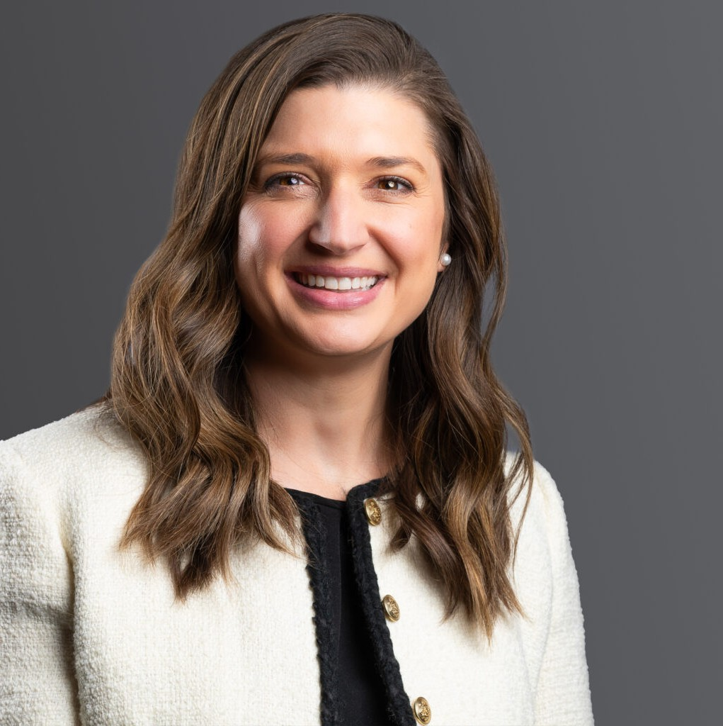
CALEENA S. BRAIG
CALEENA S. BRAIG
Director & Director of Legal Talent Acquisition

Business Litigation
Denver
P: 303.813.3808
F: 303.291.3201
cbraig@fennemorelaw.com
Caleena Braig is a seasoned trial attorney in Fennemore’s Business Litigation practice group, where she represents clients in a broad spectrum of civil litigation matters. Her practice focuses on breach of contract disputes, employment issues—including wrongful termination—real estate disputes, and complex business litigation. As the Director of Legal Talent Acquisition, Caleena handles Director recruitment and plays a key role in the firm’s strategic growth through mergers and combinations.
Caleena works closely with clients to proactively manage risk, offering strategic advice to prevent litigious disputes or reach favorable settlements. When litigation is necessary, she is a formidable advocate in jury and bench trials in both state and federal courts, as well as in
arbitration. Caleena’s experience spans the full litigation cycle from discovery and depositions to motion practice, trial preparation, and courtroom advocacy.
Before joining Fennemore, Caleena practiced at a regional litigation firm, where she defended a Fortune 500 company in complex, multi-jurisdictional matters. She also served as a trial attorney at a Dallas-based litigation defense firm, trying numerous cases to verdict in both state and federal court.
Caleena is actively engaged in the community and has held leadership and volunteer roles with several nonprofit and civic organizations. Her involvement includes service with the Alzheimer’s Association, the Association of Junior Leagues International, and Mile High 360, among others.

EDUCATION
J.D., Baylor University B.S., University of Texas

AREAS OF PRACTICE
Business Litigation Labor & Employment

AWARDS AND HONORS
Best Lawyers® Ones to Watch, 2022 – 2024
Colorado Super Lawyers®, Rising Star, 2019, 2022 – 2026 Texas Super Lawyers®, Rising Star, 2018

ARTICLES AND PRESENTATIONS
Co-Author, “Business Contracts in 2025: Straightforward Answers for Nuanced Situations,” Fennemore Blog, August 14, 2025
Author, “Advice for Women in Male-Dominated Fields,” Firm Blog, March 2022
Quoted, “Supreme Court Ruling Likely Spells the End for Vaccine-or-Test Federal Mandates at Large Businesses, But Numerous Caveats Apply”
Corporate Compliance Insights, January 2022
Author, “OSHA’S Emergency Temporary Standard is Postponed Pending Review,” Firm Blog, January 2022
Author, “Preparing To Meet OSHA’s Est Rulings Pending Court Ruling On Constitutionality,” HR Legal & Compliance, December 2021
Author, “What does OSHA’s EST ruling mean for builders?” Colorado Builder, November 2021
Author, “Preparing to Meet OSHA’s EST Rulings Pending Court Ruling on Constitutionality,” Law Week Colorado, November 2021
Author, “While Courts Consider OSHA’s Vaccine-or-Test Mandate ETS, Businesses Are Caught in Limbo,” Corporate Compliance Insights, November 2021
Co-author, “Silver Linings Provide Optimistic Future for Litigation Post-Pandemic,” ColoradoBiz, September 2021
Author, “Keep an Eye Out, Employers: The Colorado Legislature Proposed Changes to Colorado Anti-Discrimination Statute,” Law Week Colorado, May 2021
Author, “8 Things You Need to Know About Employee Vaccinations,” Colorado Builder, March 2021
Co-author, “How the Pandemic Will Impact Litigation Beyond 2021,” ColoradoBiz, December 2020
Author, “Identifying the Legal Boundaries of Employer’s GPS Use,” Texas Lawyer, December 2015
Quoted, “Wellness Programs Due for Privacy Scrutiny, Experts Say, ”HealthcareDive, October 2015
Quoted, “Employers take note: Americans with Disabilities Act payouts soaring in Texas,” Dallas Business Journal, December 2014
Speaker, “Dealing with a Snap Chatterbox: Social Media Use in Litigation,” Texas Association of Defense Counsel Annual Meeting, September 2017
Speaker, “The World of Veterinary Malpractice Claims,” Zurich Insurance, June 2017 Panelist, “Medical Malpractice isn’t Dead,” Dallas Bar Association CLE, 2016

Speaker, “Defending a Claim for Malpractice and Board Actions: Defense, Damages, and Success,” Zurich Insurance, September 2015

PROFESSIONAL AND COMMUNITY AFFILIATIONS
Member, Colorado Bar Association Junior League of Denver
Board Member, Mile High 360 Member, Texas Bar Association Member, American Bar Association

ADMISSIONS
Colorado Montana Texas
U.S. District Court – Eastern District of Texas
U.S District Court – District of Colorado
U.S. District Court – Northern District of Texas
U.S. District Court – Southern District of Texas
U.S. District Court – Western District of Texas

