
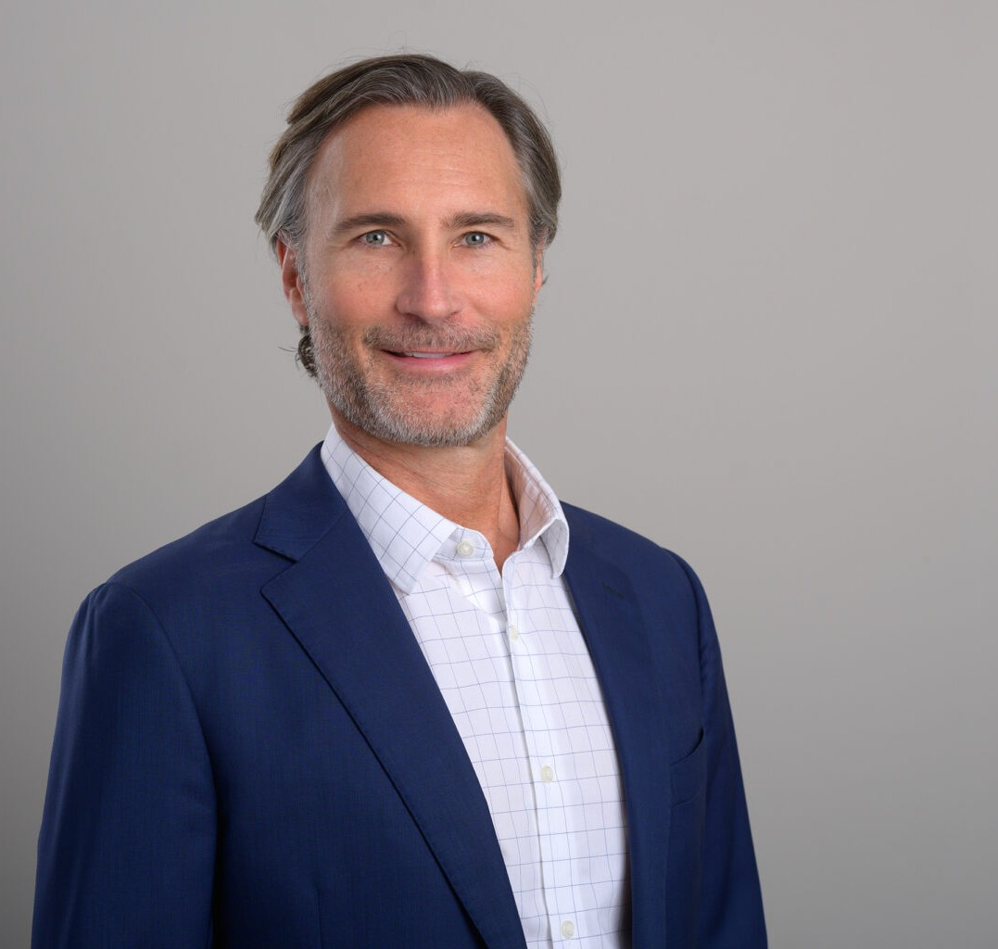
CHRISTOPHER V. HAWKINS
CHRISTOPHER V. HAWKINS
Director
Financial Restructuring
San Diego
P: 619.595.3218
F: 619.231.4372
chawkins@fennemorelaw.com
Christopher V. Hawkins practices in the Insolvency and Commercial Bankruptcy, Business
Transactions, and Commercial and Business Litigation practice groups. Within these practice areas, he represents a variety of corporate debtors, bankruptcy trustees, receivers, assignees, lenders, trade creditors, asset purchasers and other parties in interest in all aspects of commercial insolvency, including bankruptcies, receiverships, assignments for the benefit of
creditors, and out-of-court workouts. He also represents clients with non-insolvency transactional matters, including advising on real estate sales, leases and financings, entity formation and corporate governance matters. Mr. Hawkins is a frequently published author and speaker on topics related to bankruptcy, receivership, assignment for the benefit of creditors and other insolvency matters, including having served as an author for Westlaw’s Commercial Finance Newsletter.

EDUCATION
J.D., The University of Texas at Austin, School of Law B.A., Vanderbilt University

AREAS OF PRACTICE
Financial Restructuring Business & Finance Business Litigation
Emerging Businesses & Technologies Real Estate
Mergers & Acquisitions Cannabis Business

AWARDS AND HONORS

Best Lawyers in America® “Lawyer of the Year” – Bankruptcy and Creditor Debtor Rights/Insolvency and Reorganization Law, San Diego, 2025
Best Lawyers in America® “Lawyer of the Year” – Bankruptcy and Creditor Debtor Rights/Insolvency and Reorganization Law, San Diego, 2023
Best Lawyers in America® “Lawyer of the Year” – Bankruptcy and Creditor Debtor Rights/Insolvency and Reorganization Law, 2020
Super Lawyer, Bankruptcy, 2020-2026
San Diego Daily Transcript’s 2013 Top Attorney Nominee, Corporate Transactional

REPRESENTATIVE MATTERS

Insolvency and Commercial Bankruptcy

Represented the Receiver in a state court receivership involving a historic building in downtown San Francisco burdened with a complex ownership structure, outdated, CC&R’s, and financial distress brought on by both.
Represented a private lender in the jointly-administered Chapter 11 cases of a developer of ultra-high end homes.
Represented the Assignee in assignment for the benefit of creditors of a large online retailer (Zulily) which involved multiple asset sales and combined debt in excess of $100,000,000.
Represented a nursing home owner-operator in its Chapter 11 bankruptcy sale.
Represented the buyer in its purchase of LLC membership interests holding nationally franchised gym facilities.
Represented a federal equity receiver in a regulatory receivership brought by the Federal Trade Commission against a group of online automation companies.
Represented an automated vehicle technology company in its sale through an Assignment for the Benefit of Creditors.
Represented a Top 50 national craft brewer (Modern Times) in the sale of its business as a going concern through a consensual receivership.
Represented an IOT network technology company in its successful reorganization under Chapter 11.
Represented the secured lender in an Article 9 foreclosure of its collateral under a loan facility to an international restaurant organization.
Represented a Receiver appointed by the Delaware Chancery Court in the receivership of a genetic testing company.
Represented the first Chapter 11 debtor to confirm a Subchapter V Small Business Reorganization plan in the Southern District of California.
Represented the sellers of a local brewery in a workout with the buyer involving carry-back financing, avoiding an Article 9 foreclosure.
Represented a satellite communication company in connection with its efforts to “bankruptcy proof” various transactions involving dark fiber being used to build a nationwide network.
Represented the Assignee of a franchised organic snack food vending machine company in its liquidation through an assignment for the benefit of its creditors.

Represented the Assignee of a cosmetics company in its sale to a private equity fund through an assignment for the benefits of its creditors.
Represented a State Court Receiver operating Burger King franchises in litigation.
Represented the Creditors Committee in the Chapter 11 reorganization of a medical device manufacturer.
Represented a social media content arbitrage company in connection with the Chapter 7 bankruptcy of its principal.
Represented the lender in the nonjudicial foreclosure of a deed of trust encumbering real estate.
Represented a non-profit habitat preservation organization in connection with its acquisitions from various bankruptcy estates of large tracts of undeveloped land for conservation
purposes.
Represented a commercial landlord in the Chapter 11 bankruptcy of Rock Bottom Brewery.
Represented a member of the Official Committee of Unsecured Creditors in the Chapter 11 sale of FTD.
Represented a large group of wildfire victims in the Chapter 11 reorganization of Pacific Gas & Electric.
Represented the San Diego Metro Transportation Service in the Chapter 11 reorganization of the “Desert Freight Line” Railroad.
Represented the court-appointed Special Master in litigation between the owners of a large vertically integrated seed-to-sale cannabis operation.
Represented the lender in making a secured loan to a call-center provider.
Represented a home healthcare and hospice nonprofit in connection with its insolvency. Represented a Federal Court Receiver in the liquidation of an electronic cigarette company.
Represented a b-2-b jewelry company in an out-of-court workout with its senior secured lender.
Represented the Creditors’ Committee in the Chapter 11 reorganization cases of the Southern California franchises of Party City, which cases resulted in the company’s successful emergence from bankruptcy under a confirmed plan.
Represented a regional bank in numerous commercial collection and insolvency matters. Represented a national consumer financial services company in its Chapter 11 reorganization. Represented a commercial landlord in the Sports Authority Chapter 11.
Represented the principal of a nutraceutical/supplement company in connection with the section 363 sale of the company.
Represented a secured creditor in the Chapter 11 reorganization of a national fast food franchise.
Represented a snack food company in its sale as a going concern through an assignment for the benefit of creditors.
Represented a State Court Receiver in the receivership of a $50,000,000 commercial property in Northern California.

Represented the post-confirmation trustee in the jointly-administered Chapter 11 bankruptcy cases of a group of national financial services companies.
Represented a large national defense contractor in its Chapter 11 reorganization.
Represented a Federal Court Receiver in a real estate Ponzi scheme receivership commenced by the Securities Exchange Commission.
Represented the Creditors’ Committee in the Chapter 11 case of a water meter component manufacturer.
Represented an automotive parts wholesaler in its sale as a going concern through an assignment for the benefit of creditors.
Represented a national health insurance and services provider in connection with its administrative claim in the Chapter 11 case of a hospice facility.
Represented the Chapter 7 trustee in the bankruptcy liquidation of a group of 14 timeshare companies, including several hundred million dollars of notes receivable collateral.
Represented the principal of a real estate holding consortium in connection with an out-of-court workout with the senior secured lender.
Represented a State Court Receiver in connection with the liquidation of a group of health care provider entities.
Represented the purchaser of a large portfolio of distressed debt in the liquidation of the real estate acquired thereunder.
Represented the debtor-in-possession in a Chapter 11 reorganization of a professional services company.
Represented a strategic buyer in connection with its purchase of a tile company through a section 363 sale.
Represented a government contracting construction company in its liquidation through a Chapter 7 bankruptcy.
Represented a State Court Receiver in litigation over debt secured by real property, and the related Chapter 11 reorganization cases of several hundred restaurant franchises.
Represented the bankruptcy examiner in the Chapter 11 reorganization of a San Diego entertainment business.
Represented the Chapter 7 trustee in the winding up and liquidation of a large Nevada tax advice and audit advisory services company that was the target of legal attacks by the Internal Revenue Service and the Federal Trade Commission, which resulted in significant criminal and financial liability imposed upon the corporation’s principals and control-persons.
Represented the Chapter 11 trustee in a cross-border bankruptcy case involving the liquidation of a portfolio of property, including interests in the Mexico real estate holdings of a failed American development company.
Represented the founder and principal of a surgical device design company in the company’s Chapter 11 bankruptcy case.
Represented a priority creditor in the preservation and collection of a nondischargeable judgment through a structured settlement.

ARTICLES AND PRESENTATIONS
Presenter, “The ABC of ABCs,” San Diego Bankruptcy Forum, September 9, 2025

Presenter, “Swimming Smoothly Around the Rocky Shoals of Litigation,” California Bankruptcy Forum’s Annual Conference, May 18, 2024
Presenter, San Diego Craft Beer Con, SD Brewers Guild, August 8, 2023
Presenter, “Navigating a Challenging Market,” California Craft Brewers Association’s California Craft Beer Summit, March 2023
Presenter, California Craft Beer Summit, California Craft Brewers Association, March 21, 2023
Presenter, “What You Need to Know About the Small Business Reorganization Act,” San Diego Building Industry Supplier Credit Group, January 25, 2023
Presenter, “What You Need to Know About the Small Business Reorganization Act,” National Association of Credit Management’s San Diego Building Industry Supplier Credit Group
Meeting, January 2023
Presenter, “Tap Into Knowledge: Financial Distress in the Craft Beer Industry,” San Diego Brewers Guild, December 2022
Presenter, “The Uniform Commercial Code (UCC) in Bankruptcy,” San Diego County Bar Association, May 5, 2022
Author, “In re Astria Health,” Commercial Finance Newsletter by Westlaw, 2021
Author, “In re Porter,” Commercial Finance Newsletter by Westlaw and in the Insolvency Law Committee eBulletin by the California Lawyers Association, 2021
Author, “Bankruptcy Court Finds Cross-Collateralization Provision in Separate Loan Transactions Valid and Effective (In re Porter),” Commercial Finance Newsletter by Westlaw and in the Commercial Transactions Committee eBulletin by the California Lawyers Association, 2020
Second Case Review of “MOAC Mall Holdings LLC. v. Transform Holdco LLC (In re Sears Holdings Corporation),” Commercial Finance Newsletter by Westlaw and in the Commercial Transactions Committee eBulletin by the California Lawyers Association, 2020
Case Review of “MOAC Mall Holdings LLC. v. Transform Holdco LLC (In re Sears Holdings Corporation),” Commercial Finance Newsletter by Westlaw and in the Commercial Transactions Committee eBulletin by the California Lawyers Association, 2020
Author, “Creditor’s Veil-piercing Claim Not Barred by Prior Receivership. Aaron Carlson Corporation v. Cohen,” Commercial Finance Newsletter by Westlaw, 2019 WL 4282064
Author, “PG&E Chapter 11: Burning Topics for Real Estate Lawyers,” 38th Annual Real Property Law Section Spring Conference, May 2019
Author, “In an Economic Downturn, It Pays to Be in the Golden State,” Los Angeles Daily Journal, November 5, 2008: 7
Author, “Pre-Petition Security Interests and Post-Petition Advances – Beware All Ye Who Enter,” California Bankruptcy Journal, Volume 28, Number 3, 2006
Author, “Calculation of Holdover Rent in a Claim for Commercial Lease Rejection Damages,” The State Bar of California’s Business Law News, Volume 2, 2005
Author, “The Rooker-Feldman Doctrine and Preclusion in a Nondischargability Proceeding – Be Careful Where You Draw the Lines,” California Bankruptcy Journal, Volume 28, Number 1, 2005

PROFESSIONAL AND COMMUNITY ACTIVITIES
Member, San Diego Bankruptcy Forum (Past President) Member, San Diego Receivers Forum (Past President)

Member, Turnaround Management Association, San Diego Chapter Liaison Member, Business Law Section, California Lawyers Association
Member, American Bankruptcy Institute Member, Nature Conservancy
Member. Escondido Creek Conservancy Member, Surfrider Foundation
Former Author, Westlaw’s Commercial Finance Newsletter Member, California Bankruptcy Forum (Past President)
Member, California Receiver’s Forum (Past Officer and Director) Member, San Diego County Bar Association
Former Mentor, Crawford High School Academy of Law

ADMISSIONS
California Texas
U.S. District Court, Southern District of California
U.S. District Court, Central District of California
U.S. District Court, Eastern District of California
U.S. District Court, Northern District of California
U.S. District Court, Southern District of Texas

