
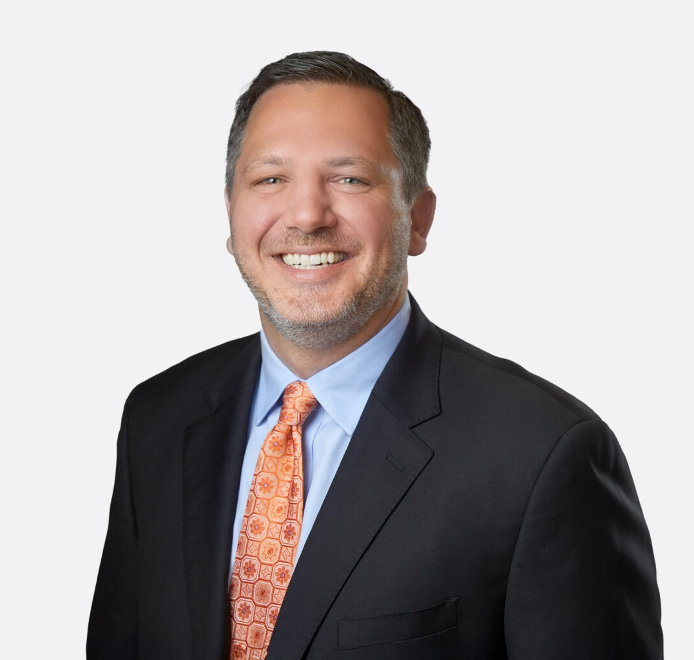
CHRISTOPHER WALTHER
CHRISTOPHER WALTHER
Director
Business & Finance
Las Vegas
P: 702.791.8226
F: 702.791.8227
cwalther@fennemorelaw.com
The credit belongs to the man who is actually in the arena...who at the best
“khenofailsthose,ws, inattheaoldTheodore-cstl e enfaandilsd, thwhimidRoosevelt,tilee triumaoulssringdph ofgwhorea"ThetneithManerly,high acsohiethkninowhetatvemhisenpicArena"toryvlacet, and wnorhalls ho defeat.neverat thebewowithrst, if
”
Christopher Walther’s transactional practice focuses on corporate, business, and commercial real estate matters.
Chris serves as Fennemore’s Assistant Secretary and counsels clients on corporate organization, governance, and restructuring (including mergers and acquisitions) and negotiates, drafts, and interprets a wide range of business agreements. He represents commercial lenders and borrowers in negotiating, documenting, modifying, and enforcing secured loans, and advises
sellers, buyers, lessors, and lessees in acquiring, financing, leasing, and disposing of commercial real estate and personal property. A member of Fennemore’s Opinion Committee, Chris has an established legal opinion letter practice, and is regularly engaged to provide opinions in
complex financing transactions.

Chris has twice been named the Las Vegas “Lawyer of the Year” in Commercial Finance Law by Best Lawyers in America® (2023 and 2025) and has been consistently recognized in real estate and corporate law. He writes frequently on corporate and real estate law developments affecting Nevada businesses.
Chris is the Secretary and a Director of Family Promise of Las Vegas, a nonprofit organization dedicated to helping at-risk families with children achieve secure housing, financial stability, and long-term independence. He also volunteers as a pro bono attorney with the Legal Aid Center of Southern Nevada’s Landlord/Tenant Ask-A-Lawyer Program, providing guidance to residential landlords and tenants navigating housing-related legal challenges.

Originally from the Pacific Northwest, Chris chose to practice law in Las Vegas because of its unique and dynamic business environment. Outside the office, he enjoys spending college football Saturdays with his family rooting on the Oregon Ducks, Michigan Wolverines, and Brown Bears (with whom he won the 1999 Ivy League Championship and later earned All-Ivy League academic and football honors).

EDUCATION
J.D., University of Oregon School of Law A.B., Brown University
Executive Editor, Oregon Law Review
Brown University Varsity Football Team (1999 Ivy League Champions) Academic All-Ivy
All-Ivy League Tight End (Honorable Mention)

AREAS OF PRACTICE

OTHER EXPERIENCE

Real Estate Finance and Lending Business & Finance
Real Estate
Venture Accelerator

REPRESENTATIVE CASES
Led the negotiations for the consignment and sale (via public auction) of the LeBron James Triple Logoman basketball card, the most expensive sports trading card ever pulled from its packaging and sold in the same year.
Guided a financial institution in entering into a long-term naming rights and sponsorship
agreement for a metropolitan, multi-purpose arena that is home to NCAA Division I men’s and women’s basketball teams.
Assisted a casino resort owner with all aspects of the lease and subsequent sale of the underlying real property to the United States Air Force for national security purposes.
Advised a real estate development company on the acquisition and development of real estate projects located throughout the country and financed by public and private funds.
Delivered a complex Nevada opinion letter in connection with financing secured by a long-term Las Vegas Strip casino resort lease.
Counseled a residential apartment developer in obtaining and refinancing numerous loans from institutional lenders (including Freddie Mac loans), which efforts included negotiating loan document terms, performing due diligence, and delivering legal opinion letters.
Successfully negotiated with government authorities regarding the placement of a temporary building wrap on a partially constructed hotel and casino project in order to improve the
aesthetic experience of pedestrians on the Las Vegas Strip.
Restructured a former Las Vegas casino owner’s corporate subsidiaries through several
mergers, conversions, and dissolutions in order to simplify the client’s ownership structure while

achieving the client’s desired tax benefits.

AWARDS AND HONORS
Best Lawyers in America®, Lawyer of the Year, Commercial Finance Law, 2023 & 2025
Best Lawyers in America®, Commercial Finance Law, 2021-2026
Best Lawyers in America®, Real Estate Law, 2018-2026 Best Lawyers in America®, Corporate Law, 2025-2026 “Legal Elite,” Nevada Business Magazine, 2018-2019
“Best Up and Coming Attorneys,” Nevada Business Magazine, 2013, 2015
Mountain States Super Lawyers Rising Star®, 2009, 2021
National Football Foundation and College Hall of Fame Scholar Athlete of the Year Scholarship (Portland, Oregon Chapter), 1998
AV® Preeminent ™ Peer Review Rated (the highest rating available), by Martindale-Hubbell

ARTICLES AND PRESENTATIONS
Author, “New Nevada Precedent: Statutes of Limitation Can Be Waived by Contract,” Las Vegas Review-Journal, September 1, 2025
Co-Author, “Treasury Suspends Enforcement of Corporate Transparency Act & Proposes Narrowed Scope,” Fennemore Blog, March 5, 2025
Co-Author, “Client Alert: Corporate Transparency Act Compliance – New Filing Deadline & Compliance Tool,” Fennemore Blog, February 20, 2025
Co-Author, “Nationwide Injunction Temporarily Halts Corporate Transparency Act BOIR Filing Requirements: What You Need to Know,” Fennemore Blog, December 5, 2024
Co-Author, Fennemore Notice To Clients – Corporate Transparency Act, Fennemore Client Alert, December 29, 2023
Author, “5 Traps to Avoid When Selling CRE in Las Vegas Area,” Law360, December 14, 2023
Author, “Traps for Sellers of Commercial Real Estate in Clark County,” Fennemore Blog, August 24, 2023
Author, “What You Need to Know About Corporate Transparency in 2022,” The Nevada Independent, April 11, 2022
Co-Author, “Bishop and Zucker on Nevada Corporations and Limited Liability Companies” Co-Author, “Doing Business in Nevada: A Practical Guide”
Contributing Author, “State-by-State Guide to Commercial Real Estate Leases,” 2019-2025 Editions, Nevada Chapter

PROFESSIONAL AND COMMUNITY ACTIVITIES
Member, State Bar of Nevada
Secretary and Director, Family Promise of Las Vegas
Pro Bono Attorney, Landlord/Tenant Ask-A-Lawyer Program, Legal Aid Center of Southern Nevada

ADMISSIONS
Nevada

