
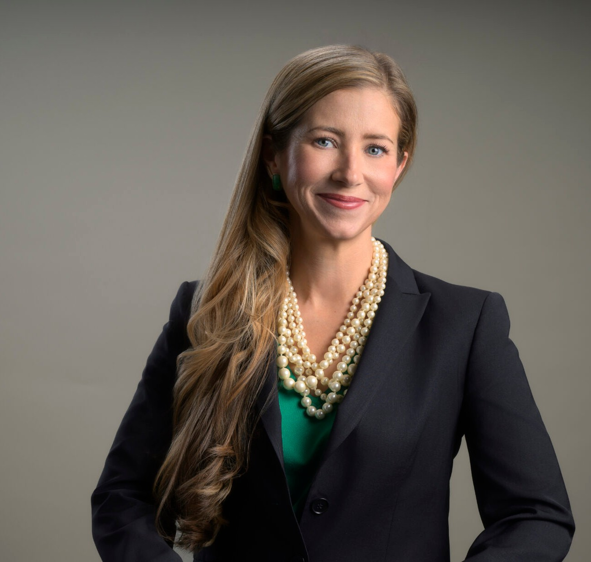
Courtney is a director in our Reno office, and her practice focuses on business litigation,
COURTNEY MILLER O’MARA
Director
Business Litigation
Reno
P: 775.788.2205
F: 775.788.2206
comara@fennemorelaw.com
“
Even paradise must have rules.
-Mary Oliver, Long Life
COURTNEY MILLER O'MARA
”
creditors’ rights and bankruptcy litigation, and trusts and estates matters, including planning, administration, and litigation
In recent years, her practice has included substantial litigation involving rights under commercial loans, both inside and outside of bankruptcy. She has also worked extensively on litigation matters involving contract and business disputes.
Courtney approaches each case like a puzzle; while some are more complex than others, it is the challenge of solving the puzzle that intrigues her. She takes a practical approach to the law, and carefully outlines options and obligations to her clients.
Courtney is experienced in helping clients navigate civil discovery, including depositions and expert issues. She has helped obtain many favorable results for her clients, including millions of dollars in judgments, dismissal of claims through dispositive motions, favorable settlements and other victories.
In her spare time, Courtney enjoys gardening, running, the beauty of Lake Tahoe and spending time with her family.

EDUCATION
J.D., University of Southern California, Gould School of Law B.A., University of Notre Dame, magna cum laude
Judicial Clerkship, Honorable Robert A. McQuaid, Jr., United States Magistrate for the District of Nevada

Judicial Extern, Honorable Justice Michael Nott, California Court of Appeal, 2nd District Production Editor, The Southern California Review of Law and Women’s Rights
AREAS OF PRACTICE

OTHER EXPERIENCE

Commercial Contingency Litigation Litigation
Mediation and Arbitration Real Estate Litigation
Trust and Estate Litigation Business Litigation
Estate Litigation Estate Planning
Financial Restructuring Trusts & Estates

AWARDS AND HONORS
Best Lawyers in America®, Lawyer of the Year, Litigation – Real Estate, 2026
Best Lawyers in America®, Commercial Litigation, 2020-2026
Outstanding Woman Attorney, Northern Nevada Women Lawyers Association, and the Washoe County Bar Association, 2026
2025 Top Rank Attorney List, Nevada Business Magazine
Mountain States Super Lawyers®, Business Litigation, Estate Litigation, Estate Planning,

Financial Restructuring, Trusts & Estates, 2024-2025 “Legal Elite,” Nevada Business Magazine, 2011-2022 Benchmark Litigation, 40 & Under Hot List, 2018-2020
Mountain States Super Lawyers Rising Stars®, 2010, 2015-2020
Twenty Under 40, Reno Tahoe Young Professional Network/Reno Gazette-Journal, 2015 Nevada Women’s Fund Woman of Achievement, 2013

ARTICLES AND PRESENTATIONS
Interview, “Inspiring the Next Generation of Female Attorneys: A Conversation with Courtney Miller O’Mara,” Fennemore Blog, March 27, 2025
Interview, “Empowering Women in the Legal Arena: A Conversation with Courtney Miller O’Mara,” Fennemore Blog, March 8, 2024
Featured, “Woman Suing Parents for Secretly Spending Her College Fund Backed Online,” Newsweek, March 23, 2023

Interview, “A Conversation On Leadership & Life In The Law With Courtney Miller O’Mara,” Fennemore Blog, November 17, 2022
Interview, “Death Disputes/Post-Mortem Creditor Claims,” KKOH, February 4, 2021
Quoted, “Eviction Moratorium Phase-Out Begins,” Nevada Public Radio, July 8, 2020
Speaker, “Forms of Administration and When They Are Used,” “First Steps and Notices, Executor Duties, Opening the Estate,” “Marshalling the Assets,” “Estate and Trust Contests, Disputes, Challenges,” Estate Administration Bootcamp, National Business Institute Seminar, August 5-6, 2019
Speaker, “Probate and Trust Essentials for Realtors,” June 13, 2019 Speaker, “What Every Realtor Should Know About Probate,” May 23, 2019
Speaker, “What Every Realtor Should Know About Probate Trusts & Powers of Attorney,” April 4-5, 2019
Speaker, “Levitate Probate: What Every Nevada Realtor Should Know About Probate,” Master Class, August 7, 2018
Interview, “Lawyers in Love,” The Good Life, July 2018
Author, “Document Preservation Obligations When Litigation is on the Horizon,” Northern Nevada Law Journal, November 6, 2017
Speaker, “Maintaining the Estate and Preparing Assets for Distribution,” “Beneficiary
Distributions, Final Account and Closing of the Estate,” National Business Institute Seminar, September 12, 2017
Interview, “Grow Nevada Team Radio,” KFOY (Reno, Nevada), October 14, 2015

PROFESSIONAL AND COMMUNITY ACTIVITIES
Member, Washoe County Bar Association
Member, Probate Bar Association of Washoe County Member, Northern Nevada Women Lawyers Association Member, Probate Section, State Bar of Nevada
Board Member, Development Committee, Nevada Discovery Museum Secretary and Member of the Board of Trustees, Casa de Vida, 2013-2017 Co-President, Northern Nevada Bankruptcy Bar Association, 2013-2015
Member, Local Rules Committee, United States Bankruptcy Court for the District of Nevada, 2015
Graduate, Chamber of Commerce’s Leadership Reno-Sparks program, 2010
Member, Bruce R. Thompson Chapter, American Inns of Court, Associate, 2006-2008, 2010; Barrister, 2011-2014
Social Chair, Young Lawyers Section, State Bar of Nevada, 2007-2010
Notre Dame Club of Northern Nevada, President, 2007-2010; Service Chair, 2006-2007

ADMISSIONS
Nevada

