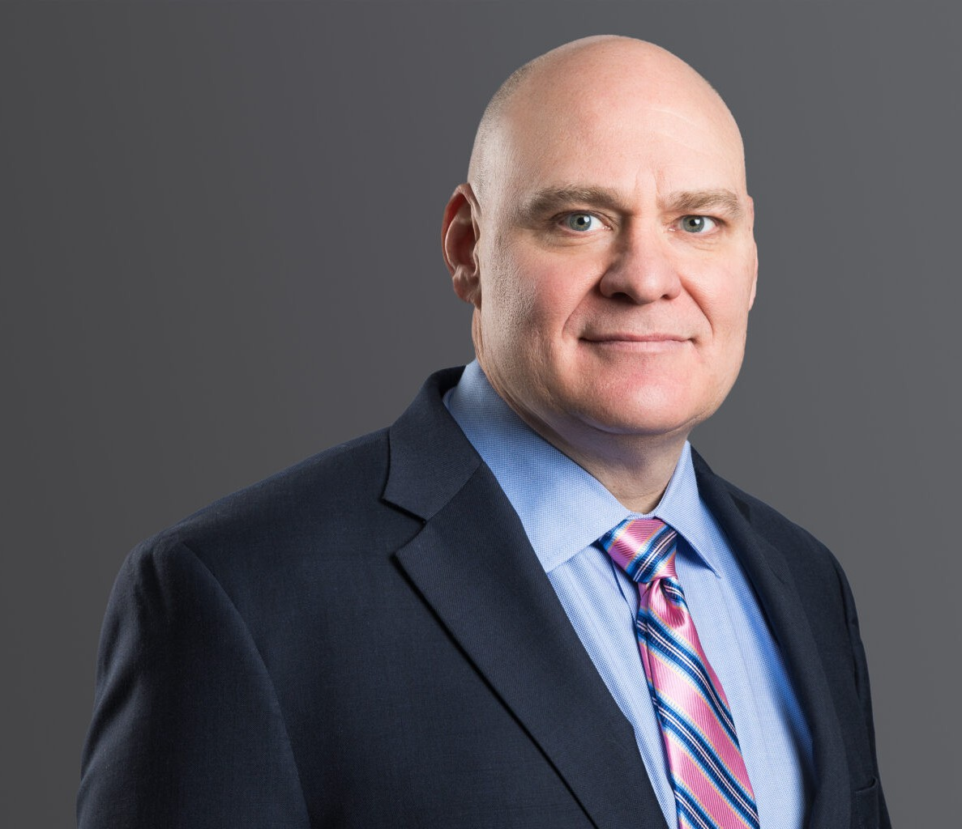

DAVID A. LAIRD
Director
Business Litigation

Denver
P: 303.813.3836 F: 303.291.3201
dlaird@fennemorelaw.com

DAVID A. LAIRD
With over 25 years of trial experience in state and federal courts, David is driven to find just and efficient results for his clients. David has found that many disputes can be resolved quickly if the issues at the heart of the matter are quickly identified and addressed. For those cases that
cannot be resolved quickly, David has the knowledge, experience, and determination to aggressively litigate disputes to a conclusion.
Much of David’s practice focuses on resolving lending and real estate disputes. Also, David litigates a wide variety of complex contract and commercial disputes, business torts, uniform commercial code disputes, insurance coverage disputes, fiduciary claims, oil and gas matters, and landlord/tenant issues, and commercial foreclosures. He also represents creditors in bankruptcy cases and clients involved in securities litigation.
With an eye toward efficient and positive solutions, David advocates for clients in court, administrative proceedings, on appeal, and via alternative methods of dispute resolution such as mediation and arbitration.
David prides himself on being responsive and proactive. His clients always know the “game
plan” and are kept apprised throughout the case. David understands that communication is the key to a successful attorney-client relationship.

EDUCATION
J.D., University of Denver
B.A., University of Denver, Honors with distinction

AREAS OF PRACTICE
Business Litigation Eminent Domain

AWARDS AND HONORS
Benchmark Litigation: Local Litigation Star – General Commercial Litigation and Bankruptcy Litigation, 2022 – 2025
Best Lawyers in America®, Commercial Litigation and Litigation – Real Estate, 2023 – 2026

Colorado Super Lawyers®, Business Litigation, 2017 – 2026
Colorado Super Lawyers®, Rising Star, Business Litigation, 2013 Martindale-Hubbell Rating: AV® Preeminent™ (highest)

ARTICLES AND PRESENTATIONS
Author, “COVID-19 Fallout: Colorado Court Upholds Allocation of Risk in Lease,” Firm Blog, February 2023
Author, “Commercial Evictions in 2021 – Will There Be Calm After the COVID-19 Storm?,” Mile High CRE, March 2021
Author, “The Trouble with Forbearance Fees,” Independent Report, December 2020 Presenter, “Getting Coloradoans Back to Work,” Firm Webinar, May 2020
Co-Author, “Evictions in the Time of COVID-19,” Colorado Real Estate Journal, April 2020
Author, “Court Gives Teeth to Defense Waiver in Loan Documents,” The Independent Report,

Independent Bankers of Colorado, November/December 2014
Author, “At Risk: Secured Creditors’ Right to Credit Bid on Assets Sold at Chapter 11 Plan Sales,” The Business Suit, Volume 13, Issue 8, October 2010
Author, “New Colorado Law Allows Expedited Real Property Foreclosures,” Firm Opportunities and Challenges, June 2010
Author, “Duties to Pay Subcontractors Under the Colorado Trust Fund Statute,” Firm Opportunities and Challenges, March 2009
Author, “Commercial Loans: Using Litigation Effectively When Borrowers Default,” Denver Business Journal, Volume 60, No. 11, August 2008

PROFESSIONAL AND COMMUNITY AFFILIATIONS
Volunteer, Ask a Lawyer
Colorado Bar Association, Litigation Section Executive Council and Annual Litigators’ Summit Planning Committee
Former Director, Colorado Bowhunters Association Former President, Contractors Council, Member Defense Research Institute
Denver Bar Association
First Judicial District Bar Association
Associate Member, Independent Bankers of Colorado

ADMISSIONS
Best Lawyers in America®,
Colorado
U.S. Court of Appeals for the Tenth Circuit
U.S. Court of Appeals – District of Colorado
U.S. District Court – District of Colorado

U.S. Supreme Court

