
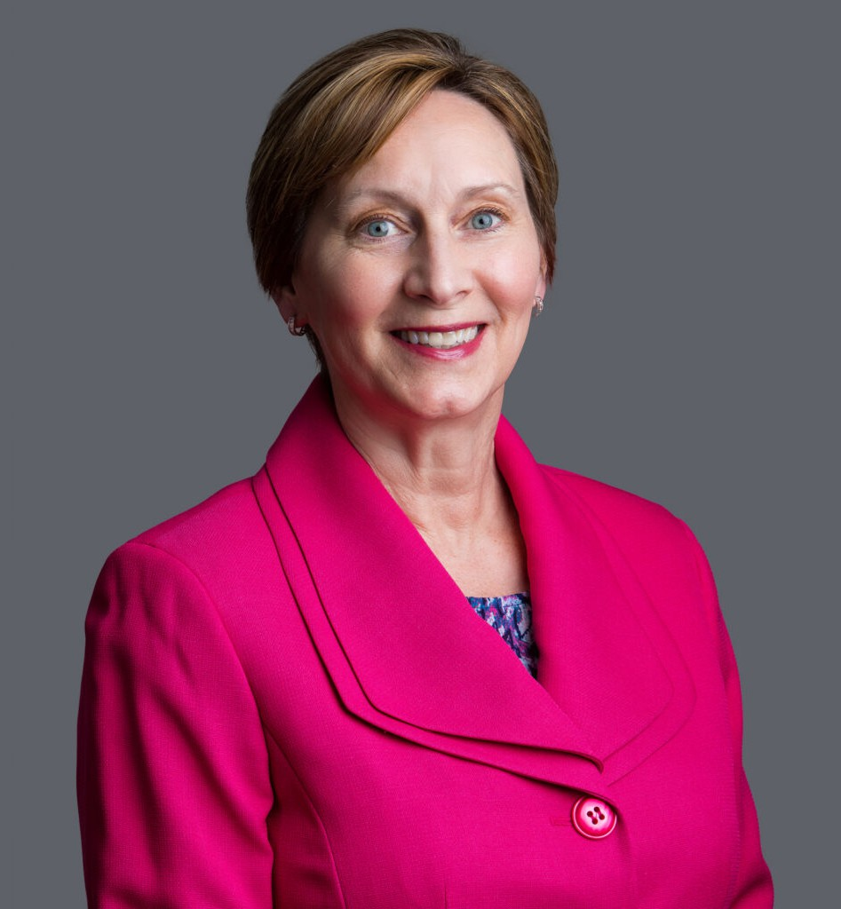
DEBRA J. POLLY
DEBRA J. POLLY
Director
Trusts & Estates
Phoenix
P: 602.916.5309 F: 602.916.5509

Las Vegas
P: 602.916.5309 F: 602.916.5509
dpolly@fennemorelaw.com
Reno
“
In Iroquois society, leaders are encouraged to remember seven generations in the past and consider seven generations in the future when making decisions that affect the people.
Wilma Mankiller
”
Debra J. Polly is a Director in Fennemore’s Trusts & Estates practice group, practicing from the firm’s Phoenix office. She advises individuals, families, fiduciaries, and closely held business owners on sophisticated estate planning and wealth transfer strategies, as well as probate and trust administration. Her practice includes estate and trust administration, retirement benefits
planning, estate, gift, and generation-skipping transfer tax planning and compliance, and family settlement agreements and dispute resolution. Deb is licensed to practice law in both Arizona and Nevada and regularly assists clients with Arizona and Nevada estate planning matters.
Deb brings a rare dual perspective to her practice as both an attorney and an Arizona Certified Public Accountant. She began her career with KPMG, where she focused on estate planning–related consulting and developed a strong foundation in complex tax planning. Recognizing
that comprehensive client representation in this area requires both technical tax acumen and legal judgment, she pursued a legal education and transitioned her practice to trusts and estates law. This combined background enables her to integrate tax strategy seamlessly with dispositive planning and fiduciary administration.
An Arizona State Bar Board-Certified Specialist in Estate and Trust Law and a Fellow of the American College of Trust and Estate Counsel (ACTEC), Deb is recognized for her depth of knowledge and professional excellence in the field. She is particularly skilled at designing tailored estate plans that reflect each client’s objectives, family dynamics, and tax considerations. Her

approach emphasizes precision, foresight, and practical implementation—ensuring that plans operate as intended both during life and after death.
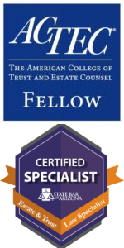
Originally from Sioux City, Iowa, Deb balances her practice with an active family life as the mother of three teenagers, including a daughter who competes on a travel ice hockey team.

EDUCATION
J.D., Arizona State University Sandra Day O’Connor School of Law Master of Taxation, Arizona State University W.P. Carey School of Business
B.S. in Accountancy, Arizona State University W.P. Carey School of Business

AREAS OF PRACTICE
Trusts & Estates Estate Planning

AWARDS AND HONORS
Super Lawyers Southwest Rising Stars 2012-2015

ARTICLES AND PRESENTATIONS
Organizations: State Bar of Arizona, Arizona ACTEC Meeting, National Business Institute, Valley Estate Planners, East Valley Estate Planning Council, Arizona Community Foundation, Planned Giving Roundtable, Catholic Community Foundation, Central Phoenix Women
Topics: Advanced Generation-Skipping Transfer Tax and Marital Deduction Issues, Income Tax Planning for Trusts and Estates, Probate Process, Generation-Skipping Transfer Tax Issues in Gift Tax Returns, Other Various Generation-Skipping Transfer Tax Issues (War Stories, General, and Current Status), Tips for Effective Estate Planning

PROFESSIONAL AND COMMUNITY ACTIVITIES
Fellow, American College of Trust and Estate Counsel
Vice Chair, Secretary and Board Member of the Estate Planning, Probate, and Trust Section of the Maricopa County Bar Association; Probate & Trust Section of the State Bar of Arizona
Co-Author, LexisNexis Practical Guidance Estate Planning Forms Member, Tax Section, American Institute of Certified Public Accountants
Member, Tax & Legal Seminar Committee, Arizona Community Foundation / Center for Jewish Philanthropy
Valley Estate Planners Past President (2011) and prior Board Member

Former Vice President, Treasurer, and Board Member for the Copper State Skating Club Presenter, Financial Series, Fresh Start Foundation for Women
Volunteer, Habitat for Humanity Volunteer, Fennemore Foundation
Regular Volunteer at her children’s school (Great Hearts Academies)

ADMISSIONS
Arizona Nevada

