
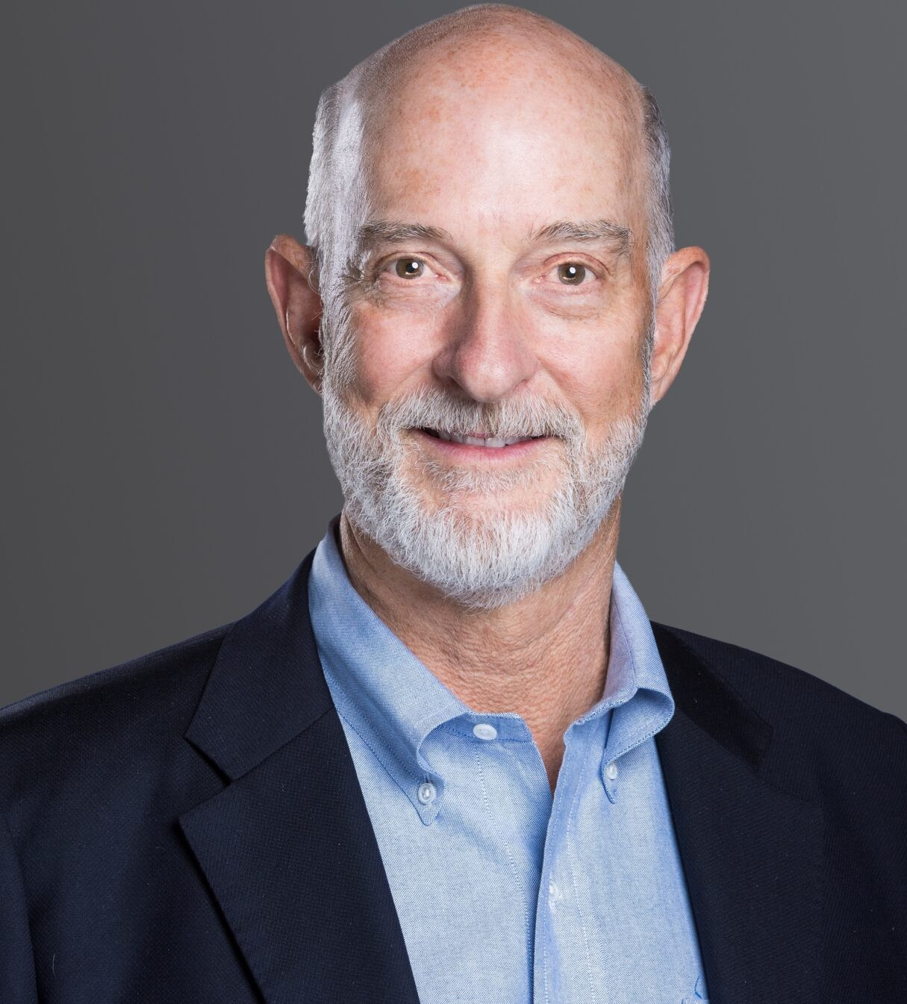
EDWARD D. "TED" WHITE
EDWARD D. “TED” WHITE
Director
Business & Finance
Denver
P: 303.813.3896
F: 303.291.3201
Basalt
P: 970.431.9060
F: 303.291.3201
twhite@fennemorelaw.com
Edward D. “Ted” White is Co-Chair of the firm’s Advanced Energy Group.

Ted’s practice focuses on corporate transactions such as mergers, acquisitions, and financings.
As a strategic partner, Ted helps clients discern opportunities and make strategic connections that add business value. He has specific experience with private capital funds and takes a
leadership role in fund formation and handling portfolio acquisitions and dispositions.

Ted currently serves as Senior Counselor for a prominent investor and philanthropist’s extensive business, policy, and philanthropic efforts. Ted is also the founder and advisory board chair for Estabrook Funds, a fund of global, multi-strategy absolute return hedge funds, one of the first of its kind in the United States. He is on the Limited Partner Advisory Committee of multiple
investment funds and serves on the board of directors or advisory boards of several funds and companies.
Ted is an arbitrator for complex commercial disputes through the American Arbitration
Association. He has resolved dozens of commercial claims relative to matters such as loans, securities fraud, mergers and acquisitions, professional sports contracts, and other complex business issues.
He is the author of Business Contracts (Bradford Publishing Co. 2010); Business Contracts: A Guide (Bradford Publishing Co. 2013); and Business Contracts: A Guide for Lawyers and Business
Owners, 2016 and 2025 Edition (CBA-CLE).

Ted has a strong record of civic leadership. He is a former Chair of the Boettcher Foundation, one of the largest privately endowed grant-making organizations in Colorado, and a former Director of Sustainability Accounting Standards Board Foundation (SASB). He serves as an officer and trustee of many community organizations, including the Rocky Mountain Institute (RMI) and the Advanced Energy Institute.
Ted is a former adjunct professor of law at the University of Colorado School of Law where he designed and taught the popular Business Transactions course. His other teaching efforts include

numerous CLE courses.

Before joining Fennemore, Ted was the name partner at the law firm Moye White LLP. Prior to that, he was the President and Managing Director of the law firm Dufford & Brown, P.C.

EDUCATION
J.D., New York University
B.A., with distinction, Yale University

AREAS OF PRACTICE
Business & Finance Advanced Energy
Family Office & Private Client Attorneys General Counsel Services

AWARDS AND HONORS
Best Lawyers in America®, Corporate Law and Leveraged Buyouts and Private Equity Law, 2005 – 2026; Mergers and Acquisitions Law 2020 – 2026
500 Leading U.S. Energy Lawyers, Lawdragon, 2025 Best of the Bar, International Law & Finance, 2005 Business for the Arts Award Finalist 2011
Colorado Super Lawyers ®, Business and Corporate, 2006 – 2026
Denver Business Journal, Power Book Winner, (Law Category) 2014; finalist in 2010 and 2011
Denver Business Journal, Who’s Who in Energy, 2017 – 2019 Denver Five Star Wealth Manager, 5280 Magazine, 2011 – 2013
Law Week Colorado, “Barrister’s Best” Mergers & Acquisitions Lawyer 2019, 2021, and 2023
Law Week Colorado, Private Equity Lawyer 2013 – 2018
Law Week Colorado Top Lawyer
Martindale-Hubbell Rating: AV® Preeminent™ (highest)
Martindale-Hubbell Rating: AV® Preeminent™ (highest) – Judicial Edition National Law Journal Trailblazer in Energy/Environmental Law 2021 Healing Hands Award Recipient, Judi’s House

ARTICLES AND PRESENTATIONS
Co-Author, “Business Contracts in 2025: Straightforward Answers for Nuanced Situations,” Fennemore Blog, August 14, 2025
Author, “Establishing a Family Office: 5 Essential Tips for Getting Started,” Fennemore Blog, July 10, 2025
Co-Author, “Q&A: Lawyers Ted White and Dan Reilly reflect on Fennemore’s expansion and future footprint,” Denver Business Journal, March 1, 2025

Quoted, “Moye White’s New Managing Partner On Firm Strategy,” Law360 Pulse, August 2022
Co-Author, “Advanced Energy Success Depends on Interdisciplinary Team,” Law Week Colorado, December 2019
Co-Author, “Clean Energy Powers Colorado’s Economy,” ColoradoBiz Magazine, October 2018
Presenter, Business Contracts Continuing Legal Education, 2016
Author, “Business Contracts: A Guide for Lawyers and Business Owners,” CLE and Colorado, Inc. 2013

PROFESSIONAL AND COMMUNITY AFFILIATIONS
Board of Directors, Advanced Energy Institute (AEI) Former Vice President, Ally Law
Former Trustee and Board Chair, Boettcher Foundation Corporate Code Committee, Colorado Bar Association Nonprofit Corporation Committee, Colorado Bar Association The Colorado Forum
Denver Bar Association
Colorado Bar Association
District of Columbia Bar Association
Former Board Chair, Biennial of the Americas Former Board Chair, Rocky Mountain Institute (RMI) Board of Advisors, Blackhorn Ventures
Former Trustee, Colorado History Museum
Former Trustee and Officer, Denver Botanic Gardens LPAC Member, Earthshot Ventures
Senior Counselor, Fahr LLC
Board of Directors, Finite Corporation, Inc.
Former Board President, Graland Country Day School
Founding Board Member, Judi’s House and Judith Ann Griese Foundation Former Board Member, Kent Denver School
Chair, Board of Directors, NextGen America LPAC Member, Power Sustainable Lios Fund LPAC Member, Roha Group Inc.
Senior Advisor, SidePorch Consulting
Licensed Broker, Colorado Real Estate Commission (Inactive)

ADMISSIONS
Colorado

District of Columbia

