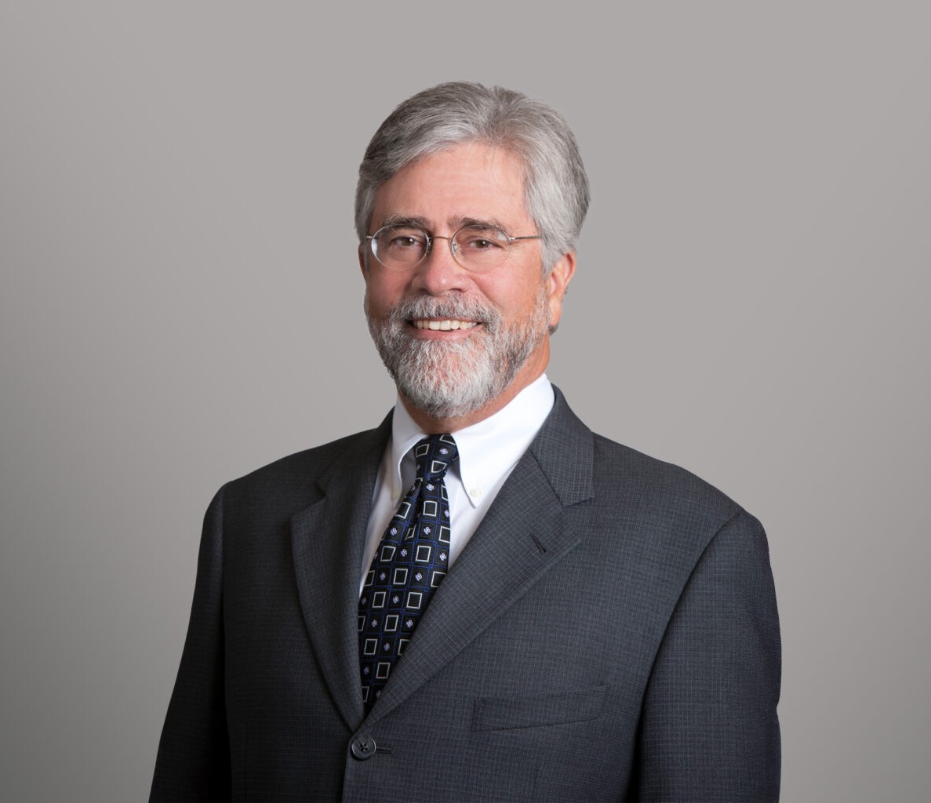

JAMES P. HILL
Director
Financial Restructuring

San Diego
P: 619.595.3226 F: 619.231.4372
jhill@fennemorelaw.com

JAMES P. HILL
Jim Hill is a seasoned bankruptcy, insolvency, and commercial law attorney. His practice, emphasizing personalized debt relief strategies and comprehensive financial analysis, includes representing creditors, bankruptcy trustees, and select bankruptcy debtors in Chapter 11 business reorganization cases. He also serves as a court-appointed examiner and mediator, showcasing his versatility and in-depth knowledge in the field.
In addition to his bankruptcy work, Jim is adept in asset sales and acquisitions, state and federal court receivership cases, and business workouts, restructuring, and dissolution matters. His approach to providing tailored solutions and conducting detailed financial assessments makes him a sought-after advisor in complex commercial law matters.
Jim’s leadership extends beyond his practice. He served two terms as the inaugural Chair of the California Lawyers Association (CLA) Board of Representatives from its launch in January 2018 through October 2019, representing nearly 100,000 California attorneys and other members of the CLA’s various Sections. Jim previously served as the CLA Board Representative of the Business Law Section, of which he was the chair in when it was still part of the State Bar of California. Prior to that, Mr. Hill was co-chair of the BLS Insolvency Law Committee. His dedication to the legal community is further shown by his recognition of receiving the California Lawyers Association’s Business Law Section Lifetime Achievement Award in October 2022, highlighting his contributions to business law in California.

EDUCATION
J.D., The University of Texas at Austin, School of Law, with Honors B.J., University of Texas, High Honors

AREAS OF PRACTICE
Financial Restructuring Agribusiness
Business Litigation Business & Finance Real Estate

AWARDS AND HONORS
Top San Diego Lawyer, San Diego Magazine, 2025
Best Lawyers® “Lawyer of the Year” in San Diego – Bankruptcy and Creditor Debtor Rights/Insolvency and Reorganization Law
Best Lawyers in America®, Bankruptcy and Creditor Debtor Rights/Insolvency and Reorganization Law
Best Lawyers in America®, Commercial Litigation Top Rated Lawyer by Martindale-Hubbell
Top Rated Lawyer by American Lawyer Media, Commercial Bankruptcy and Creditor-Debtor Rights
Top Rated Lawyer by American Lawyer Media, Corporate Restructuring and Bankruptcy AV® Preeminent™ Peer Review Rating by Martindale-Hubbell
Lifetime Achievement Award, Business Law Section, California Lawyers Association Super Lawyer, Bankruptcy and Creditor/Debtor Rights, 2007-2026
Top San Diego Lawyer by San Diego Magazine, 2015-2023
50 Influential Leaders in San Diego Business Community by the Daily Transcript, 2018
Mediator of the Year by the Bankruptcy Court for the Southern District of California, 2013-2015 San Diego Business Journal’s Best of The Bar

ARTICLES AND PRESENTATION
Presenter, “The ABC of ABCs,” San Diego Bankruptcy Forum, September 9, 2025
Panelist, “Stalking Horse Real Property Sales in Bankruptcy: To Stalk or Not to Stalk,” California Lawyer Association, October 11, 2023
Presenter, “Litigation Funding in Bankruptcy Cases: How to Get it & Potential Pitfalls (Help Me Legalist, You’re My Only Hope,” California Lawyer Association, October 21, 2021

PROFESSIONAL AND COMMUNITY ACTIVITIES
Order of the Coif Member, Phi Kappa PHi
Member, Kappa Tau Alpha Member, American Bar Association
Member, Subcommittee on Business Bankruptcy, American Bar Association Member, San Diego County Bar Association
Member, Bankruptcy Law Section, San Diego County Bar Association Member, San Diego County Chapter of the Federal Bar Association Member, National Association of Bankruptcy Trustees
Member, California Bankruptcy Forum Member, San Diego Bankruptcy Forum

Member, San Diego Receivers Forum Member, California Receivers Forum

ADMISSIONS
California Texas
U.S. Supreme Court
U.S. Court of Appeals, Ninth Circuit
U.S. District and Bankruptcy Courts for Southern, Central, Eastern and Northern Districts of California

