
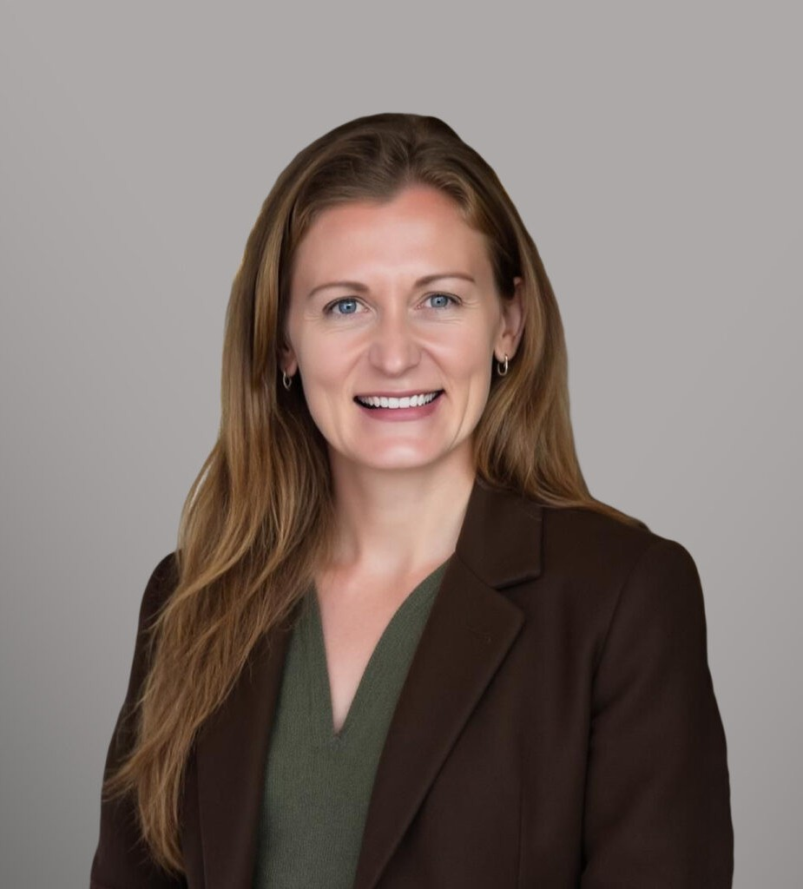
KATHERINE A. BOWLES
KATHERINE A. BOWLES
Director
Business Litigation
Orange County
P: 949.430.3437
F: 949.752.0953
Fresno
P: 949.430.3437
F: 949.752.0953
kbowles@fennemorelaw.com
Kate Bowle’s law practice focuses on providing business solutions, including preventive and litigation strategies for health organizations, such as companies with large healthcare networks. Kate has spent 15 years immersed in the legalities of our federal, state, and local infrastructure and has touched on almost every subject within healthcare. During and before law school, Kate worked as a Registered Nurse in hospitals throughout Los Angeles County and helped manage a 60-bed unit in an acute care hospital.
Kate puts her clients first. Assisting clients with compliance, investigation, and enforcement of Medicare/Medi-Cal Fraud and Abuse, Stark Law\Anti-Kickback Statute, payor disputes, and business litigation, she has a passion for helping clients see the big picture within their organization and attempts to address compliance issues before they arise. Her representations have focused on everything from impact litigation to corrective legislation to negotiating new contracts to achieving early settlement outside of court. When necessary, Kate takes matters through trial and up on appeal. Many of Kate’s clients are nontraditional; for example, she has helped many organizations structure compliant programs with California’s whole-person-centered care program through Medi-Cal. Representing a diversity of providers allows Kate to effectively evaluate the motivations of various participants within the healthcare industry and take advantage of emerging trends. Kate is also versed in artificial intelligence and uses these tools efficiently and confidentially to handle her clients’ needs.
She is licensed throughout California, including the U.S. District Courts for the Eastern, Central, and Southern Districts of California and the Ninth Circuit Court of Appeal.

EDUCATION
J.D., Pepperdine University School of Law, cum laude
B.S.N., University of Pennsylvania

AREAS OF PRACTICE
Business Litigation

Health Care ERISA

ARTICLES AND PRESENTATIONS
Host and Moderator, “U.S. Department of Education’s Notice of Proposed Rulemaking on 34 CFR Parts 674, 682, and 685,” American Bar Association Health Law Section panel, March 31, 2026
Speaker, “Legal Aspects of Anesthesiology,” Washington Association of Nurse Anesthesiology, Bellingham, Washington, March 28, 2026
Co-Speaker, with Assemblymember Flora, “The Facts About AB 876,” January 28, 2026 Webinar.
Speaker, “Lessons Learned: Health Plan Litigation for Fraudulent Mommy Makeovers,” January 22, 2026, Health Benefits Conference and Expo, Jacksonville, Florida.
Speaker, USC Keck School of Medicine Program of Nurse Anesthesiology, November 5, 2025, Los Angeles, California.
Speaker, “The Anatomy of a California Hit Job and Resulting Crisis of Confidence,” CANA Western States Regional Anesthesia Seminar, October 4, 2025, Las Vegas, Nevada.
Author, “U.S. Healthcare in OBBBA: A Patchwork of Big Changes,” Fennemore Blog, August 19, 2025
Author, “Federal and California’s Shared Interest in Promoting Open Competition: Isn’t it Ironic?,” Fennemore Blog, July 31, 2025
Author, “California’s Bold Experiment with Whole-Person Centered Care: Has it Worked?,” Fennemore Blog, June 11, 2025
Co-Author, “We Are Almost Back to Normal Post-COVID, Except When it Comes to Nurse Staffing,” Fennemore Blog, April 29, 2025
Author, “Nursing Impact Litigation – A Tale of Two Matters,” JD Supra, March 18, 2025
Author, “Lessons Learned from ERISA Health Plan Representation and Recommendations for Plan Design and Oversight,” JD Supra, February 19, 2025
Author, “Regulatory Landscape of Insurance Claims Denial Practices and Suggestions for a Path Forward to a Sustainable Healthcare Future,” JD Supra, January 31, 2025
Author, “California Department of Public Health (CDPH) ‘All Facilities Letter’ and Survey Activities Impacting Nurse Anesthesiology Scope of Practice,” JD Supra, December 9, 2024
Co-Presenter, CalAIM Initiative on Enhanced Care Management and Community Supports, 2024 CSHA Annual Meeting and Spring SeminarLegal Update, May 3, 2024
Author, CIGNA’s New CRNA Payment Policy Adds Fuel To The Fire, Coronis Health, October 27, 2023

AWARDS AND HONORS
Super Lawyers® Rising Stars, Business Litigation, Health Care, ERISA, 2025-2026
Best Lawyers in America®, Health Care Law, 2025 and 2026
Outstanding Interest Group (Nursing and Allied Health Professionals), American Bar Association, 2025

PROFESSIONAL AND COMMUNITY ACTIVITIES
American Bar Association, Vice Chair, Nursing & Allied Healthcare Professionals

ADMISSIONS
California

