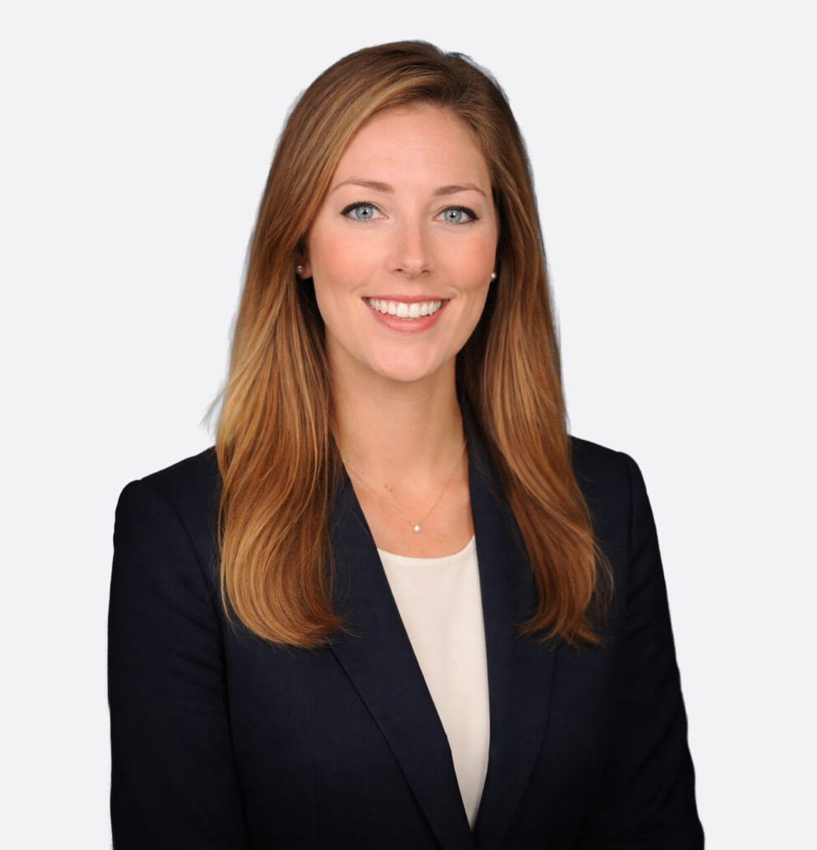

KATHERINE SULTENFUSS SCHICHTEL
Director
Trusts & Estates

Fennemore Forward
P: 863.315.3286
kschichtel@fennemorelaw.com

KATHERINE SULTENFUSS SCHICHTEL
Katherine Sultenfuss Schichtel advises families on estate planning strategies and related tax
considerations, helping them navigate both routine and sophisticated planning needs. Drawing on her prior experience in trusts and estates and commercial litigation, she brings a practical perspective to her planning work, helping clients implement clear, effective estate plans designed to minimize the potential for future disputes.
Katherine earned her LL.M. in Taxation from the University of Florida Levin College of Law, where she served as a Graduate Assistant Editor on the Florida Tax Review and received book awards for Tax Policy, Advanced Topics in Taxation of Estates, and Trusts, and Estate Planning. She graduated from the University of Virginia School of Law, where she served in the Virginia Law and Business Review and worked as a teaching assistant.
She is actively involved in her community, participating in various civic and professional organizations, and enjoys spending time with her family.

EDUCATION
L.L.M., University of Florida Levin College of Law Graduate Tax Program J.D., University of Virginia School of Law
B.S., Duke University

AREAS OF PRACTICE
Trusts & Estates Estate Planning

AWARDS AND HONORS
Super Lawyers, Rising Star, 2015-2018; 2020-2025
Best Lawyers in America, Ones to Watch, 2021-2025

PROFESSIONAL AND COMMUNITY ACTIVITIES
Member, Hospice Women of Giving Member, Florida House (Lakeland Chapter)
Counsel to the Board of the GiveWell Community Foundation Former Member, The C.H. Ferguson-M.E. White Inn of Court

ADMISSIONS
Florida
U.S. District Court, Middle District of Florida

