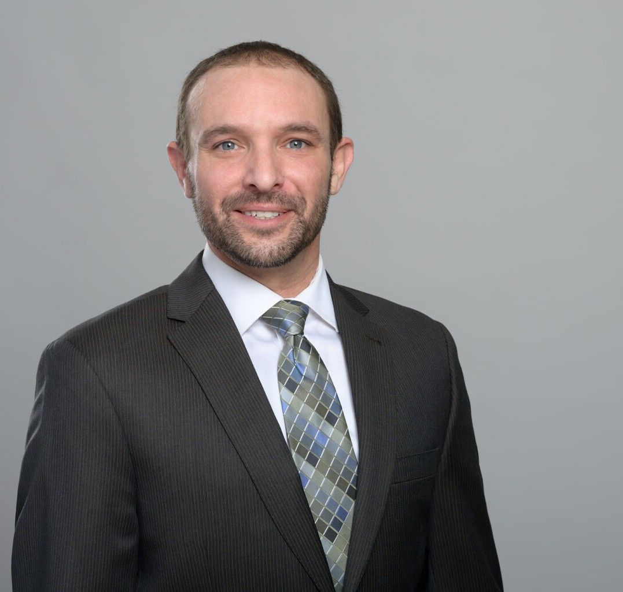

MICHAEL ZARCONI
Director
Business Litigation

Fennemore Forward
P: 619.595.3221 F: 619.595.3221
mzarconi@fennemorelaw.com

MICHAEL ZARCONI
Michael Zarconi, a member of the Firm’s Litigation, Construction, and Insurance practice groups, brings a broad range of experience as a general civil litigator. His practice encompasses commercial and business litigation, construction disputes, insurance coverage, anti-SLAPP
litigation, and labor and employment law matters. Notably, he applies comprehensive construction law knowledge and efficient dispute resolution techniques in his construction litigation cases.
Michael earned his J.D. from the University of San Diego, School of Law, focusing on civil litigation and public interest law, with a particular interest in environmental and consumer protection
regulation. His active involvement with the University of San Diego Center for Public Interest Law led to him being recognized with the Outstanding Public Interest Advocate Award in 2012.

EDUCATION
J.D., University of San Diego School of Law B.A., University of Colorado

AREAS OF PRACTICE
Business Litigation Construction Law Estate Litigation Real Estate Insurance Coverage

REPRESENTATIVE MATTERS
Led a trial team which obtained a jury verdict in favor of the client for over $30 million, supported by special verdicts of malice, oppression, and fraud.

AWARDS AND HONORS

Best Lawyers: Ones to Watch, by Best Lawyers in America® – Commercial Litigation, 2025 Best Lawyers: Ones to Watch, by Best Lawyers in America® – Insurance Law, 2025
Rising Star by Super Lawyers – Business/Corporate Litigation Rising Star by Super Lawyers – Construction Litigation Outstanding Public Interest Advocate Award

PROFESSIONAL AND COMMUNITY ACTIVITIES
Member, State Bar of California
Member, San Diego County Bar Association Member, Building Industry Association of San Diego
Member, San Diego Chapter of Associate General Contractors of America Member, San Diego County Bar Association, Construction Law Section Member, Little Italy Association
Member, Little Italy Residents Association

ADMISSIONS
California
District Court for the Southern District of California

