
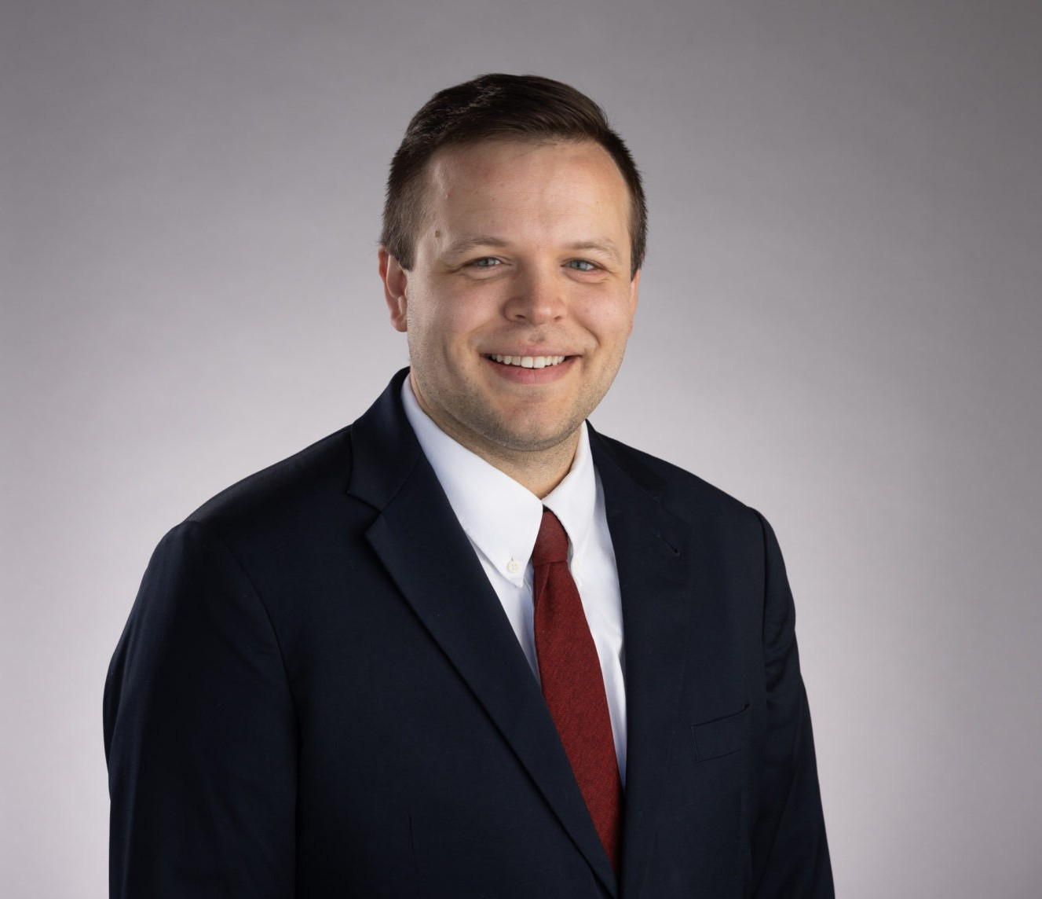
Darien Key is a director who works out of our Oakland office in our Land Use and Natural Resources practice groups. Darien’s practice focuses on Land Use entitlement (such as the Subdivision Map Act, Housing Accountability Act, and Builder’s Remedy), CEQA (California Environmental Quality Act), municipal law (such as the Brown Act, Public Records Act, Conflicts of Interest, etc.), water (SGMA compliance and groundwater adjudications), and related environmental laws both on the transactional side but also in litigation.
DARIEN KEY
Director
Land Use
Oakland
P: 510.834.6600 F: 510.834.6600
dkey@fennemorelaw.com
“
Happiness lies in the joy of achievement and the thrill of creative effort.
Franklin Delano Roosevelt
DARIEN KEY
”
Born and raised in Bakersfield, CA, Darien understands the importance of land use, water, and environmental regulations in California. His extensive experience in administrative rule-making and municipal processes ensures that clients receive knowledgeable and strategic counsel in addressing local land use, water, and environmental challenges. Additionally he helps his agricultural and industrial clients in developing and implementing effective strategies to obtain, maintain, protect and transfer water rights and supplies. Darien enjoys helping people,
businesses, and local governments solve their problems by translating “legalese” into everyday language that helps clients make the necessary decisions to push projects forward. In his role, he becomes the face of the law – forming solid relationships and making sure he cares for his clients business the same way they do.
Outside of work, Darien is a workout warrior who enjoys hiking, weight lifting, and rock climbing, as well as just relaxing with his two dogs and two cats. He’s also a great cook inspired by the creativity offered by his epicurean adventures – ask him about his go-to lasagna dish!
Land Use
Natural Resources Water Law

EDUCATION
J.D., University of San Diego School of Law B.A., San Diego State University, cum laude

AREAS OF PRACTICE
Land Use
Natural Resources Water Law

PROFESSIONAL AND COMMUNITY ACTIVITIES
Current Editor, California Land Use & Policy Reporter Previous Member, City of Pleasant Hill Planning Commission
Previous Member, Contra Costa Solid Waste Local Enforcement Agency Independent Hearing Panel

ARTICLES AND PRESENTATIONS
Co-Author, “Sites Reservoir Moves Forward: Understanding the Federal ROD and the Road Ahead,” California Water Law & Policy Reporter, March 2026
Co-Author, “When One Species’ Lifeline Endangers Another: Ninth Circuit Clarifies Injuction Standards Under the Endangered Species Act,” Western Water Law & Policy Reporter, February 2026
Co-Author, “California Department of Water Resources’ Conservative Opening to the Water Year: The State Water Project’s Initial Allocation of Ten Percent,” California Land Use Law & Policy Reporter, January 2026
Author, “Newport Beach’s Responsible Housing Initiative”: Citizens Push Back on Regional Housing Needs Allocations Previously Set,” California Land Use Law & Policy Reporter, January 2026
Author, “When One Species’ Lifeline Endangers Another: Ninth Circuit Clarifies Injunction Standards Under the ESA,” California Water Law & Policy Reporter, February 2026
Author, “When a “Fee” Becomes a Tax: Groundwater Replenishment Charges Under Renewed Constitutional Scrutiny,” Western Water Law & Policy Reporter, January 2026
Author, “Fourth District Court Reinforces State Oversight of Local Housing Plans in Landmark Decision,” California Land Use Law & Policy Reporter, November 2025
Co-Author, “Floodwater as Personal Property? Fifth District Court Clarifies Groundwater Classification,” California Water Law And Policy Reporter, July 2025
Co-Author, “First District Court Finds Combined Wastewater and Stormwater System is a

‘Sewer’ For Purposes of Proposition 218,” California Water Law And Policy Reporter, July 2025
Author, “Recalibrating NEPA Compliance: The U.S. Supreme Court’s Clarification on the Purpose and Scope of Environmental Review,” California Water Law And Policy Reporter, Western Water Law And Policy Reporter July 2025
Co-Author, “Ninth Circuit Finds City’s Distance Requirement for Group-living Facilities Survives Challenge that Regulation Discriminated Against Persons with Disabilities,” California Land Use

Law and Policy Reporter, June 2025
Co-Author, “YIMBY Challenges City of Cupertino’s Alleged Violation of Builder’s Remedy Project Processing,” California Water Law And Policy Reporter, California Water Law And Policy Reporter, June 2025
Author, “Chowchilla Subbasin Potentially Avoids Probation Hearing,” California Water Law And Policy Reporter, June 2025
Author, “Fourth District Court Invalidates San Diego County’s CEQA Thresholds for Infill and Small Projects,” California Land Use and Policy Reporter, May 2025
Co-Author, “Housing Advocacy Group Sues City of Lafayette Alleging City’s Housing Element Fails to Comply with State Housing Laws,” California Land Use and Policy Reporter, May 2025
Author, “California Court of Appeal Upholds Santa Clara Groundwater Charges Under Proposition 26,” Western Water Law And Policy Reporter, California Water Law And Policy Reporter, California Land Use And Policy Reporter, May 2025
Co-Author, “Superior Court Analyzes the Housing Accountability Act and a Vesting Tentative Tract Map,” California Land Use Law And Policy Reporter, April 2025
Author, “California High Speed Rail Authority Inspector General Issues Report and Proposes Eddiciencies to Control Costs and Expedite Completion of the Project,” California Land Use Law And Policy Reporter, April 2025
Author, “Mendocino County Declines Proposed Groundwater Extraction Ordinance,” California Land Use Law And Policy Reporter, California Water Law And Policy Reporter, April 2025
Co-Author, “Reaffirming Taxpayer Protections: Fourth District Court Finds Water District’s Rate Structure Ran Afoul of the California Constitution,” California Water Law And Policy Reporter, Western Water Law And Policy Reporter, California Land Use Law And Policy Reporter, March 2025
Co-Author, “California Supreme Court Addresses When the Conveyance of Land Actually Amounts to a Subdivision,” California Land Use Law And Policy Reporter, March 2025
Author, “Executive Orders by Governor Newsom Expedite Rebuilding Efforts Following California Wildfires by Relaxing CEQA and Coastal Act Requirements,” California Water Law And Policy Reporter, California Land Use Law And Policy Reporter, March 2025
Co-Author, “California Expands Efforts to Capture Excess Flood Flows for Groundwater Recharge Via Governor Newsom’s Executive Order N-16-25,” California Water Law And Policy Reporter, March 2025
Author, “Fourth District Court Affirms Upland Park Project Amid CEQA Challenges,” California Land Use Law and Policy Reporter, February 2025
Co-Author, “Superior Court Orders Sonoma County To Cease Issuing Well Permits Except for Emergency Permits” California Water Law And Policy Reporter, February 2025
Author, “First District Court Addresses the Government Claims Act and the Discovery Rule in the Context of a Development Project with Bond Financing,” California Land Use Law and Policy Reporter, January 2025
Co-Author, “State Water Project Allocations Started at 5 Percent, Then Jump to 15 Percent After Late November Atmospheric Rivers Marking A Wetter Year Than Initially Forecasted” California Water Law And Policy Reporter, January 2025

Author, “Bay Conservation and Development Commission Publishes Regional Shoreline Adaptation Plan Implementation,” Western Water Law And Policy Reporter, California Water Law And Policy Reporter January 2025
Author, “Lawsuit Filed by California Attorney General Takes Aim at Defiant City and Alleged Non-Compliance with ‘Housing Element” Law, California Land Use Law and Policy Reporter, December 2024
Speaker “Managing Flood Control and New Storage Plans – Capturing Flood Flows Water—California’s Recent Legislative Efforts” California Water Law and Policy 38th Annual
Conference, September 30, 2024
Author, “California Bill Could Transform Prime Agricultural Land Into Solar Farms,” California Water Law And Policy Reporter, July 2024
Author, “California Flood Flows – New Legislative Attempts to Capture Precipitation under New Water Code 1242 After Another Wet Water Year,” California Water Law And Policy Reporter, June 2024
Author, “California State Board Hosts Workshop On Revised Draft Proposed Regulation For ‘Making Conservation A California Way Of Life,’” California Water Law And Policy Reporter, May 2024
Author, “California Department Of Water Resources Releases Draft California Water Plan Update 2023,” California Water Law and Policy Reporter, November 2023
Author, “Federal Open Access Evapotranspiration Data Act in Congress Proposes Significant Updates to Water Measurement and Management,” California Water Law and Policy, July 2023
Author, “California Legislature Introduces Bills Impacting The Elevated Status Of Pre-1914 And Riparian Water Rights,” California Water Law And Policy Reporter, March 2023
American Bar Association, Water Resources Newsletter, Mexican Sewage in American Waters: Who Is Responsible for Fixing the Sewage Crisis?

AWARDS AND HONORS
Best Lawyers in America®, Ones to Watch, Land Use and Zoning Law, Natural Resources Law, 2026
CALI Awards (Highest Grade) at the University of San Diego School of Law in Ocean, Coast Law and Animal Law Classes
Donald Weckstein Scholarship, awarded annually to law students based on their contribution to the University of San Diego School of Law

ADMISSIONS
California

