
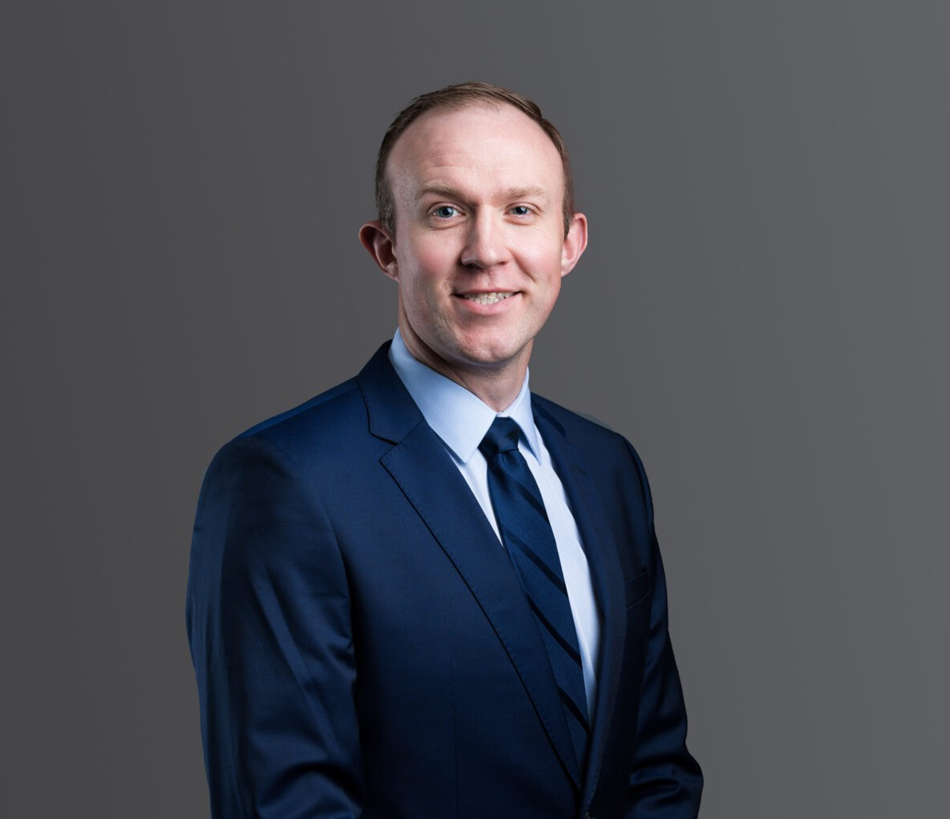
DAVID SIECK
DAVID SIECK
Associate
Labor & Employment
Phoenix
P: 602.916.5334 F: 602.916.5999
dsieck@fennemorelaw.com
“
We choose to go to the Moon this decade and do the other things, not because they are easy, but because they are hard.
John F. Kennedy
”
David Sieck is an Associate attorney in our firm’s Employment & Labor practice group who works out of the Phoenix office. His practice focuses on providing legal services to numerous joint labor-management trust funds’ employee benefit plans and their fiduciaries, including consultation,
collection, and litigation services.

Prior to joining Fennemore, David represented a number of pension (including 401(k) plans), health and welfare plans, and apprenticeship plans. He works in-depth with the provisions of the Employee Retirement Income Security Act of 1974, as amended (ERISA), the Internal Revenue
Code, the Taft-Hartley Act, relevant state statutes, and the related administrative regulations.
David advises plan sponsors and fiduciaries on all aspects of plan governance and
administration, including governmental compliance, and has experience in both federal and state courts.
Born and raised in Spokane, Washington, David considers himself a counselor at law. He’s comfortable in a room with the labor trustees of the union on one side, and management trustees on the other – and he has the ability to understand, relate to and speak to both sides in a meaningful way that solves problems and finds solutions. This passion for insurance,
employment and labor law, and all things ERISA and Taft-Hartley-related serve David well, and he enjoys the mix of transactional and litigation work needed by his clients – with an eye towards constantly improving and learning more.
Outside of work, you’d better be a warrior if you want to keep up with David. He’s a Triathlete who has completed several full-iron distance Triathlons and numerous half-iron distance races,
and he has his sights set on the world’s most famous triathlon: the Ironman World Championship. David enjoys adventuring and traveling with his wife and spending time with his Alaskan Malamute and two cats.

EDUCATION
J.D., Gonzaga University School of Law B.A., Washington State University

AREAS OF PRACTICE
Labor & Employment ERISA

REPRESENTATIVE MATTERS
Defended Walker Specialty Construction against more than $5 million in withdrawal liability payments related to its cessation of work within a union pension plan’s jurisdiction. As a result of a unanimous win in the Ninth Circuit Court of Appeals, Walker had no withdrawal liability and received reimbursement for the payments it made during the litigation, plus interest.

AWARDS AND HONORS
50 Emerging Leaders in Arizona Law to Watch, AZ Big Media, 2026
Super Lawyers® Rising Stars, 2020-2024

ARTICLES AND PRESENTATIONS
Co-Author, “The ‘No Tax’ Overtime Myth: Employer Payroll and Reporting Obligations Under the One Big Beautiful Bill Act Explained,” Fennemore Blog, February 16, 2026
Co-Author, “Navigating Employment Policy Shifts in Trump 2.0,” Fennemore Blog, October 30, 2025
Co-Author, “One Big Beautiful bill: What employers need to know,” BLR, August 20, 2025
Co-Author, “‘One Big Beautiful Bill’ – what employers need to know,” AZ Big Media, July 26, 2025
Co-Author, “Supreme Court Makes It Easier For Plaintiffs To Sue Plan Fiduciaries,” Fennemore Blog, April 21, 2025
Co-Author, Justices Likely To Stay In ERISA’s Bounds On Pleadings, Law360, February 12, 2025
Co-Author, Buying Or Selling A Business? Don’t Forget To Look Out For These Employee Benefits Issues!, Fennemore Blog, June 26, 2024
Author, “California civil penalties await Arizona employers enforcing noncompete clauses across state lines,” Phoenix Business Journal, April 1, 2024
Co-Author “New 401(k) Plan Rules Impose Mandatory Eligibility Requirements for Part-Time Employees in 2024,” Fennemore Client Alert, October 5, 2023
Co-Author “Roth Catch-Up Contributions Under SECURE 2.0: The IRS Delays New Requirements to 2026,” Fennemore Client Alert, September 6, 2023
Co-Author “Health Plans Must Attest They Have No “Gag Clause” By End of 2023: It’s Time To Check Your Service Provider Agreement,” Fennemore Client Alert, August 24, 2023

PROFESSIONAL AND COMMUNITY ACTIVITIES

Board Member and Volunteer for Play for Gracie Foundation, Spokane, WA, 2014-2019

ADMISSIONS
Arizona Washington
U.S. District Court, District of Arizona
U.S. District Court, Eastern District of Washington
U.S. District Court, Western District of Washington
U.S. Bankruptcy Court, Eastern District of Washington
U.S. Bankruptcy Court, Western District of Washington

