
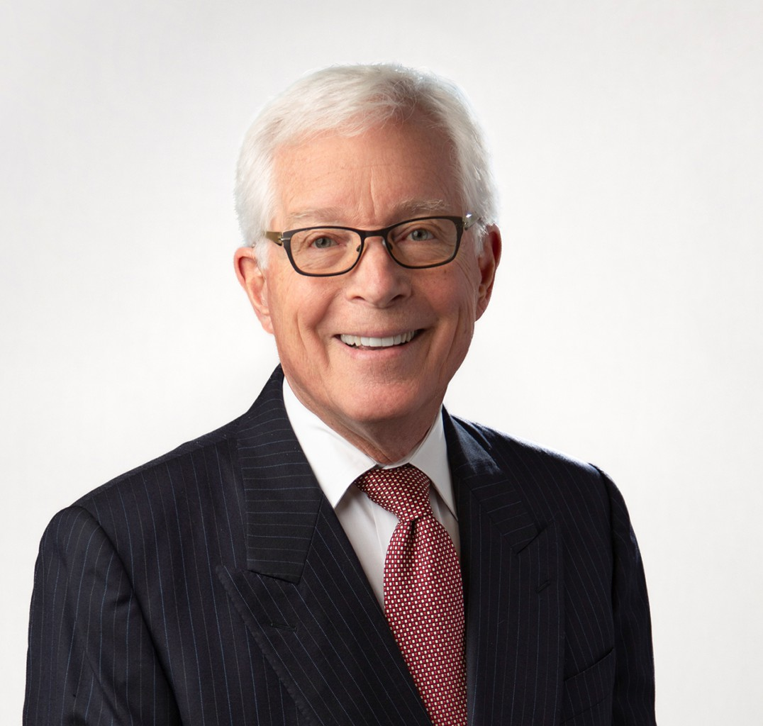
JOHN J. MCGREGOR
JOHN J. MCGREGOR
Of Counsel
Tax Law
Fresno
P: 559.753.2802
F: 559.432.4590
jmcgregor@fennemorelaw.com
John J. McGregor is an Of Counsel attorney who works out of our Fresno office. A seasoned professional with over 40 years of experience in taxation and business transactions, John is certified as a specialist in Taxation Law by the State Bar of California Board of Legal
Specialization. He has successfully represented taxpayers in income, estate, property, sales and use tax controversies in federal courts and before the Internal Revenue Service, the California Franchise Tax Board, and the California Board of Equalization.
Additionally, his tenure as a member and chair of the Fresno County Assessment Appeals Board is a testament to his knowledge in California property tax disputes.

EDUCATION
Master of Laws, Taxation, New York University
J.D., University of California College of the Law, San Francisco B.A., University of San Francisco

AREAS OF PRACTICE
Tax Law
Business Litigation Agribusiness

AWARDS AND HONORS
Only elected member of the American Law Institute practicing in the Central Valley AV® Preeminent™ Peer Review Rated by Martindale Hubbell
Northern California Super Lawyer in the field of Taxation, 2005, 2008-2025 Marquis’ Who’s Who in America
Marquis’ Who’s Who in American Law Marquis’ Who’s Who in the West

Fresno County Bar Association 1983 volunteer attorney of the year
2018 Alumnus of the Year of the Fresno Chapter of the University of California Hastings College of Law Alumni Association

ARTICLES AND PRESENTATIONS
“New Wine in AMT Old Bottle,” with Charles Davenport, 74 Tax Notes 939, 1997
“Taxation of Real Property Transfers,” (1981) and supplements; California Continuing Education of the Bar
“Collection of Delinquent Federal Taxes,” with Charles Davenport, 28 U.S.C. Tax Institute 589, 1976
Presenter, University of Southern California Tax Institute
Presenter, California CPA Society Farmers’ Tax and Accounting Conferences Presenter, Annual Meetings of the California Tax Bars
Presenter, IRS Tax Institutes
Presenter, The California State Bar Fall Section Education Institute
Adjunct Professor of Law, San Joaquin College of Law, teaching federal tax procedure Guest lecturer, California State University, Fresno, teaching mergers and acquisitions

PROFESSIONAL AND COMMUNITY AFFILIATIONS
Member, American Law Institute, 1991-present Trustee, Community Health Systems, 2011 – 2022
Trustee, California Health Sciences University 2012 – 2023 Community Advisor, San Joaquin Valley Town Hall
Member, State Bar of California Taxation Section Executive Committee (1983-86)
Chair, State Bar of California Taxation Section Standards of Tax Practice Committee (1997-1998)
Editor, The California Tax Lawyer, 1985-1986 Director, Fresno County Bar Association, 1983-1986
President, Fresno County Young Lawyers Association, 1982 Member, State Bar of California
Member, Fresno County Bar Association

ADMISSIONS
California
U.S. Tax Court
U.S. District Court, Eastern District of California
U.S. Court of Appeals, Ninth Circuit

