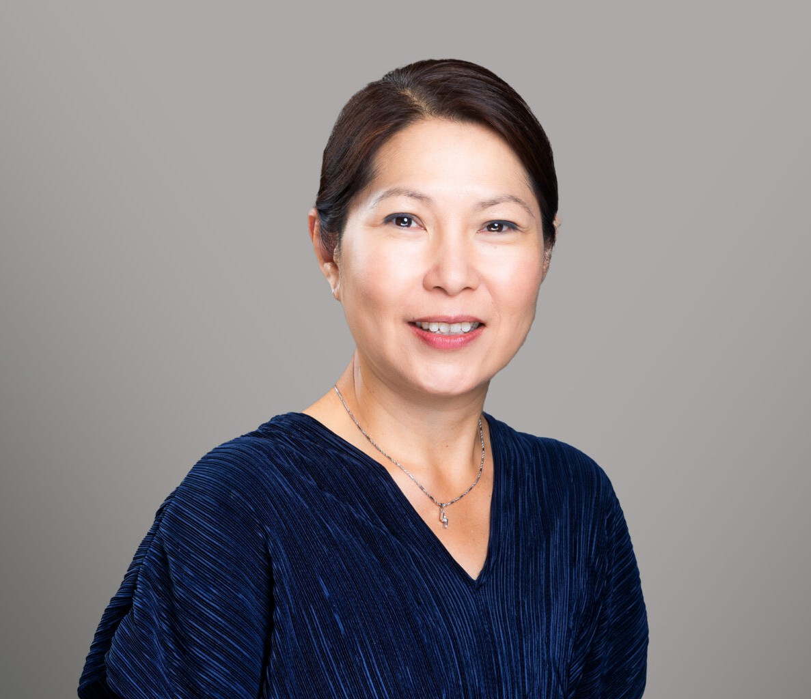

JUDITH Y. TANG
Director
Trusts & Estates

Oakland
P: 510.834.6600 F: 510.834.1928
jtang@fennemorelaw.com

JUDITH Y. TANG
Judith is a Director and the Co-Vice Chair of the Trusts and Estates Practice group at Fennemore. She has over 25 years’ experience and breadth of knowledge providing comprehensive personalized estate planning and trust and estate administration services. She is one of very few Certified Specialists in Estate Planning, Trust and Probate law by the State Bar of California Board of Legal Specialization who speaks fluent Cantonese. She also speaks conversational Mandarin.
Judith counsels and assists clients in estate planning matters to protect loved ones and minimize tax consequences. She prepares wills, trusts, life insurance trusts, durable powers of attorney, Advance Health Care Directives, and related documents. She also represents trustees,
executors, administrators, and beneficiaries in estate and trust administration. She is experienced in implementing estate plans, resolving creditor and tax issues, and administering the estate in accordance with the decedent’s wishes.
Judith was appointed to the Executive Committee of the California Lawyers Association’s Trusts and Estates section. She is an author and speaks on estate planning topics for the State Bar of California and the Continuing Education of the Bar. Judith is active in the Bay Area Chinese community and has been featured on Chinese radio and on TVB’s “Financial Magazine” television program. She was a board member of the Oakland Chinatown Chamber of Commerce for nine years.

EDUCATION
J.D., University of California College of the Law, San Francisco (formerly known as Hastings College of the Law)
B.S., University of California, Berkeley, high honors

AREAS OF PRACTICE
Trusts & Estates Estate Planning Tax Law

AWARDS AND HONORS

Certified Specialist in Estate Planning, Trust and Probate Law by the State Bar of California Board of Legal Specialization, 2005-present
Northern California Super Lawyers®, 2010-2025
Northern California Super Lawyers®, Top Women Attorneys, 2010-2024 American Jurisprudence Award
Judicial Extern to Judge Saundra Brown Armstrong, U.S. District Court, Northern District of California

ARTICLES AND PRESENTATIONS
Presenter, “AB 2016 – Non Probate Transfer of Decedent’s Principal Residence” California Advocates for Nursing Home Reform (CANHR), April 29, 2026
Ventura County Bar Association, March 26, 2026
California Lawyers Association, “Trust Me” podcast, Season 6, February 2026 Alameda County Bar Association, January 22, 2026
Professional Fiduciary Association of California, August 14, 2025 Berkeley Albany Bar Association, May 20, 2025
Continuing Education of the Bar, May 14, 2025 East Bay Trusts and Estates Lawyers, April 9, 2025
Author, “California Proposition 19’s Impact on Estate Planning and Gifting of Real Property,” Fennemore Blog, February 17, 2025
Presenter, “Trusts and Estates Career Panel and Lunch at UC Law San Francisco,” California Lawyers Association, Trusts and Estates Executive Committee, February 25, 2025 and March 27, 2024
Presenter, “Trusts and Estates Career Panel and Lunch at Berkeley Law,” California Lawyers Association, Trusts and Estates Executive Committee, March 22, 2023
Update Author, “Drafting California Revocable Trusts, Chapter 21 – Funding the Trust,” Continuing Education of the Bar, 2020-2025
Contributing Author, “California Basic Practice Handbook,” Continuing Education of the Bar, 2012-2025
Presenter, “Transferring Real Property,” Continuing Education of the Bar, December 5, 2017
Presenter, “Tax Talk—Income and Estate Tax Issues Your Clients Need to Know,” East Bay Trusts & Estates Lawyers, September 15, 2017
Presenter, “Real Property Essentials for Estate Planning,” Continuing Education of the Bar, May 4, 2017
Presenter, “Estate Planning and Wealth Transfers,” Sierra Pacific Financial Advisors, December 6, 2012
Presenter, “Real Estate Basics for Estate Planners,” Continuing Education of the Bar, November 9, 2012
Presenter, “Culturally Competent Trusts and Estates Practice,” State Bar’s Trust and Estates Section, October 13, 2012 and September 14, 2012

Presenter, “Wealth Transfer for Real Estate Investors,” Chinese-American Real Estate Association (CAREA), April 19, 2012
Presenter, “Gifting and Estate Planning Opportunities in 2012,” Charles Schwab, Berkeley, January 11, 2012
Presenter, “Estate Planning for Owners of Real Estate,” Red Oak Realty Client Program, November 7, 2011
Presenter, “Wills and Trusts,” Community Outreach Health Fair, Asian Cultural Center, October 6, 2011
Presenter, “Estate Planning Strategies for Passing on Real Estate,” Asian Real Estate Association of the East Bay, September 22, 2011
Presenter, “Opportunities in Gifting and Real Estate,” Chinese American Real Estate Association, March 31, 2011
Author, “Do I Need a Will?” Chinese Translation,” State Bar of California, 2003, 2010
Author, “Do I Need Estate Planning?” Chinese Translation, State Bar of California, 2003, 2011 Author, “Do I Need a Living Trust?” Chinese Translation, State Bar of California, 2003, 2011

PROFESSIONAL AND COMMUNITY ACTIVITIES
Member, Executive Committee, Trusts and Estates Section, California Lawyers Association Chair, Estate Planning Committee, 2025-2026
Vice Chair, Estate Planning Committee, 2024-2025 Chair, Ethics Committee, 2023-2025
Chair, Uniform Laws Committee, 2024-2025 Vice Chair, Taxation Committee, 2023-2024
Member, East Bay Trusts and Estates Lawyers Member, Asian American Bar Association Member, Alameda County Bar Association President, Arioso Homeowner’s Association
Former Board of Director, Oakland Chinatown Chamber of Commerce Volunteer Docent, Easy Bay Regional Parks District

ADMISSIONS
California

LANGUAGES
Cantonese Chinese (Fluent) Mandarin Chinese (Conversational)

