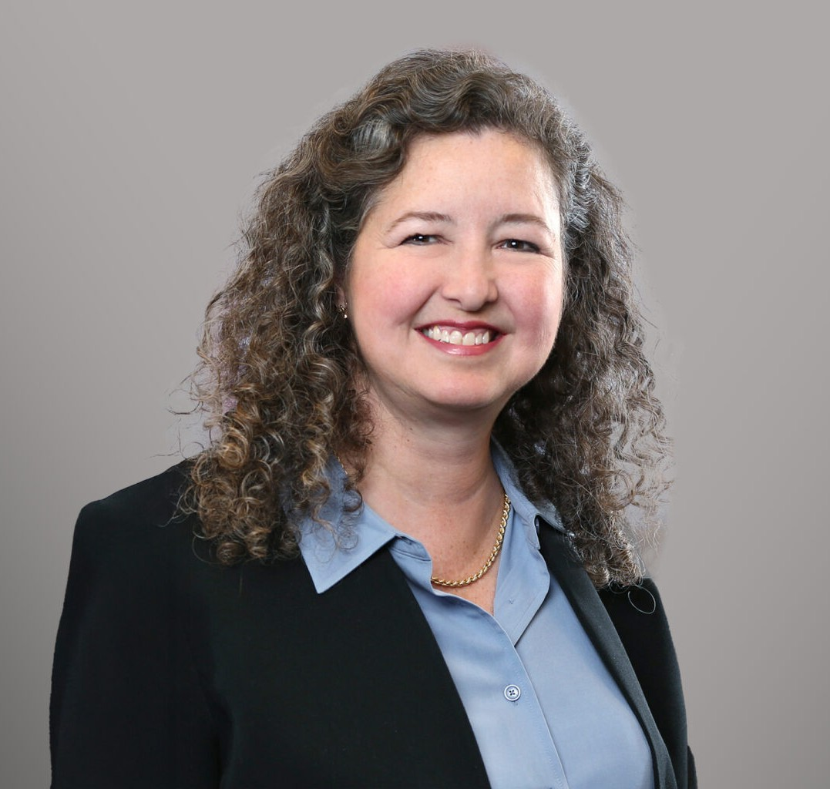

KATHLEEN B. CARR
Director
Intellectual Property

Fennemore Forward
P: 617.927.9925 F: 602.916.5999
kbcarr@fennemorelaw.com

KATHLEEN B. CARR
Kathleen B. Carr is a Director in Fennemore’s Intellectual Property practice group. She draws upon extensive litigation experience to strategically guide clients through a broad spectrum of complex intellectual property and commercial litigation matters.
Kathleen’s practice encompasses patent, trademark, and copyright litigation. She has led trial teams in multibillion- and multimillion-dollar Hatch Waxman pharmaceutical patent litigation. She has successfully litigated patent disputes across diverse technologies—such as pharmaceuticals, biotechnology, mechanical devices, business methods, printing machines, mechanical seals, fax technology, and photocopiers—and has led inter partes review proceedings with favorable
outcomes. In trademark matters, Kathleen has represented clients in industries spanning pharmaceuticals, hair restoration, and modeling agencies. She also is a registered U.S. patent attorney.
Her commercial litigation and counseling practice includes admiralty and maritime law,
contract disputes, insurance coverage, antitrust, offshore wind, COVID-19 issues, real estate, architecture and engineering, and fire damage cases. She also has an enduring interest in constitutional law and federal statutory interpretation, having authored articles and amicus briefs on these subjects.
Kathleen co-authored a treatise chapter, “Litigation Management by Judges,” in the nationally well-known federal court litigation treatise, Business and Commercial Litigation in Federal Court (Thompson Reuters, 2021) (co-authored with Hon. George A. O’Toole, U.S. District Court, D.
Mass.).

EDUCATION
J.D., Tulane University School of Law
B.A., English; B.A., Physics, Dartmouth College

AREAS OF PRACTICE
Intellectual Property Business Litigation

Apparel & Fashion

REPRESENTATIVE MATTERS
Lead trial counsel in Hatch-Waxman litigation involving a cholesterol-lowering drug; 9-related cases. Favorably settled 7, and prevailed at trial against remaining 2 defendants. Prevailed on appeal to Federal Circuit.
Lead counsel in three IPR proceedings brought by generic pharmaceutical manufacturers against patent owner in related Hatch-Waxman litigation; successfully obtained denial of institution of all petitions.
Lead counsel on U.S. Supreme Court Amicus briefs.
Lead trial counsel in Hatch-Waxman litigation involving a direct thrombin inhibitor. Prevailed on all claims in a 156-page District Court decision, affirmed on appeal to the Federal Circuit.
In a multibillion-dollar Hatch Waxman pharmaceutical litigation, successfully defended
against multiple generic manufacturers’ ANDA attacks on diabetes drug patents. Prevailed in both District Court and on appeal to the Federal Circuit.
Lead counsel in the negotiation of numerous settlements in Hatch-Waxman ANDA litigation.
Lead counsel obtaining an $18+ million award for a pharmaceutical patent holder on an attorneys’ fees petition.
Lead counsel in patent litigation filed in the Eastern District of Texas involving 29 patents covering photocopier technology. Settled favorably.
Trial counsel in a patent infringement action involving mechanical seals. Settled favorably on the fifth day of jury trial.
Multiple successes on behalf of an excavator in a patent license dispute, and ultimately obtained a favorable settlement in patent litigation involving a tree stump excavating and crushing device patent.
Represented a hair restoration company in trademark and unfair competition litigation. Obtained dismissal of all claims against the client.
Represented a global modeling agency in trademark and dilution litigation. Successfully negotiated a favorable settlement protecting the agency’s trade name.
Represented a pharmaceutical company in trademark litigation. Negotiated a favorable settlement protecting the company’s trade name and marks.
Multiple successes on behalf of clients through litigation and pre-litigation/cease and desist letters, including early and practical resolution of disputes.
Represented an intermodal carrier in a hotly contested contract and insurance dispute. Settled on favorable terms, which preserved the client’s business.
Represented and counseled clients on admiralty and maritime law issues and litigation, vessel arrests and attachments, on-board investigations and vessel-related incidents, marine insurance coverage matters, and offshore wind farm issues.
Defended securities fraud class and derivative actions.
Wide variety of experience in contract, insurance, and business litigation.

AWARDS AND HONORS

The Best Lawyers in America, 2016-2025

Intellectual Property Litigation, Patent Litigation, Patent Law, and Trademark Law

The Legal 500 Boston City Elite for Commercial Litigation The Legal 500 Boston City Elite for Intellectual Property
LMG Life Sciences Star, General Patent Litigation, Hatch-Waxman Patent Litigation, 2012‒2025
Euromoney’s Women in Business Law Expert Guide: Patent The Legal 500 United States for Health Care: Life Sciences American Bar Foundation-Life Fellow
Litigation Counsel of America-Fellow

PROFESSIONAL AND COMMUNITY ACTIVITIES
Chair, Merit Selection Panel for the Reappointment of U.S. Magistrate Judge Jennifer C. Boal,

U.S. District Court, District of Massachusetts, 2018
Board Member, Former Counselor, Boston IP American Inn of Court
Former Elected Member, Charter Commission, Town of Braintree, Massachusetts Former Member, Government Study Committee, Town of Braintree, Massachusetts Member, American Bar Association
Member, Federal Circuit Bar Association Member, Boston Patent Law Association Member, Federal Bar Association Member, Maritime Law Association Member, Massachusetts Bar Association Member, Rhode Island Bar Association Member, Boston Bar Association
Member, American Intellectual Property Law Association (AIPLA) Former Volunteer, Volunteers in Service to America (VISTA) Former Captain, US Coast Guard 100-ton licensed boat captain

ARTICLES AND PRESENTATIONS
Moderator and Panelist, “The Interplay Between ‘Skinny Labels’ and Inducement to Infringe,” Federal Circuit Bar Association, March 26, 2026

ADMISSIONS
Massachusetts Rhode Island
U.S. Patent & Trademark Office
U.S. Court of Appeals, First, Sixth, and Federal Circuits
U.S. District Court, District of Massachusetts
U.S. District Court, Eastern District of Michigan

U.S. District Court, District of Rhode Island
U.S. District Court, Eastern District of Texas
U.S. Supreme Court

