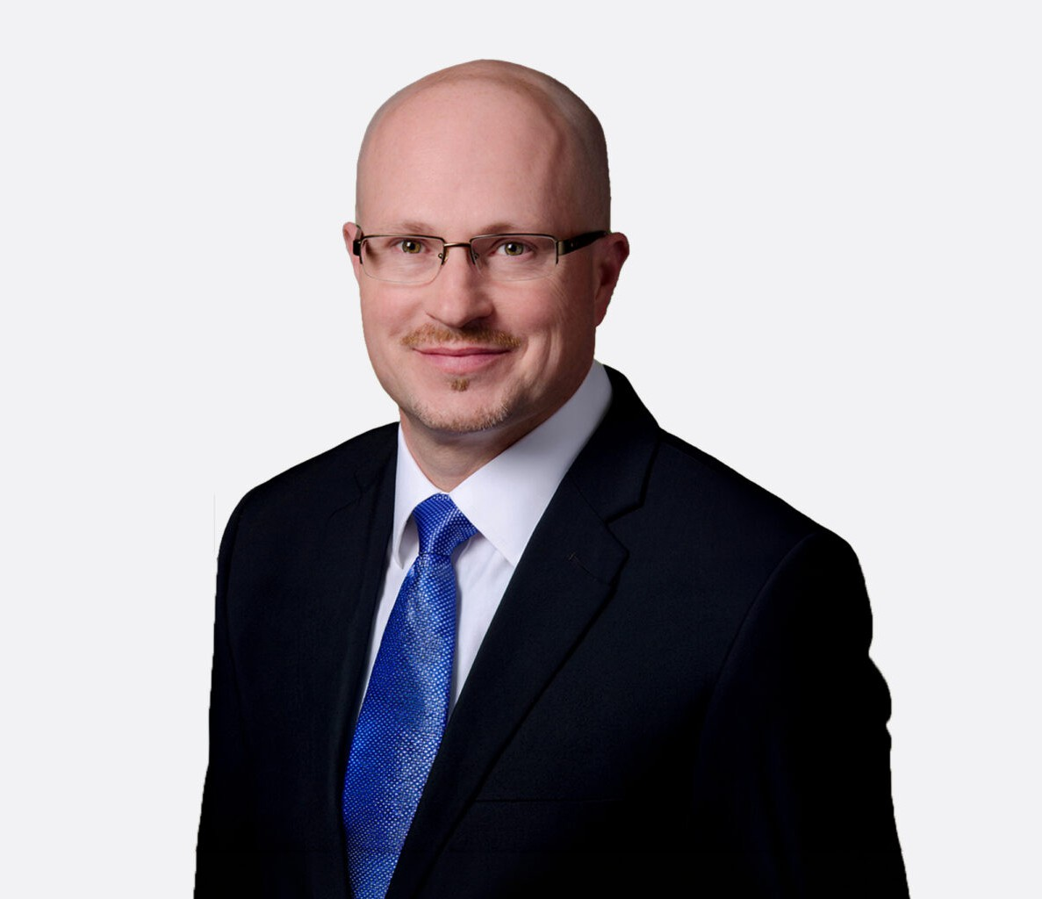

KEITH C. SMITH
Director
Real Estate

Fennemore Forward
P: 863.315.3280
kcsmith@fennemorelaw.com

KEITH C. SMITH
Keith Smith is a seasoned attorney in Fennemore’s real estate group, representing businesses and individuals in corporate law and commercial real estate matters. He advises clients on business formation, corporate governance, commercial transactions, and mergers and acquisitions, helping organizations structure and scale with confidence. Keith also serves as outside general counsel to a range of companies, providing ongoing strategic and legal guidance tailored to evolving business needs.
With a background as Senior Attorney and Vice President at Citigroup, Keith brings valuable financial services and transactional insight to complex real estate and corporate matters. He supports clients across a wide range of real estate projects, including office buildings, commercial centers, industrial parks, apartment communities, and multi-family developments. His work spans acquisitions, development, financing, and disposition, making him a trusted advisor for clients navigating the real estate market.
Keith is widely recognized for his contributions to commercial real estate and his forward-looking approach to economic development and public-private partnerships, particularly in Central
Florida. He works closely with colleagues in banking and finance, real estate, and utilities to deliver coordinated legal strategies that align with clients’ business goals and long-term growth plans.
Earlier in his career, Keith served as a judicial clerk to the Honorable David Ross in the Maryland Circuit Court and practiced with law firms in both Maryland and Florida. He remains active in the business community and is frequently engaged as a thought leader on issues related to corporate transactions, infrastructure development, and strategic expansion.

EDUCATION
J.D., Widener University School of Law, cum laude
B.A., McDaniel College

AREAS OF PRACTICE
Real Estate Agribusiness

Business & Finance General Counsel Services Mergers & Acquisitions Natural Resources

AWARDS AND HONORS
Best Lawyers in America, Real Estate Law, 2025-2026 NAIOP, Best Land Deal of the Year, 2023
NAIOP, Best Industrial Real Estate Project, 2022 NAIOP, Best Land Deal of the Year, 2025

PROFESSIONAL AND COMMUNITY ACTIVITIES
Member, Electric Cooperative Bar Association
Member, The Florida Bar, Real Property, Probate and Trust Law Section, and Business Law Section
Board Member, Girl Scouts of West Central Florida, 2019-2024 Member, Maryland Bar Association
Chair, Plant City Economic Development Corporation, 2017-2018

ADMISSIONS
Florida Maryland

